Navigation Pane
Opening the Navigation Pane will allow you to move around the document using the section headings.

- Open the document and click the View tab at the top of the screen

- Check the ‘Navigation Pane’ box
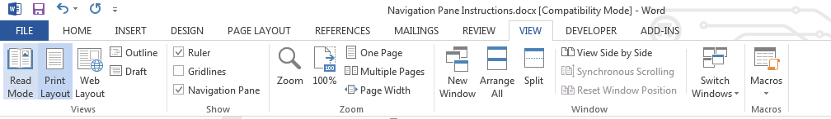

- The Navigation Pane will appear on the left side of the screen. Click on the heading of the section that you wish to view.
