Welcome to the March EduExe newsletter!

The EduExe Newsletter is an initiative for all colleagues involved in education, focusing on news, updates and all things educator development and enhancement. This monthly newsletter will include relevant articles and resources according to the time of the academic year, updates on strategic projects, reminders of key deadlines (i.e. for module amendments) and much more!
This issue we have articles and resources on:
- Student Academic Support Project Update
- Neurodiversity Celebration Week
- Doctoral Supervisor training sessions - more dates added
- Opportunity for students at THE Digital Universities UK Conference
- Curriculum for Change Design Principles - Correction
- Reminder: Module amendment deadlines for 24/25
- Reminder: ASPIRE PRP deadlines 2023/2024
- QAA Assessment Festival 2024
- THE Campus Call for Contributions
- On EduExe socials this month
- March Challenge - EduExe Only Connect

Student academic support Project Update
The Student Academic Support Project Group, led by Professor Nicky King (APVC, Education - Faculty of ESE) and Professor Adam Watt (DPVC, Faculty of HASS) are piloting a new model for proactive, data-informed and digitally enabled student academic and pastoral support.
Following the successful implementation of the pilot in Physics and HASS Cornwall, the full project roll-out is now beginning with an expansion to a further three departments this academic year – Engineering, Psychology and Law (Streatham). The project introduces dedicated Pastoral Mentors embedded in departments to provide high-quality proactive academic and pastoral support for students experiencing difficulties, which impact their ability to study and be successful on their programme of study. Pastoral Mentors will be a point of contact for both students and Academic Advisors (currently Personal Tutors), and provide end-to-end support for student queries, including signposting to expert teams as required, such as Wellbeing and Welfare.
The Project Group has worked with Faculties and Departments to agree the phased rollout to all University Departments by September 2025. The Group will hold implementation planning meetings with colleagues in Departments in advance of each phase of rollout. To find out more about the project, including it’s objectives, benefits and success measures please visit this webpage: Projects | Learning Experiences and Innovation | University of Exeter
A reminder that tutoring resources for all staff involved in tutoring are now housed in the EduExe Toolkit - Home (sharepoint.com) – easy for you to find, and to share with colleagues.
The Education Welfare and Wellbeing services remain the same and staff should continue to refer to this team for support as needed.

As part of Neurodiversity Celebration Week, on 21 March 10 am to 11 am the University are holding a panel event about Neurodivergent Staff experiences of working in HE. You'll hear from staff members at all levels of the institution and hear about how neurodiversity has impacted their work and what support we could provide them to make sure that Neurodivergent people flourish at Exeter. The event will be held on Teams and you can sign up for it on eventbrite. If you would like to discuss ways to make the talk more accessible for you, please contact Lena at s.worwood2@exeter.ac.uk
Book your place

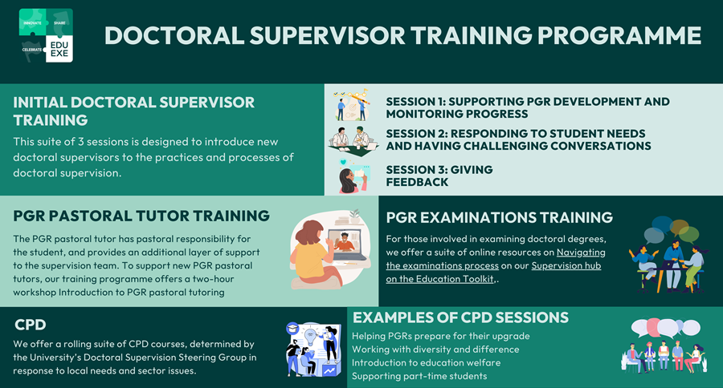

Doctoral Supervisor training sessions - more dates added
In January 2024 we launched a new programme of Doctoral Supervision training. We have added new dates for the initial supervisor training sessions, which will be running again in the summer term:
- Supporting PGR development and monitoring progress
- Responding to student needs and having challenging conversations
- Giving feedback
If you have any questions about our Doctoral Supervision training programme, please contact the Educator Development team on eduexe@exeter.ac.uk.
Find out more about the Doctoral Supervisor training programme

Opportunity for students at THE Digital Universities UK Conference
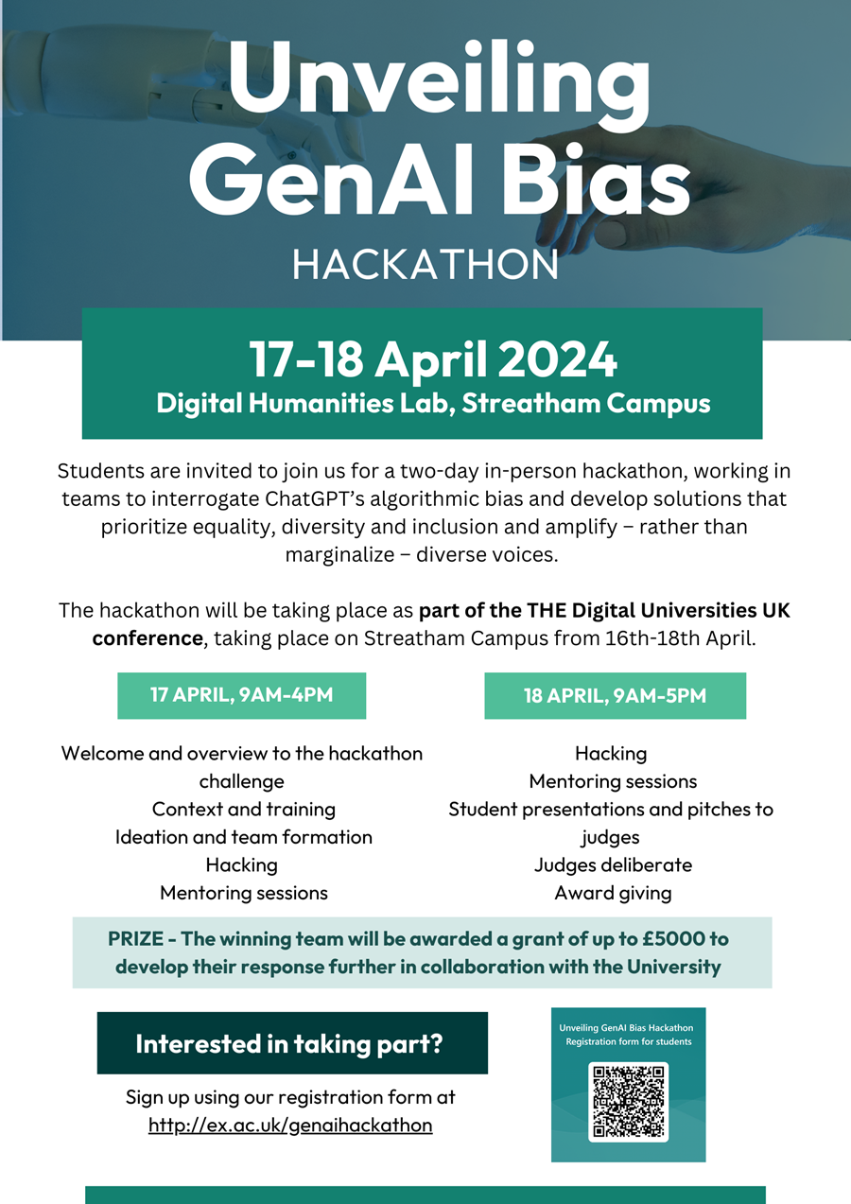

C4C Design Principles - Correction
Apologies, the full version of the C4C design principles was not shared in the previous newsletter. Please find the corrected and full articilation of the principles below.
Our Education Strategy set a priority to articulate a distinctive model for education at Exeter. With the introduction of Strategy 2030, this has evolved into Curriculum for Change (C4C) – a model that reimagines our undergraduate offer to develop our students as highly-employable and sought after, future positive change makers. A key first step has been to develop the C4C Design Principles, which will be incorporated into all undergraduate degree programmes. Having been approved by EdSEEC and UEB, we are delighted to announce the principles that will inform the C4C work as we moved forward.
The Design Principles
- Future Positive: We will foster the development of the next generation of global citizens and change agents who contribute to the creation of a fairer, greener, and healthier world through the alignment of our curriculum to the transformative education framework and UN SDGs.​
- Market-Leading: We will design our new and revise our current offerings to align to market and employer demands currently in demand and what they foresee needs will be in the future, with a focus on international attractiveness, widening participation, and enhancing our global reputation.​
- Skills Aligned: We will align our educational offerings with in-demand and skills essential to future success, with a focus on a mapping our curriculum to skills and graduate attributes, measuring students' educational gain, and helping students evidence and communicate skill acquisition through a longitudinal portfolio, all in an effort to enhance graduate outcomes for our students.​
- Efficient and Cohesive: We will implement efficient delivery models and cohesive, consistent practices across the curriculum that emphasise interdisciplinarity. Our curriculum will be hybrid and multi-modal, take advantage of digital tools and reusable learning assets, and implement standards for assessment practices to reduce and smooth the assessment load. ​
- Authentic and Experiential: We will deploy real-world challenges as a foundational building-block for our curriculum, expand the use of flipped classrooms to enable active learning, deploy experiential and problem-based learning across the curriculum, and emphasise the use of authentic assessment methods that provide students with portfolio-building learning artifacts.​
- Inclusive and Student-centred: We will co-create C4C with our students, with the aim of enhancing the student experience for all students, emphasising Equality, Diversity, Inclusion (EDI) and Success for All as core to our offer, and creating a sense of belonging and mattering within our university community.​
- High-quality: We will uphold our extremely high standards for the quality of our educational offering as measured through TEF, NSS, and other quality benchmarks. Our top priority is to deliver an exceptional student experience in all areas of our educational offer.​
- Data-informed: We will make decisions informed by relevant data on market demands, student needs and choice, cost-to-deliver, reputational impact assessments, National Student Survey (NSS) results, and other relevant metrics to guide educational strategies and decisions.​
- Digitally-enabled: We will take full advantage of digital transformation and responsible use of digital tools to enhance our curriculum and student and staff.

Module amendment deadlines for 24/25
Please find below a summary of the module amendment guidance note for 24/25. This guidance is also available via the TQA Manual’s forms page, here
Deadlines - please note some of these deadlines have now passed
The deadlines are as follows (Note, faculty-specific deadlines below*):
- UG 2/3/4: Friday 1st March 2024
- UG 1 / PGT: Friday 26th April 2024
These are the dates by which amendments need to have been:
a) submitted via the Module Amendment Site;
b) approved by DESEs and
c) progressed to the PDQE Team (formley QST) for review/publication
*HASS deadlines:
- UG 2/3/4: Wednesday 28th February 2024
- UG 1/PGT: Wednesday 17th April 2024
*Business School deadlines:
- New modules / suspensions of existing modules: Monday 22nd January 2024
- Amendments to UG 2 & Finalist modules: Monday 22nd January 2024
- Amendments to UG 1 & PGT modules: Friday 12th April 2024
Post-deadlines administrative downtime:
There is a new addition to the process, there will be two periods of two weeks of ‘downtime’ to the module amendment site to allow PDQE and the Hubs to complete all required administrative tasks:
- Monday 4th March 2023 – Friday 15th March 2023
- Monday 29th April 2023 – Friday 10th May 2023
If any urgent late amendments are needed during these times, staff are advised to contact the PDQE team directly.
Faculty of Environment, Science and Economy: ese-quality@exeter.ac.uk
Faculty of Health and Life Sciences: hls-quality@exeter.ac.uk
Faculty of Humanities, Arts and Social Sciences: hass-quality@exeter.ac.uk
Late amendments:
As per the guidance, ‘a judgement must be made by the relevant DESE(s) or APVCE (as agreed by Faculty)’ as to whether late amendments are to be permitted. Late module amendments should only be made where deemed to be absolutely essential.

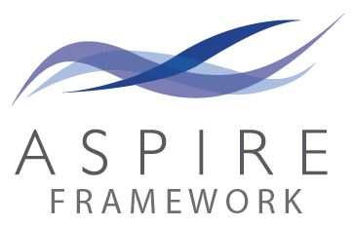

Reminder: ASPIRE PRP deadlines 2023/2024
As we move through our reaccreditation of ASPIRE PRP with Advance HE, colleagues should be aware that the last deadline for PRP applications in this academic year will be 30th June. We will pause submissions over the summer while we transition to the new PSF 2023 framework, moving to six submission points a year. Our first submission point is yet to be confirmed, but will be late September or early October - more details to follow. For more information on how to notify us of your intention to submit, please see the relevant fellowship pages on our ASPIRE PRP Sharepoint.

QAA Assessment Festival 2024
Back for its second year after great feedback in 2023, get your festival season started with QAA’s Assessment Festival. The format of the sessions will mix lively panel debates with interactive seminars that allow for sharing insights and experiences between presenters and delegates.
The week starts with a debate on the opportunities and challenges of Generative Artificial Intelligence for our approaches to assessment, setting the tone for a week of provocative discussions. Throughout the event, we'll dive deep into a range of topics including: diverse assessment cultures and traditions (competence based, programmatic and modular); compassionate assessment; postgraduate assessment practices; and the future ways we anticipate recording student achievement.
Assessment Festival promises to be a melting pot of ideas, debates and collaborative learning, offering fresh perspectives on the future of assessment in higher education. Join us for an unforgettable journey through the challenges and opportunities shaping our approach to assessment and feedback.
Find out more and book your place

THE Campus call for contributions
Through our partnership with THE Campus, we receive regular calls for content, as well as a rolling call for contributions on THE Campus key topics. The current calls for content are on:
How to develop tough skin for the cold, hard world of higher education. Practical advice from and for HE professionals on:
- Anxiety over public speaking
- What to do when students make you cry
- Dealing with bad feedback/peer reviews
- What to do when your student surveys are awful
- Should I care about my Rate My Professor score?
- Resilience skills to cope with rejection of a paper/job application/funding proposal
- How to persist through setbacks in your research
- How to deal with competition in your department
- Setting boundaries for your own well-being
- Deadline for content: Monday, 25 March
Assessments and AI. Practical advice from and for HE professionals on:
- How to foster critical thinking
- What are we measuring?
- How to re-invent assessments to robustly measure learning
- How to assess students’ AI literacy
- How to decide if your assessments are still fit for purpose
- Ungrading in an age of AI
- Is generative AI friend or foe?
- AI and feedback mechanisms
- Remote proctoring and how to make it work
Deadline for content: Monday, 8 April
If you are interested in contributing to THE Campus, please contact eduexe@exeter.ac.uk with your pitch and download the Campus editorial guidelines.
Send your pitch to the EduExe team!

On EduExe socials this month
EduExe continues to grow our social media presence, sharing updates, best practice and discussing current issues in Higher Education. This month we shared blog posts on:
- Co-designing marking criteria with students for non-standards assessments - Dr. Jennifer Lea
If you are interested in contributing a case study of your practice to the EduExe blog, please contact us on eduexe@exeter.ac.uk!
Don't forget you can follow us on LinkedIn for updates!
Read the EduExe blog

March Challenge - EduExe Only Connect
This month's EduExe challenge is our very own Only Connect wall!
If you successfully complete the wall, send us a screenshot to claim your EduExe lanyard or coffee cup!
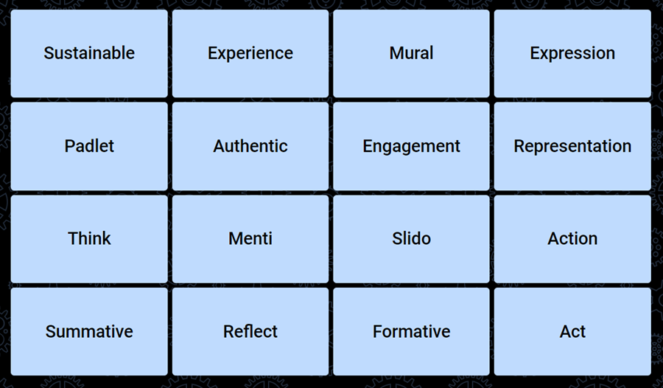
Try our Only Connect wall!

Interested in contributing to the newsletter?
We will have rolling deadlines for submissions each month, so please get in touch with eduexe@exeter.ac.uk if you would like to contribute!
We want your feedback!
The EduExe newsletter is a new initiative, and we would love to hear from you if you have any feedback! You can share it with us anonymously on our feedback form or by email to eduexe@exeter.ac.uk.

Follow us on social media or visit our website to find out more about educator development and enhancement at Exeter!

Join the EduExe teams site to connect with educators across the University

