Welcome to the November EduExe newsletter!

The EduExe Newsletter is a new initiative for all colleagues involved in education, focusing on news, updates and all things educator development and enhancement. This monthly newsletter will include relevant articles and resources according to the time of the academic year, updates on strategic projects, reminders of key deadlines (i.e. for module amendments) and much more!
This issue we have a special focus on feedback, including articles and resources on:
- The role of feedback in the assessment journey
- Signposting your students
- What makes good feedback?
- The student perspective on feedback
- Power automate as a peer-to-peer feedback tool
- ELE 2 Coursework Marking Tools and Feedback Studio
- Support from Educator Development
- Call for good practice case studies
- Events and project calls
- On EduExe socials this month
- EduExe wordsearch - the answers and the EduExe Wordle challenge!

Feedback in the assessment journey
It's important to remember that feedback is part of the wider assessment journey for students. We have developed the following infographic to help students understand the journey of their assessment, and when and how they will receive feedback.
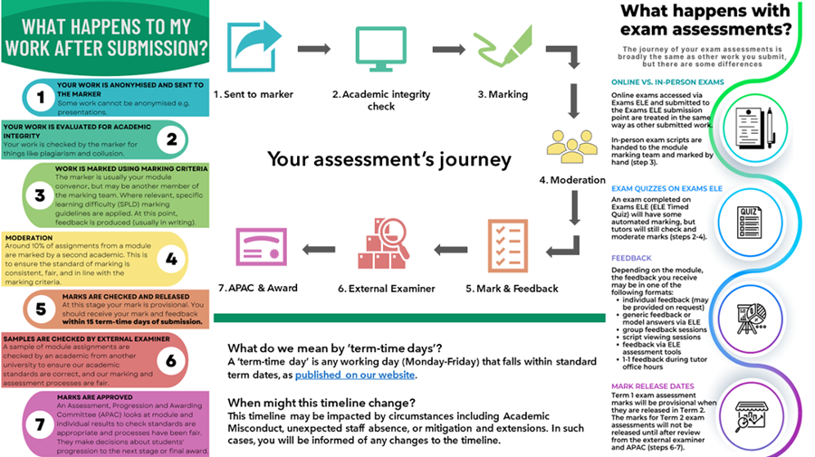

Student facing resources
Study Zone Digital have some excellent resources for students on Using assessment feedback, including pages on:
- Formative vs. summative assessment
- Understanding your feedback
- Making a feedback log
- Feeding forward: acting on your feedback
- Studiosity

What makes good feedback?
Last year, the University's NSS Assessment and Feedback Expert Group identified the 5 qualities of good feedback.
We will be using these qualities as part of our Five days of feedback event in the week commencing 11th December. Every day, we will share case studies and top tips focusing on each of these qualities of good feedback in turn by email, on X and on LinkedIn.
We are also running an online Q&A session on 14th December, 1-2pm on How ELE2 and the Turnitin Feedback Studio can facilitate good feedback. If you would like to attend, email eduexe@exeter.ac.uk.
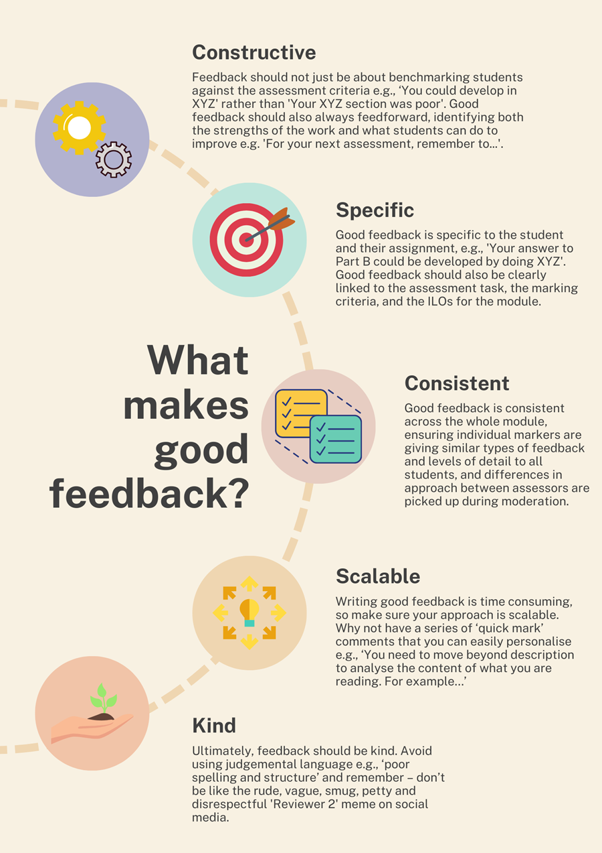
Book your place for How ELE2 and the Turnitin Feedback Studio can faciltiate good feedback

The student perspective on feedback
We asked Rosie Cornelius-Light, our Transformative Education Assistant and recent University graduate what good feedback looks like to students
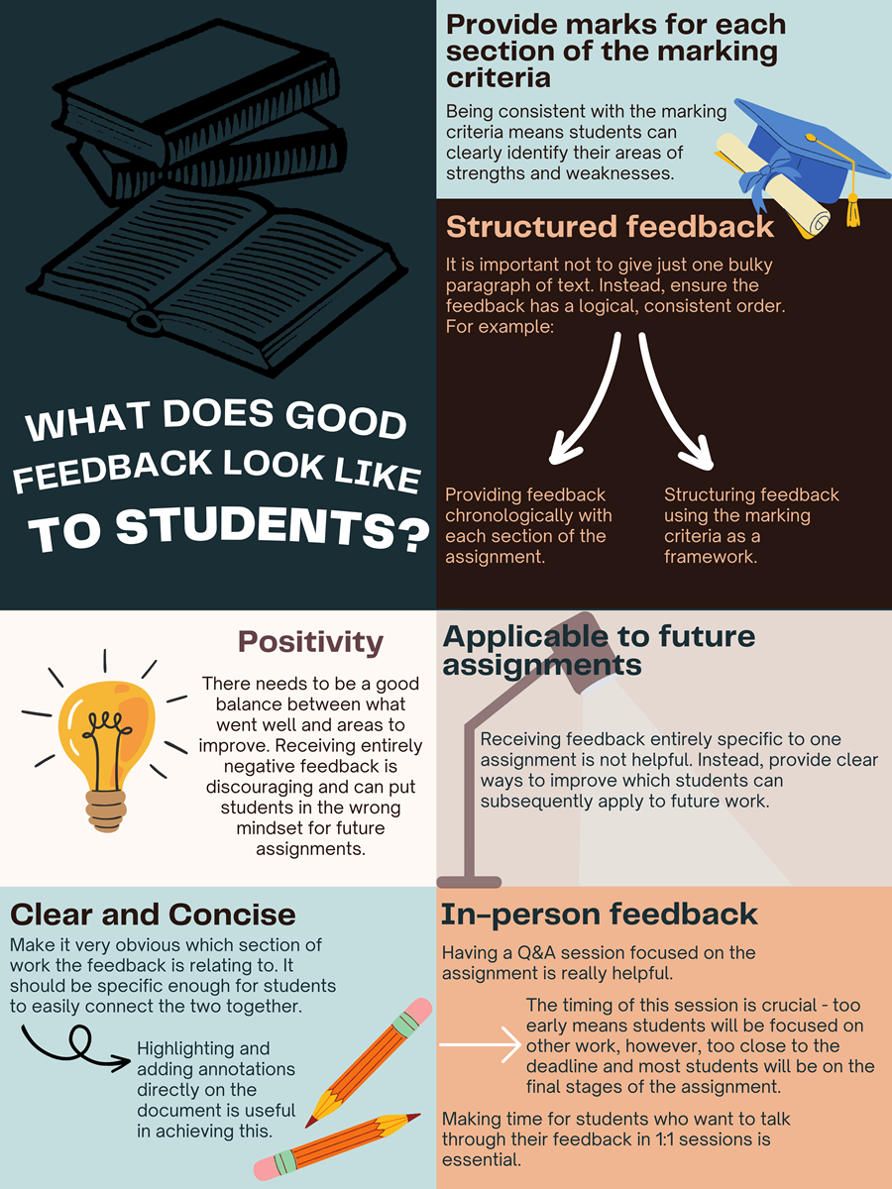

Power Automate as a Peer-to-Peer Feedback Tool
Dr. Dominic Wiredu Boakye, Lecturer in Biomedical Sciences, has developed an app using power automate to manage and distribute peer feedback.
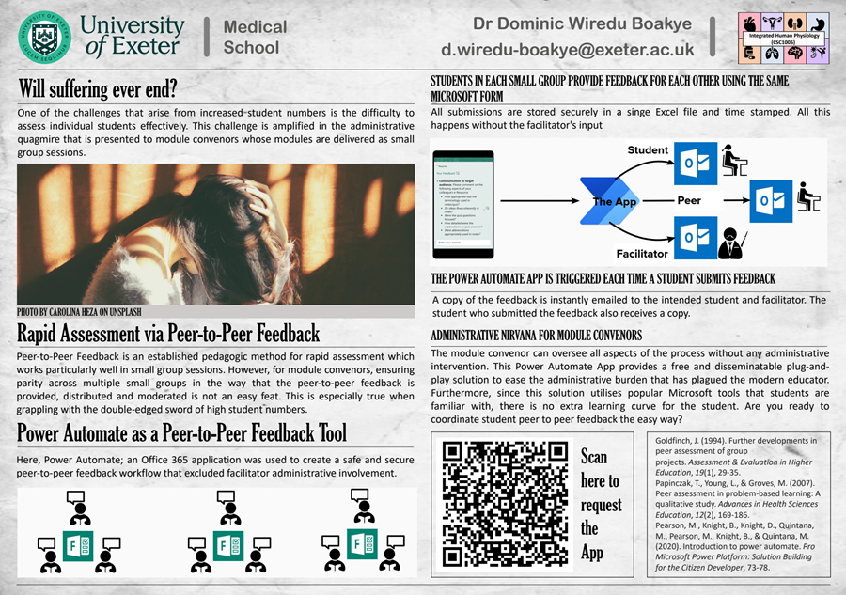
Access the peer-to-peer feedback tool

ELE 2 Coursework Marking Tools and Feedback Studio
There are some great tools in ELE 2 to help facilitate good quality feedback.
A comprehensive guide to Coursework Activity in ELE 2 can be found on the Hubs Academic Staff Guidance page. There's also a guide here to creating a qualitative rubric and its potential uses.
Turnitin Feedback Studio is a new option for marking and feedback, and you can find a selection of helpful videos highlighting some of its capabilities on the Turnitin Feedback Studio page, along with recordings of recent Feedback Studio training sessions. The Assessment and Marking Tools table shows the capabilities of the marking tools on offer within ELE 2, and which to use for different tasks.
There is an opportunity to build more capabilities in Turnitin Feedback Studio based on the requirements of our assessment and feedback practices - these tools are the starting point. In the meantime, if you have questions about assessment tools or processes please get in touch with the ELE 2 project team at ELE2project@exeter.ac.uk or directly with one of the project team.
Access Guidance on the Turnitin Feedback Studio

Support from Educator Development
The Educator Development team have already developed workshops and resources on the following Assessment and Feedback topics. We are always developing new workshops and resources, and can also develop bespoke training and support with you. You may also find these resources on the Education Toolkit useful:
- Introduction to feedback
- How to give good feedback
- Giving feedback to students
- Comprehensive guide to feedback
- Good practice: Assessment and feedback
- Helping students make sense of feedback
You can download our 'menu' of assessment and feedback support on our website

Good practice case studies
Interested in what colleagues are doing across the University? Here are some examples of good feedback practice:
- Marking and feedback guidelines in Biosciences
- Helping students engage with feedback in Education
- Using audio feedback in Sport and Health Sciences

Share your feedback practice with us!
We want to know all about your good practice in giving feedback - including examples, case studies, hints and tips!
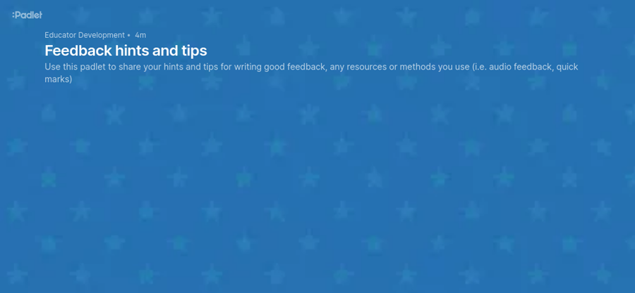
Add your good feedback practice to our padlet!

Events this month
The Education Incubator Lunch Time Talks, 7th of December, 12.30pm-1.15pm
All staff and students are warmly invited to join our first online Lunch Time Talk where our new Education Incubator Fellows will share their exciting projects on pedagogical innovation at the University. Register on EventBrite.

Transformative Education Seminar Series
The seventh seminar in the Transformative Education Seminar Series took place on the 2nd November led by Professor Vrinda Nayak, Associate Dean for Taught Students (Racial Equality and Inclusion), with a focus on 'Supporting Student Mental Health in Higher Education.' Contributions included Professor Louise Lawrence, Dr Polly Card, and Dr Felicity Thomas, University of Exeter, who presented their work on 'Nurture-U: Whole Institutional Approaches to Student Wellbeing.' Dr Cassie Hazell, University of Surrey, spoke about 'UniVRse’, the co-development and implementation of Virtual Reality interventions for first-generation students with social anxiety. Emma Speed, Loraine Dinham, Danielle Spencer, and Dr Gillian Rayner, University of Central Lancashire, led the final presentation on 'Creative Mental Health Framework: Reducing Mental Health Stigma for the LGBTQ+ Community.'
The seminar recording, presentation slides, and other additional resources are available on the Transformative Education SharePoint. Please contact Rosie (r.cornelius-light@exeter.ac.uk) or Sean (s.porter3@exeter.ac.uk) for any further questions.

Student-led projects grants call
The Education Incubator in collaboration with the Wellbeing Inclusion and Culture Committee are delivering funding calls for students at our institution to develop student-led projects on anti-racism and inclusivity, and gender safety. Please share this opportunity with your students who maybe interested in applying: Student-led Project Grants.

On EduExe socials this month
EduExe continues to grow our social media presence, sharing updates, best practice and discussing current issues in Higher Education. This month we shared blog posts on:
- Embedding wellbeing from the get-go: exploring best practices in teaching that promote student wellbeing - Katherine Ashbulby and Julie Pepper
- The impact of thinking fast and slow on teaching and learning strategies in mathematics - Layal Hakim and Peter Ashwin
- Scaffolding reflective writing for undergraduate students - Rossana Guttilla
- Steps for creating quality online modules - Lisa Harris
- Tailoring employability provision for international students - Melanie Nearchou and Pauline Zhang
We also released the third episode of the EduExe podcast, discussing embedding skills development in teaching and learning with Nicky Thomas (Business School) and Kate Pettifer (Educator Development).
Don't forget you can follow us on LinkedIn for updates!
Read the EduExe blog
Listen to the EduExe podcast

The EduExe wordsearch - the answers
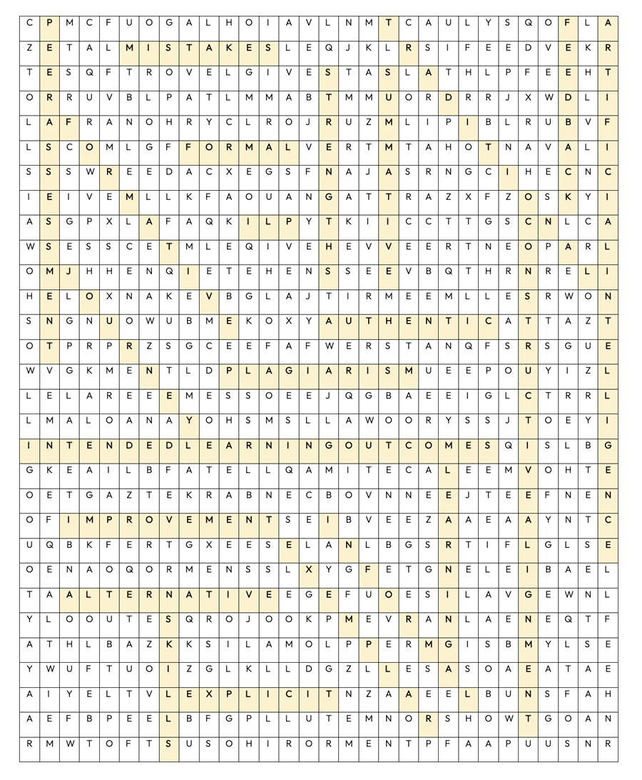

The EduExe Wordle challenge!
This month we have created a custom wordle challenge, with a word related to feedback! Try your luck, and if you guess correctly send us a screenshot and you can grab yourself an EduExe coffee mug or a brand new EduExe lanyard!
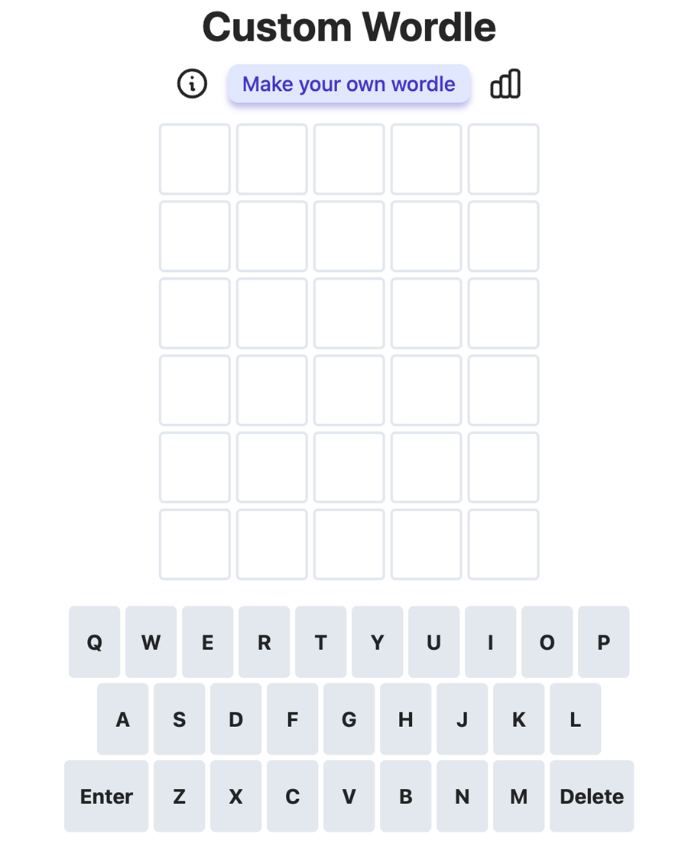
Play our custom wordle

Interested in contributing to the newsletter?
We will have rolling deadlines for submissions each month, so please get in touch with eduexe@exeter.ac.uk if you would like to contribute!
We want your feedback!
The EduExe newsletter is a new initiative, and we would love to hear from you if you have any feedback! You can share it with us anonymously on our feedback form or by email to eduexe@exeter.ac.uk.

Follow us on social media or visit our website to find out more about educator development and enhancement at Exeter!

Join the EduExe teams site for connect with educators across the University

