Student instructions for Accelerate
- Access Accelerate through the button on your ELE page or via https://accelerate.exeter.ac.uk/login

- Login screen
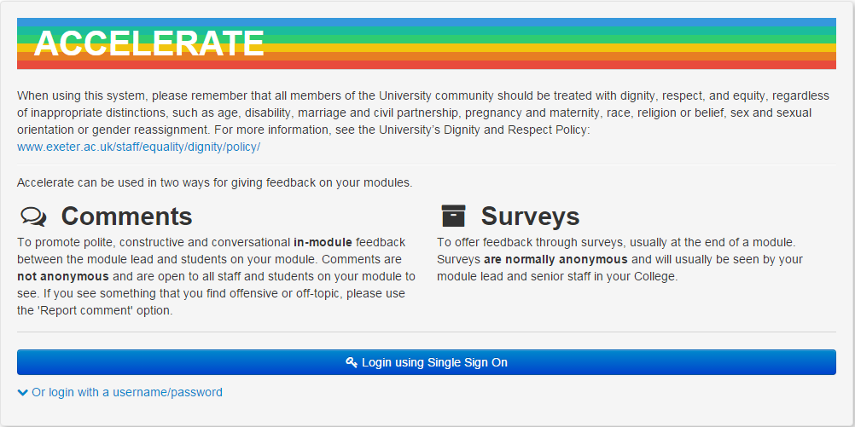
On the login screen you are presented with two options. You can either login using Single Sign On or you can login with username/password.

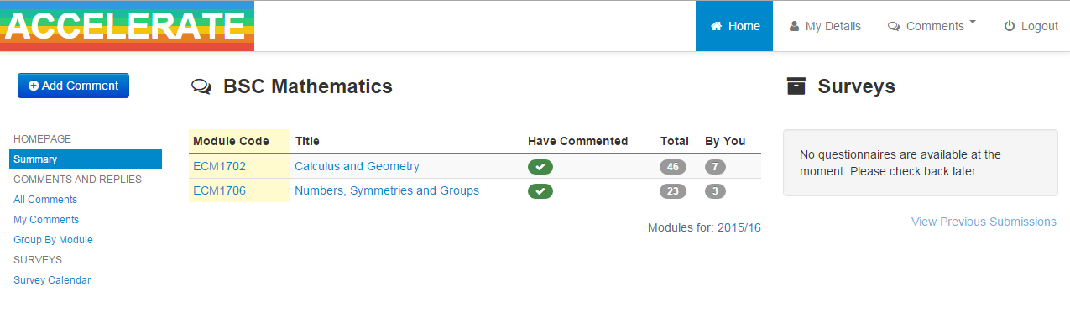
- Home page
You can see on this page how many people have replied to your comments and how many of your replies have been liked or disliked.

On this page the active links are as follows:
Module names – Clicking on a module will take you to a page that shows all comment threads for that module.
‘+Add Comment’ – this will allow you to start a comment thread on a module.
‘All Comments’ – view all comment threads across all modules that you are enrolled on.
‘My Comments’ – view all of the comments you have made on each module.
‘Group By Module’ – view your modules that have been commented on.
‘Survey Calendar’ – view the dates of your Accelerate Surveys

- + Add Comment

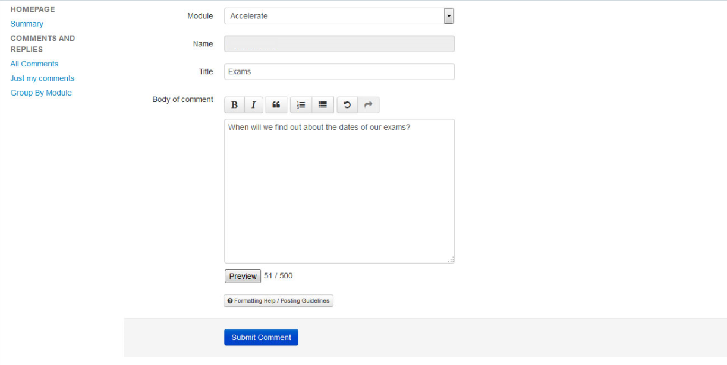
On this page you can submit your comment. Choose the module you want to comment on, your name will be entered for you, add a title, type your comment and then click submit. It is important to note that your comments will not be anonymous and will be visible to all students and staff enrolled on your module. If you wish to submit anonymous feedback you can do this through your department’s Student Staff Liaison Committee (SSLC).

- Comments page
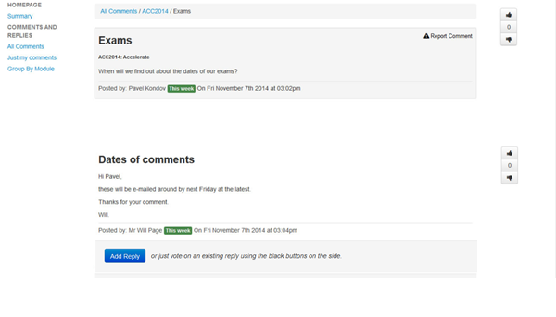
When you have submitted your comment it will look like this. The image above shows you what a reply from a staff member looks like.
If you agree or disagree with an existing comment you can show this by clicking like or dislike on the right hand side of the screen.
You can see how many hits each comment has and also its score. (Score = the number of students who have clicked like on a comment – the number of students who have clicked dislike on a comment.)
You can reply to a comment by a student, or a member of staff, by clicking Add Reply.
To return to the home screen just click on the accelerate logo.
You also have the option to report a comment to staff if you feel it’s inappropriate.

- Inappropriate Comments
All comments entered onto the Accelerate system are expected to comply with the University’s Dignity and Respect Policy: http://www.exeter.ac.uk/staff/equality/dignity/policy/. If a comment is rude or otherwise offensive you may report the comment by using the ‘Report’ button. This will inform your module lead of the comment who can delete it from the system. Inappropriate comments may be dealt with through the University’s Disciplinary Procedure: http://www.exeter.ac.uk/staff/policies/calendar/part1/otherregs/discipline/.

- Any questions/problems
SID is available to assist with any problems concerning Accelerate.

