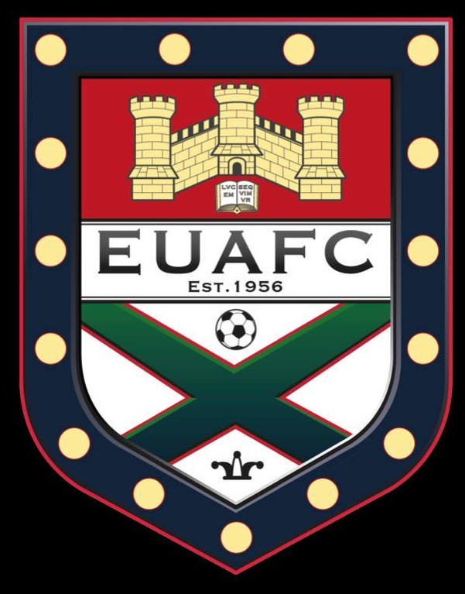

Exeter University AFC Reunion Dinner

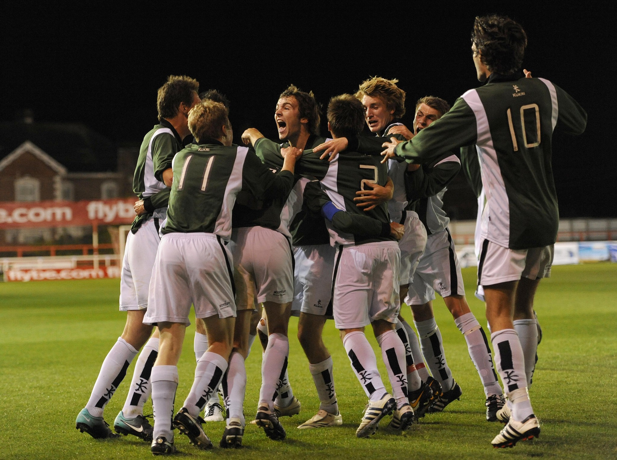

SATURDAY 13 NOVEMBER 2021

Mercure Southgate Hotel, Exeter

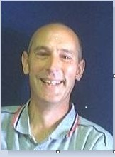
Welcome everyone to the 2nd EUAFC alumni reunion. Over the last few years, it has been an absolute pleasure to re-engage with old friends from EUAFC, and to meet so many like minded alumni from different eras, who always bond so quickly and strongly due to our powerful and similar shared experiences.

I have been hugely impressed by the current club in each of the 3 years of involvement, running one of the biggest clubs in the university with very limited support. The ethos and culture of the club is so similar to the club we all remember from the past, and this is very much why there is such a strong desire amongst the alumni to
support further development in any way we can, and in particular to lobby for the university support that the club deserves.

I hope that you have enjoyed the weekend so far, enjoy this evening and tomorrow's activities and continue to celebrate, reunite and support all things EUAFC in future.

Thank you for your support.

John Palmer 1979-83
EUAFC Alumni Network Co-ordinator

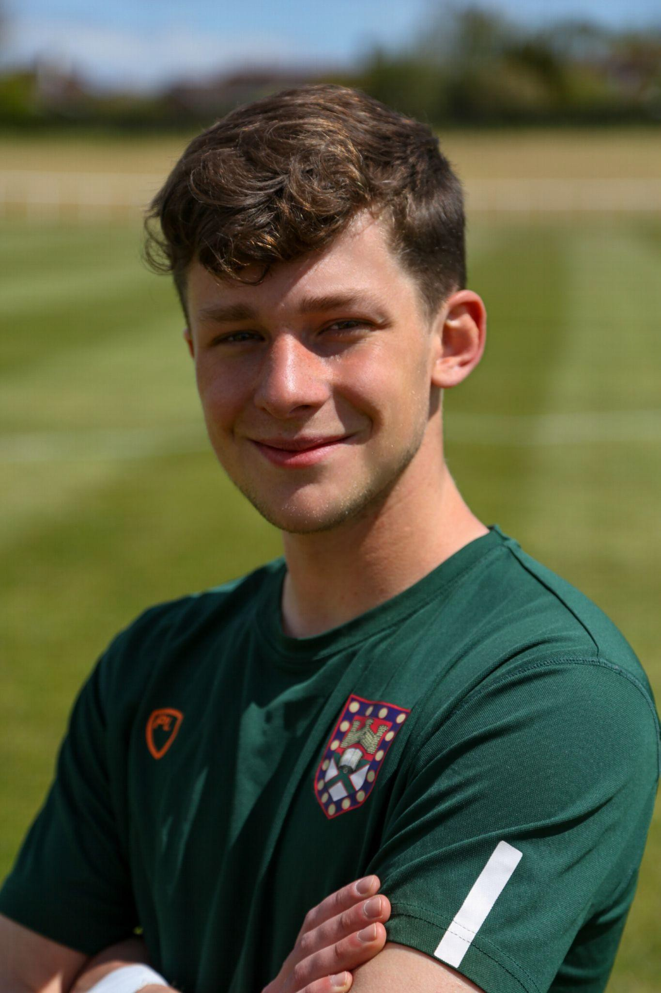
Good evening all, and welcome back to Exeter. Firstly, I wanted to extend my gratitude to you all for endeavouring to be here tonight to share memories, reunite with fellow alumni, and celebrate EUAFC’s past, present and hopefully future successes. Whilst the football club might be unrecognisable in its current size to many of you, let me assure you that through conversations I have had with various alumni, very little has changed indeed, and the club retains those cultures and traditions that no doubt won it such a prized place in your memories. The club has been performing in exemplary fashion so far this year, with our first team punching far above our weight in terms of University funding in the BUCS Premier Division, under the guidance of our new coach Javier and captain Jimmy Hawkings.
However, results have been stellar across the board, and our intake
of freshers this year has included some incredibly promising prospects for future years. I look forward to chatting with many of you over the course of the evening, and thank you again for your support.

Harry Isaacs
EUAFC Club Captain 2021-22

Order of Evening
Professor Wragg – just ‘Ted’ to all who played football at Exeter
– was a true legend within the football club for over 30 years.

“I was always amazed how Ted Wragg managed to get to so many games. One time, in order to watch us play in the UAU against Bristol, he ducked out of a meeting with Minister for Education Sir Keith Joseph. We were far more important”

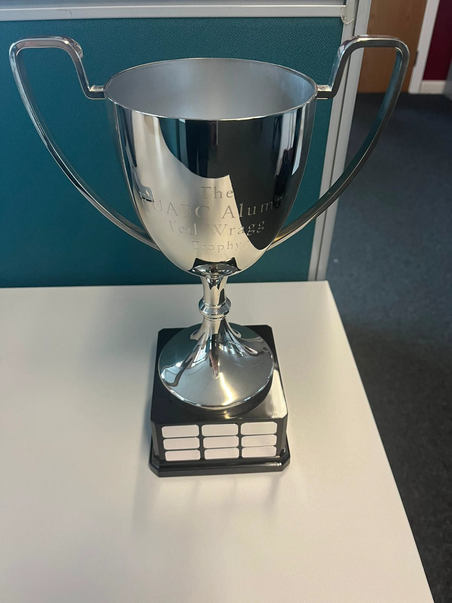
“One of the most influential people I was lucky enough to meet and know, I will always remember what you did for me personally and the whole of EUAFC”

The Ted Wragg EUAFC Alumni Trophy

7.00pm for 7.30pm Arrive / View displays

7.30pm Dinner

After Main Course ‘Cards’ Fundraiser £10 entry Post Dessert / During Coffee Prize Draw
After Coffee Presentation ‘A celebration of EUAFC’
Drinks break
Speeches Javier Martin 1st X1 Coach Harry Isaacs Joint Club Captain
Craig Williams EUAFC Alumnus /
Current Professor of Sport Science

