National Insurance, Tax and Claiming Tax Back
What is a National Insurance Number (NINO)?

A National Insurance Number (NINO) is a number unique to you to help your employer pay your National Insurance contributions; no one else can use this number. It is used to help build up your entitlement to state benefits including the state pension. This cannot be claimed back.
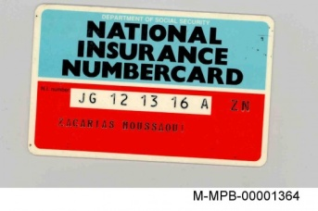
I've lost my National Insurance Number. What do I do?

Check previous pay slips, the number should be on it.

To help you remember your National Insurance number, you are sent a plastic National Insurance number card, generally just before your 16th birthday. It’s blue and red with a long number, which looks something like AB123456C, printed on it.

If you can’t find it, and don’t know your NI number, check previous pay slips or if it's not on there call the National Insurance Tracing Line on 0845 915 7006. They will set up an interview with you to prove who you are, and give you another card.

If you are an International Student needing a National Insurance Number click here.

Do I have to pay tax?

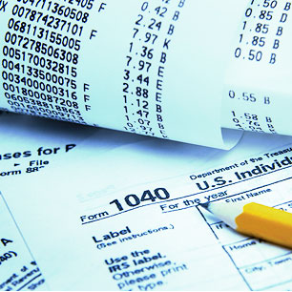
Income tax is your contribution to public services. Everyone, including students, who earns or receives income over a certain amount in the tax year (April 6th - April 5th) pays income tax, and the more that you earn, the more you will pay.
If you work for a company then your employer will usually take tax from your earnings each pay day and pass it on to the Inland Revenue. This is known as the Pay As You Earn (PAYE) system. This system takes care of your tax automatically, and saves you having to pay tax in one go at the end of the year.
Everyone can earn or receive an amount of income in the tax year before paying tax. This is called your personal allowance. The personal allowance for 2011-12 is £7,475. Most students find their income has varied throughout the year and their total pay has not exceeded their personal allowance. If this is the case they can claim a tax refund at the end of the tax year.

See our support sheet for claiming back tax

