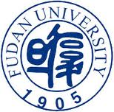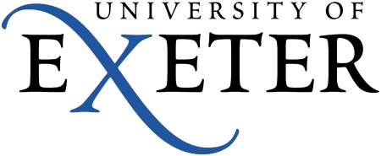
Fudan-Exeter Colloquium
Reading across Cultures:
Global Configurations of Reception, Adaptation and Transmission
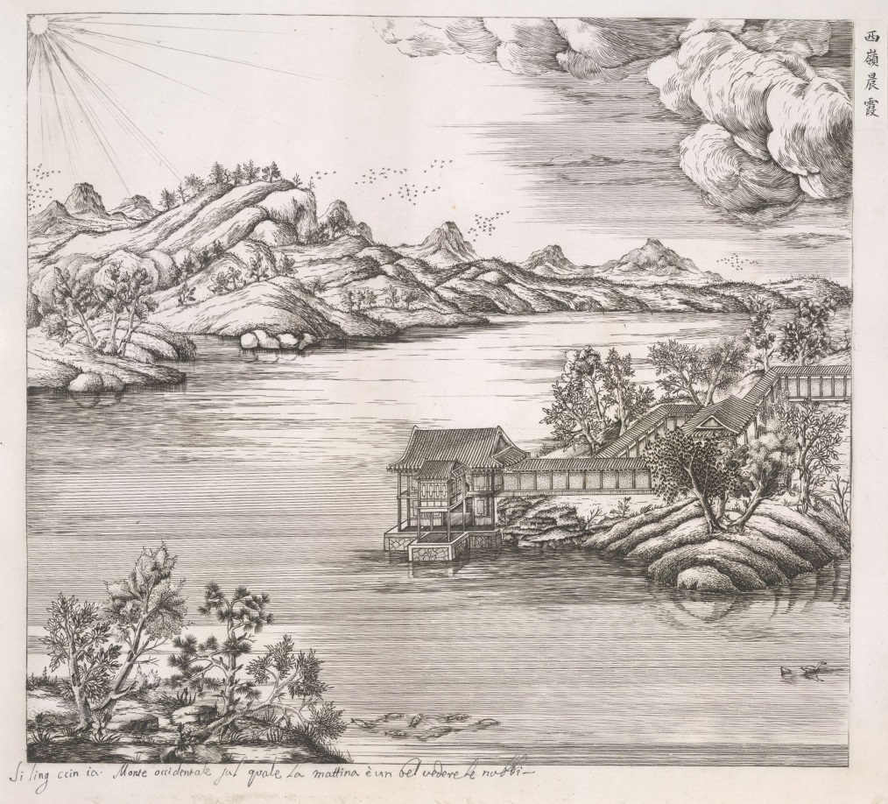
Fudan University, Shanghai
Monday 23rd-Wednesday 25th June, 2014

Monday June 23rd
9 am Opening remarks and welcome: Dean Chu and Dean Nick Kaye
9.15 Keynote lecture: Dean Chu, ‘Linguistic diversity in trans-cultural communication’ [CHAIR: Dean Nick Kaye]
10.15 BREAK
10.45 –12.30 Session 1: Thinking through Literary Reception and Adaptation
[CHAIR: Dean Chu]

Emma Cayley, ‘Between manuscript and print: literary reception in late medieval France’
Guo Sijia, ‘Between Assimilation and Alienation: the Adaptation and performance of French Dramas in China’
Zhang Chong, ‘To be or not to be: The end of revenge in Renaissance and Yuan revenge tragedies’
Adam Watt, ‘Proust between print culture and visual art – the reception and adaptation of A la recherche du temps perdu, with reference to Eve Kosofsky Sedgwick’

12.30—2 LUNCH

2—3.15 Session 2: Visual Culture and Global Exchange [CHAIR: Dean Nick Kaye]
Yue Zhuang, ‘Sharawaddgi – the entanglement of Chinese garden and European vitalism in 17th-century England’
Zhang Hua, ‘Images and mirages of China created by Chinese writer in French’
Corinna Wagner, ‘Visual Culture and the Body: the Global exchange of medical images’

Tuesday June 24th
9—10.15 Session 3: Cultural Entanglements I [CHAIR: Professor Wang Hongzhang]
Jane Spencer, ‘The animals of China in the eighteenth-century English imagination’
Jin Wen, ‘Sentimentalism and the Cult of qing: Writing Romantic Love in Eighteenth-century England and Late Ming China’
Henry Power, ‘Homer and the East’
10.15 BREAK
10.45—12 Session 4: Cultural Entanglements II [CHAIR: Professor Jane Spencer]
Zhu Jianxin, ‘A Discussion on Political Appropriation of HCA’s Fairy Tales in China’
Laura Salisbury, ‘Undiscovered Countries: On Woolf, Illness and Language’
Tan Zheng, ‘Chuang Tsu and Oscar Wilde’

12—1.30 LUNCH

1.30—2.45 Session 5: Cultural Adaptations [CHAIR: Professor Zhu Jianxin]
Ye Rulan, ‘Chinese resonance to H.C. Andersen: A Study of Andersen’s literary and Artistic values Observed in China’
Wang Aiping, ‘Fantasy, Irony and Autonomy – a Feminist Transcoding of The Little Mermaid’
Qian Xinyi, Yang Jiaqi, and Hong Yang, ‘Intertextualizing & Recontextualizing Classics: Creative readings of The Little Mermaid ‘
2.45 BREAK
3.15—4.30 Session 6: Global Narratives [CHAIR: Professor Emma Cayley]
Wang Hongzhang, ‘From the Reader’s Point of View’
Ulrike Zitzlsperger, ‘Global Narratives: the importance of hotels and Railway Stations’
Li Xinmei, ‘The Reception and Diversification of Socialist Realism in Chinese Literature Circles’
Wednesday June 25th
9—10.15 Session 7: Cultural Translation and Transmission I
[CHAIR: Professor Zhang Chong]

Ding Jun, ‘Loyalty in Literary Translation – retranslating The English Patient by Michael Ondaatje
Vike Martina Plock, James Joyce’s In-Between Bodies
Wu Yongli, ‘How is the concept of “Tian” understood in the West?’
10.15 BREAK
10.45—12.30 Session 8: Cultural Translation and Transmission II
[CHAIR: Professor Adam Watt]
Zhang Qiong, ‘Victory across cultures: on Yu Hua’s “Victory”
Chloe Paver, ‘The Transmission of Family Belongings from the National Socialist Era to Contemporary Museums in Germany and Austria’
Chen Liang ‘Spatial Construction in Shanghai Lady: a Chinese adaptation’
Muireann Maguire, ‘Maksim Gorky and Irish Realism: Cultural Translation and Autobiography’

12.30—2 LUNCH

2—3 Keynote lecture: Dean Nick Kaye, ‘Site Works: Archaeologies of Bay Area Performance, 1969—85’ [CHAIR: Dean Chu]
3—3.45 Round table: Reflections on the colloquium, led by Jane Spencer, Emma Cayley, and representatives from Fudan
3.45 Closing remarks: Dean Chu

