Payroll cost codes

Payroll codes are 20 characters long with no spaces or hyphens. The final 5 digits (the nominal code) must be one of five that are valid on the payroll.

PROJECT NUMBER & TYPE  If non-project then all zeros |  |  |  |  |  |  | FUND SOURCE  If non-project then all zeros |  |  |  | BUDGET CENTRE |  |  |  | NOMINAL CODE  Must be one of the following:  21305 Support staff  21205 Research staff  21005 Academic staff  21340 TRU  21005 Student

To convert an Aptos code into a T1 code.

Use the Code Converter Tool on the Finance Services web page at http://www.exeter.ac.uk/finance/budgetsandcostcodes/ (use Internet Explorer).

2. This will give you a T1 code.
Please note: further conversion is needed for payroll.
1. Enter the Aptos code and click search

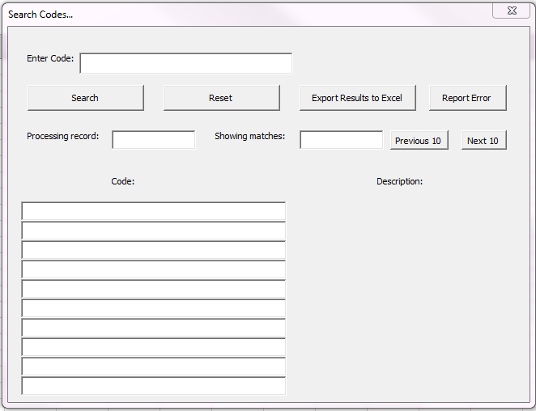
To convert a T1 code into a Payroll code

Open the payroll code converter (on the above web page, under the Code Converter Tool).

There are two types of T1 code:

Non-project, which are formatted as XX-XXX-X-XXXX-XXXXX
Project, which are formatted as XXXXXX-X-XX-XXXX-XXXX-XXXXX

Input the T1 code into the yellow box on the payroll code converter spreadsheet. There is a separate tab for Non-Project (GL) or Project (PJ).

This will create a valid payroll code in the green box.

The final 5 digits of the payroll code must be one from the list below. If the converter is unable to use one of these nominal codes then it will return ‘N/A’. In these cases you will need to refer to the finance teams for confirmation on which code to use.

- 21305 Support staff
- 21205 Research staff
- 21005 Academic staff
- 21340 Temporary Resourcing Unit
- 21105 Student

If anyone has any queries about the cost codes then they should contact financialplanningreporting@exeter.ac.uk.

Manual breakdown

It is always useful to have an understanding of how to manually convert a T1 cost code into a payroll code in case the converter is unavailable.

Non- project, which are formatted as XX-XXX-X-XXXX-XXXXX.

To convert this into a payroll code you need to use the last two sections (9 digits), remove the hyphen, and add 11 zeros in front of it.

Eg. T1 code: 01-000-0-2353-21005
Payroll code: 00000000000235321005

Project, which are formatted as XXXXXX-X-XX-XXXX-XXXX-XXXXX

To convert this into a payroll code you need to remove the third section (2 digits), the rest will make up the payroll code after the hyphens have been removed.

Eg. T1 code: 101114-G-00-1030-2494-21005
Payroll code: 101114G1030249421005

The final 5 digits are the nominal code, they must be one of the following:
- 21305 Support staff
- 21205 Research staff
- 21005 Academic staff
- 21340 Temporary Resourcing Unit
- 21105 Student

If your code does not have one of these then you can change it to the correct nominal code using the Aptos subjective J** code.

J0* = 21005
J1* = 21205
J2* = 21005
J4* = 21105
J5* = 21305
J6* = 21305
J7* = 21305
J8* = 21340

If your Aptos cost code does not have a subjective J** code, then you will need to contact your finance team to confirm which nominal code you should use.

