Guidance for setting up your workstation safely
DSE Self-Assessment (portable/laptop users)

This guidance should be followed in addition to the “Guidance for Setting up Your Workstation”.

Using portable equipment over a prolonged period of time can cause discomfort in the short term, but much more damage to the neck and shoulders in the longer term. The same principles should be applied to using portable equipment as with all other DSE. There are several options to ensure that you adopt and maintain a good posture.

Option 1  Use a separate keyboard and mouse (you can plug them into most laptops). You will then need to raise the screen level up to the normal position of a monitor – toolbar at the top of the screen level with your eyes. This solution is good as long as your screen is large enough. | 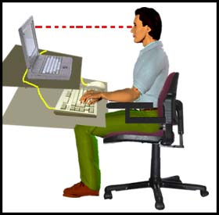
Option 2  Use a separate monitor and use the laptop’s keyboard. You must ensure that your head is approximately an arm’s length away from the screen and that your screen is straight in front of you with the tool bar at eye level when looking straight ahead. | 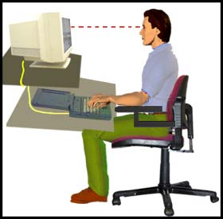
Option 3  Consider using a separate monitor and keyboard. This is the most effective option. For people using the laptop for daily work, it is the most comfortable option. A docking station would be a useful addition to make connecting and disconnecting an easier process. | 