The eSR1 System key tips for approvers
Changes to staffing which require budgetary spend such as recruiting for new or replacement positions, or any changes which require additional budget (eg increasing hours, extensions of fixed term contracts etc.) all need your prior approval via an eSR1.
Content:
Step 1 – Recruiting Manager fills out the eSR1 and submits for approval
Step 2 – Approvers consider the request
Step 3 – Approvers approve/reject the eSR1
Workflow and approval
Proxy approval guide

Overview of process
Step 1 - Recruiting Manager fills out the eSR1 and submits it for approval
This triggers an automated email to the first approver, when you receive the email click on the link to view the individual eSR1.

You can also view all eSR1s awaiting your approval by logging on to the eSR1 system and clicking on SR1 > SR1 Listings:
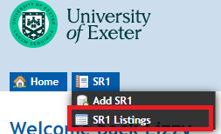

All eSR1s awaiting your approval will be listed under the Awaiting Approval tab:

Step 2 – Approvers consider the request
Approvers review the eSR1 content as follows:
The Proposal Info tab includes details about the position and how it is to be funded.
The Recruitment Info tab includes details about the proposed recruitment campaign and copies of the job description and advert which can be downloaded and reviewed.
The Health Surveillance tab has one question relating to health surveillance and will trigger a reminder later on in the process if required.
The Financial Info tab displays a summary of the costs of the position over 6 years and is completed by Finance and/or Research Finance depending on how the position is being funded.
The Approval tab is where approvers add comments on the proposal and approve/reject the eSR1.
Step 3 – Approvers approve/reject the eSR1
On the Approval tab

Choose the appropriate status option from the dropdown and add any comments in the comment box:
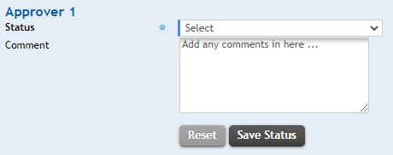
Click Save Status.

If you are unable to make a decision straight away please use the “Reviewing” status to indicate that you are considering the request.

Status and workflow
The following status options are available to you:
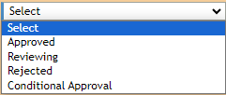

Depending on which status you choose the system then actions as follows:
If approved - the system will notify the next approver to consider the request and a copy email will be sent to the Recruiting Manager to update them on progress.
If rejected – the system will notify the Recruiting Manager and all previous approvers that the eSR1 has been rejected. Please ensure you have included comments in the comment box to explain the reasoning.
If reviewing – the system will notify the Recruiting Manager that the eSR1 is being reviewed. Please ensure you include any useful comments in the comment box.
When the eSR1 is finally approved, the system will email the Recruiting Manager and HR who will then action the request if all the correct information has been provided (eg for contract changes or named researchers – HR Operations Team will process the request, for recruitment – Recruitment Team will advertise).

eSR1 proxy approval
If you are an eSR1 approver and are going to be absent from the University for a period of time please email e.sones@ex.ac.uk and ask that your proxy be given access on the eSR1 system to approve on your behalf, please include the dates of your absence so that the access can be removed again on your return.
You will also need to set up an email forwarding rule on your outlook account to forward eSR1 emails to your proxy so that they can action any approvals.
Automatically forwarding ESR1 emails to Proxies in your absence (email forwarding rule)
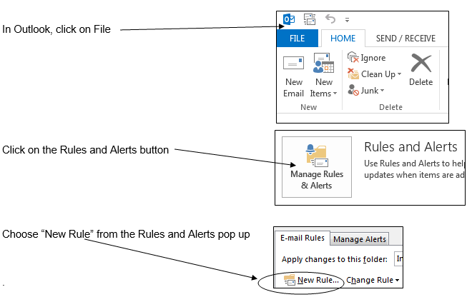
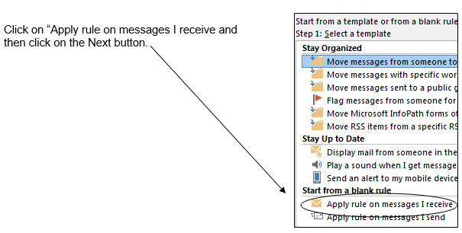

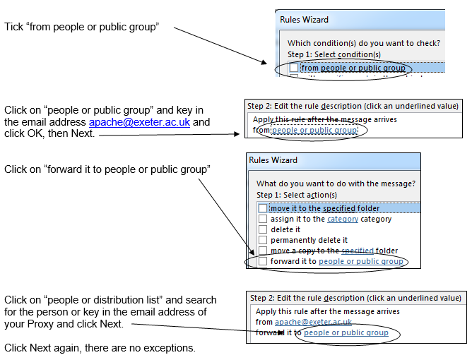
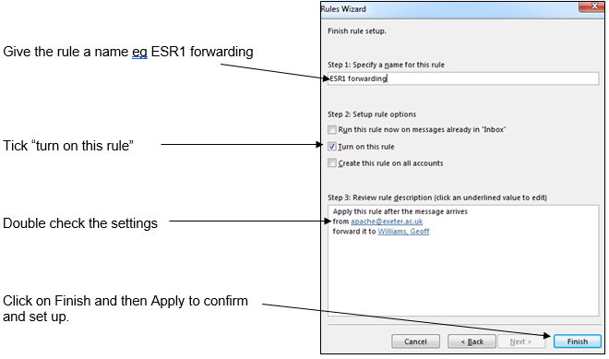
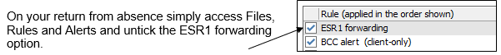

January 2024

