Reference Guide to Recording Completion of Probation Reviews
This guide enables managers to record the successful completion of probation, and the uploading and viewing of supporting paperwork.
If you have any concerns about your employee’s performance, conduct or progress please speak to your HR Advisor and do not follow these instructions as once probation has been marked as complete on Trent your employee will automatically receive an email confirming the successful completion of their probation review.
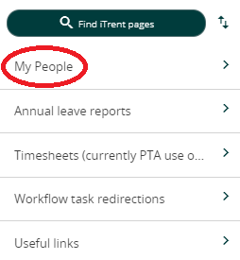
Further guidance on managing probation for new staff (who are not on the Professional Development Programme for new Lecturers) can be found here.
Log into iTrent by clicking here (if you have more than one role select the appropriate People Manager role).
Once you’ve selected ‘My People’ from the home page and selected or searched for the appropriate individual follow the instructions below:

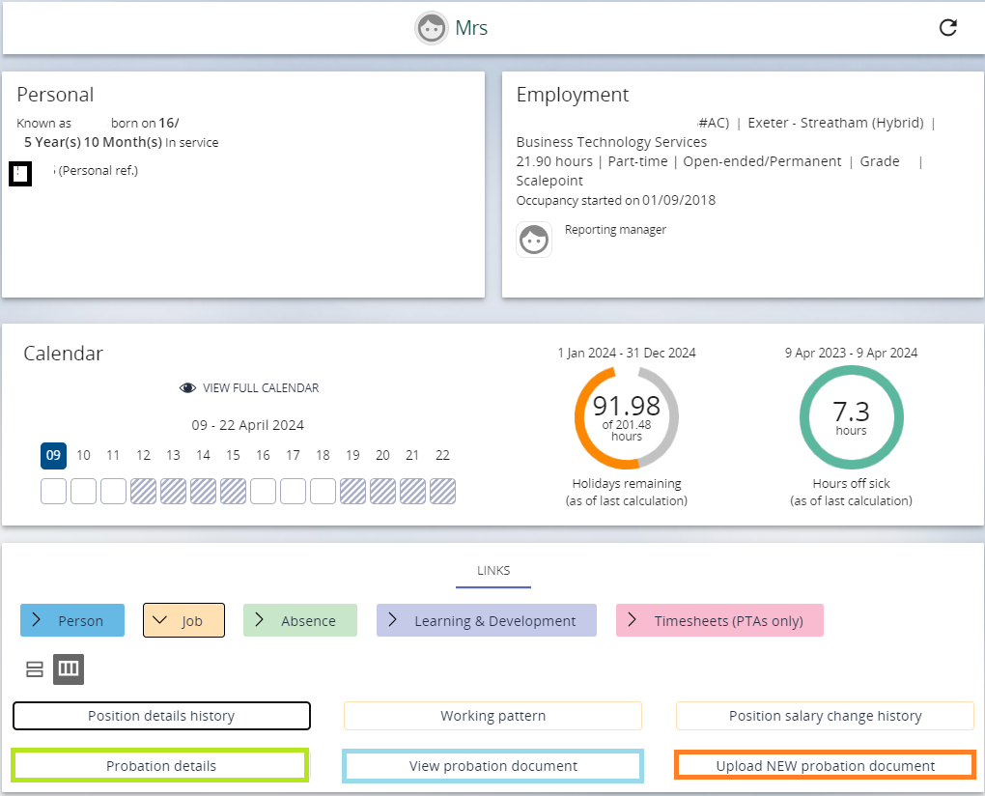
- Select 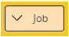
- Select the relevant position if the individual has more than one position.
- Select
- Select the relevant probation review eg First or Final Review.
You may need to expand the panel on the left hand side or scroll across to see all details.
- Click in the ‘Complete’ box to confirm probation review has been passed.
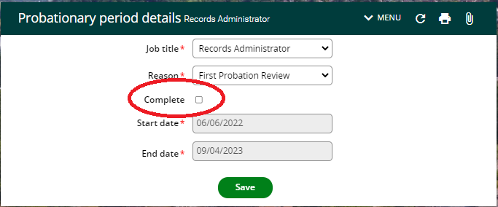
- Click on
Upon ticking complete you’ll automatically receive an email, as will the employee, confirming successful completion of the probation review.
- Click on the at the top of the menu bar
- Select 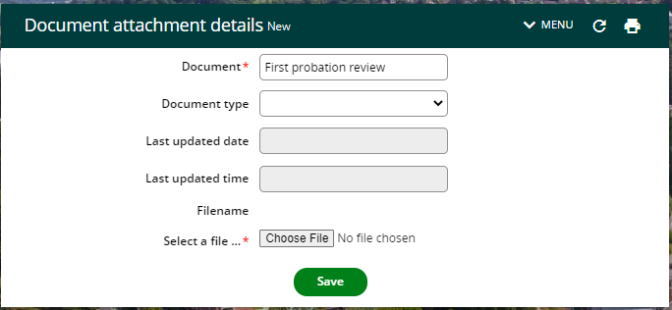
- Enter Document name (free text field) eg ‘First probation review’, ‘Final probation review’
- Document Type - Select ‘Learning and Development – Probation’
- Choose file to upload
- Click on

To view probation reports/forms

- Select ‘My People’ from the home page and select or search for the appropriate individual.
- Select
- Select the relevant position if the individual has more than one position.
- Select
- Click on

