The eSR1 System – Key tips for users
Changes to staffing which require budgetary spend such as recruiting for new or replacement positions, or any changes which require additional budget (eg increasing hours, extensions of fixed term contracts etc.) all need prior approval via an eSR1.
Content:
Before you start
Step 1 – request an eSR1 to be set up for you
Step 2 – complete the eSR1
Step 3 – workflow and approval
Step 4 – recruitment
eSR1 step by step guide

Before you start
You will need an understanding of how the position is being funded ie by the University (and what budget centre funds are coming from), by external funds such as a research grant, or by a mix of both. Contact your Budget Holder (this is usually your manager) to determine the funding. The Finance and Research Finance Teams can advise if you are unsure.
If you will be recruiting, you will also need the following documents:
- An advert
- An up to date job description
If you are appointing a named researcher, you will need the following documents:
- The individual’s CV
- The job description
You will be unable to submit the eSR1 without attaching these documents (the Recruitment Team can help if you have any questions about these documents).

Step 1 – request an eSR1 to be set up for you
The first step is to complete an eSR1 request form or a Leaver notification form (if someone is leaving and you want to replace). A unique eSR1 form will be created for you by HR, and you will receive an email with a hyperlink to your eSR1 for you to complete.
Step 2 - complete the eSR1
Use the link in the email and log in to the system with your University username and password.
The eSR1 form has a maximum of 6 tabs depending on the type of SR1 requested:
For recruitment: Recruiting Managers complete the Proposal Info, Recruitment and Health Surveillance tabs. For changes: Recruiting Managers will only see, and therefore only need to complete, the Proposal Info tab.
Finance and/or Research Finance complete the Financial Info tab.
Work through the form by completing all the white boxes, these will have been prepopulated wherever possible but you can change these details if they are incorrect.
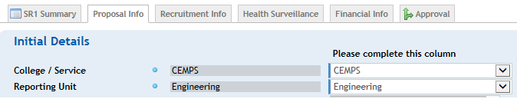Click at the bottom of every tab.
Most fields in the form are mandatory (as indicated by the blue dots) and if not completed will not allow you to submit the SR1 for approval. When you save each tab the top of the form will identify any fields that still need completing.
The Proposal Info tab requests details about the position and how it is to be funded.
The Recruitment Info tab requests details about the proposed recruitment campaign and is where you will be asked to upload the job description and advert. Documents can be uploaded by using drag and drop.
The Health Surveillance tab has one question relating to health surveillance and will trigger a reminder later on in the process if required.
The Financial Info tab displays a summary of the costs of the position over 6 years and is completed by Finance and/or Research Finance depending on how the position is being funded.
The Recruiting Manager uses this tab to submit the eSR1 for approval and approvers use this tab to add comments on the proposal and to approve the eSR1. You will be unable to submit the eSR1 until all the tabs are complete.
Step 3 - workflow and approval
Once submitted for approval, the system will email the first approver (normally Finance and/or Research Finance) who will then complete the Financial Info tab and approve the eSR1. The system will then email the next approver and so on.
Recruiting Managers will also receive an email after each approval, they can also track the progress of their SR1s using the SR1 Listings page which lists all of their SR1s together with the status of the approvers (Authorised Signatories):
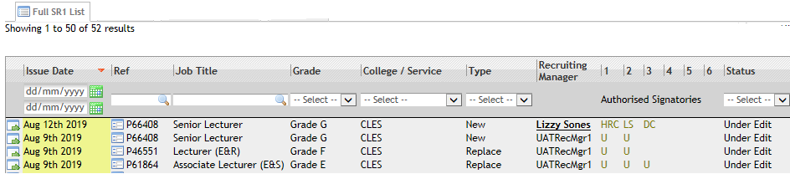
On occasion an eSR1 may be missed by an approver, we recommend chasing an approver if your eSR1 has not been approved by them within 3 working days:
Approver | Email address
PS Finance | PSFinanceTeam@ex.ac.uk
Cornwall Research Cluster | Cluster_CornwallSR1@ex.ac.uk
EU Research Cluster | Cluster_EUSR1@ex.ac.uk
ESE Research Cluster | ESE-ResearchCluster@ex.ac.uk
HASS Research Cluster | HASS-ResearchCluster@ex.ac.uk
HLS Research Cluster | HLS-ResearchCluster@ex.ac.uk

When the eSR1 is finally approved, the system will email the Recruiting Manager and HR who will then action the request if all the correct information has been provided (eg for contract changes or named researchers – Employee Services Team will process the request, for recruitment – Recruitment Team will advertise).
Step 4 - recruitment
If the eSR1 is for recruitment the Recruitment Team will advertise the position (usually within 5 working days on full completion and approval) and, prior to your interviews, will send you an email with your interview timetable information which includes a link to the Appointment Details tab on your SR1. You can complete this with details of the successful candidate once the interviews have taken place.

The Appointment Details tab requests details about the person you are appointing, the start date and any amendments to the position details. Note – the details you provide here will be inserted into the contract of employment and will be legally binding.
Once submitted the system will alert the Recruitment Team who will then issue the contract of employment within 5 working days.
eSR1 step by step guide

Initial Details
Faculty / Service | Academic staff will be within a Faculty.  Professional Services staff will be within a Service.  Some PS staff are funded by external grants or other departments/faculties, they should still be based within the service which best fits their type of work.
Reporting Unit | The lowest level of Trent unit which this position sits within.
Post Title | Job titles should conform with the UoE standard guidance

Proposal
Is this position a Graduate Business Partner? | (Only displays if eSR1 is for a change and is in Support job family) Choose No unless it is a GBP.
Please specify changes | (Only displays if eSR1 is for a change) Tick the type of change that you are proposing.
Give Details of request | Brief explanation of why the request for approval is being made
Start date/date of change | The provisional start date for a new/replacement position.  The actual start date for a change to an existing member of staff or for a Named Researcher.
Is this change permanent? | (Only displays if eSR1 is for a change) If you choose No you will be asked for the date the change will cease.
Is increment due in August? | (Only displays if eSR1 is for a change) Choose yes if the person has been employed continuously prior to 1 February.

Employment Type
Contract type | Fixed term contract (for use when need for work is for a fixed period, or funding is not permanent)  Open-ended/Permanent (for use when need for work and funding is ongoing)  Open-ended time/Permanent – time limited funding (for use when funding is fixed term but person has accrued continuous service).

Fixed Term Contract Details (Only shows if contract type is fixed term).
End date | End date of fixed term contract
Reason | Dropdown of reasons why the position is fixed term.
For whom is cover required? | If reason for fixed term is cover, insert the name of the person this position is covering for.

Details
Reporting Manager | The manager who supervises this position, this is the name that is entered on to Trent and will receive workflow alerts for probation etc. For academic positions this will be the HoD, for research positions this may be the PI (this varies between Faculties).
Job family | Research only (academic job family)  Support (professional services job family)  Teaching & Research (academic job family) also known as Education & Research  Teaching only (academic job family) also known as Education and Scholarship

Salary Details
Grade* | Academic grades are as follows:
 | E | Graduate Research Assistant (R), Postdoctoral Research Associate (R), Associate Lecturer (E&S)
 | F | Research Fellow (R) Lecturer (E&R, E&S)
 | G | Senior Research Fellow (R), Senior Lecturer (E&R, E&S)
 | H | Associate Professor
 | Prof 1, 2, 3 | Professor
 | Professional Services grades are subject to job evaluation.
Point | University policy is for appointments to be made at the bottom point of grade, if you wish to appoint above the bottom point you will need approval via your HR Business Partner or the Pay Exceptions process before the offer is made.

Working Pattern
Select working pattern | Choose the pattern which describes when the hours will be worked each week.

Employment Details
Hours Per Week | The hours that will be worked each week.
FTE | (only displays if job family is E&S) The FTE of the appointment, 1 = full time.

Basis
Term Time Only? | Select yes for positions that work less than 52 weeks per year. If you choose Yes you will be asked to enter the number of working weeks.

Work Location Arrangements
This position will be | Select Campus based, Hybrid or Remote and choose the location when prompted or explain the reason for remote working.

Financial Information
Source of Funding | Choose the funding type  University – funded by the University budget  External – funded by an external grant  Mixed – funded by a combination of both
University Funding information | Only displays if Source of Funding is University or Mixed.
Proposal matches approved business plan | Choose Yes or Yes with Changes. Your Budget Holder or Finance Team will be able to support you with this aspect. If you choose No you will be unable to progress the eSR1 until your proposal matches an approved business plan.
Give details of how this position will be funded | Provide the budget centre code (4 digits) and as much additional detail as possible to identify how the position is being funded. Speak to your Budget Holder to determine the funding. The Finance Team can advise if you are unsure.
External Funding Information | Only displays if Source of Funding is External or Mixed.
Number of external sources | The number of external funding sources.
Name of source/grant | The name of the source of grant together with the project code (6 digits).
Grant holder or UoE contact | The name of the grant holder or University contact
Mixed funding details | Only displays if Source of Funding is Mixed.
Amount to be Externally Funded | How much of the cost of the position will be funded from the External funding.

Business Case For Proposal (only displays for Support job family)
Why is this post Business Critical? | Explain in detail why the appointment is required. This will be considered by the Registrar.
Why do we need to make the appointment now? | Give details about the timeliness of the appointment.
Can we perform the role in an alternative way? | If not, give details about why the duties cannot be performed in an alternative way.
Can existing staff pick up some or all of the workload? | If not, give details about how the duties cannot be covered.

Allowances
Add new allowance | Any allowances that are appropriate from the dropdown.

(This tab only displays for Recruitment eSR1s)

Graduate Business Partners (only displays if job family is Support)
Proposal for GBP recruitment? | Choose Yes or No. If yes, you will be asked to upload a copy of the student internship form.

Researchers (only displays if job family is Research)
Proposal for named Researcher? | Choose Yes or No. If yes, you will be asked to complete details about the researcher.

Named Researcher (only displays for Named Researchers)
Name | Choose Yes or No. If yes, you will be asked to complete details about the researcher.
Home Address | The home address of the named researcher
Email | The email address of the named researcher
Date of Birth | The date of birth of the named researcher
Registered Induction facilitator | Choose the appropriate facilitator from the list, ensure you have confirmed they are available before submitting these details.
CV | Upload a copy of the named researcher’s CV
Job description | Upload a copy of the job description.
Is the attached job description new, or has the content been amended. | Choose Yes if the job description is new or it is one that has been amended and then upload confirmation of the grade from the HERA Panel.
Right to work documents | Upload certified copies.

Recruiting Documentation
Job description | Upload a copy of the job description.
Advert | Upload a copy of the advert
Is the attached job description new, or has the content been amended. | Choose Yes if the job description is new or it is one that has been amended and then upload confirmation of the grade from the HERA Panel.

Panel Membership
Faculty/Service Admin contact | The name of the person who will administer the recruitment arrangements.
Add University Staff Member | Use the system to search for and add panel members from members of staff at the University
Add Non-Staff Member | Use the fields to add panel members that are not members of staff.

Advertising
How many weeks do you want this post advertised | 4 weeks advertising is essential if a Tier 2 visa may be required.
Please give details of any flexibility of working hours that can be advertised | Advertising flexibility in the advert can make the role more attractive and will help us to fill the vacancy.
Choose Media | Tick the media that you want the advert to appear in
If you would like your vacancy advertised on any other media, please give details and costcode | Please give details and costcode
Logos | If position is funded by ESIF tick the appropriate logo

Disclosure and Barring Services
DBS check required? | Choose No unless the postholder will be working with children or vulnerable adults, you will also be asked for a costcode.

Driving
Driving required? | Choose No unless it is an essential part of the role that that the postholder will be required to drive. If you choose Yes please specify the vehicles as prompted.

Security Screening for Home Office designated facilities
Advanced screening required? | Choose No unless the postholder will require access to secure areas. Contact the Head of Biological Services for advice.

Recruiting Practising Doctors or Qualified Nurses
Does the role require candidates to be a practising Doctor registered with the GMC? | Choose No unless the postholder must be a practising Doctor.
Does the role require candidates to be a practising Nurse registered with the NMC? | Choose No unless the postholder must be a practising Nurse.

(This tab only displays for Recruitment eSR1s)

Health Surveillance
Will the postholder’s role involve work with the following? | Choose No unless the postholder will be working with any of the hazards listed.

Submission
Submit for Approval | Click the button to submit the eSR1. The system will then alert each approver in turn. The system will email you updates of the eSR1’s progress. When complete the eSR1 will alert HR who will then advertise the position (for recruitment eSR1s) or make the changes to the member of staff’s contract (for change eSR1s).  If you feel there is a delay in your eSR1 being approved you should contact the approver who it is sitting with.

(This tab only displays for Recruitment eSR1s once an eSR1 has been approved)

IMPORTANT – these details are used to populate the employment contract.

Appointment Details
Post title | Only amend if the advertised job title has been agreed to be changed
Name of Appointee | Insert the name of the person appointed

Employment Details
Provisional start date | Insert the agreed start date
Hours per week | Only amend if the advertised hours have been agreed to be changed.

Salary Details
Grade | Only amend if the advertised grade has been agreed to be changed, you will be asked for additional details and to attach confirmation that the role has been graded.
Point (or Salary) | University policy is for appointments to be made at the bottom point of grade, if you wish to appoint above the bottom point you will need approval via your HRBP or the Pay Exceptions process before the offer is made.

Authorisation of Changes
If details offered are different to those approved in the eSR1 please state changes required and authorisation gained. | Give details if appropriate.

Allowances/Additional Payments
Details of any other allowances/additional payments | Give details if appropriate and attach a copy of the approval or Pay Exception process form.

Relocation
If different, give details | Give details if appropriate.

Working Arrangements
Select Working Pattern | Only amend if the pattern has been agreed to be changed.

Work Location Arrangements
This position will be | Only amend if the location has been agreed to be changed or if you are now confirming the location.

Key Contacts
Registered Induction facilitator | Choose the appropriate facilitator from the list, ensure you have confirmed they are available before submitting these details.
Reporting Manager | Only amend if the manager needs to be changed.
Academic Lead/ Mentor | (Only displays for academic job families)

Ref Unit of Assessment | For a list of the units, click on Related Pages at the top right hand side of the screen and choose REF Unit of Assessment from the dropdown.

PDP | (Only displays for grade F, E&R job family)
PDP Stream | Choose appropriate stream
Appointee will be required to meet | Choose standard of non standard targets
Details if appropriate | Give details of any non standard targets
Attach PDP documentation if appropriate | Upload if appropriate.

Please detail any other information here | Use this section to inform the Recruitment Team of any other relevant information about the appointment eg if the candidate didn’t bring in right to work documents detail when this will be collected etc

To be completed for all recruitment
Right to work documents | Upload certified copies.
PD01 | Upload – the Recruitment Team need this information in order to communicate with unsuccessful candidates.
Interview Notes | Upload – for audit purposes.

Condition of Appointment
Save Changes & Submit | Click the button to submit the eSR1. The system will then alert the Recruitment Team who will then issue the contract within 5 working days.

eSR1 proxy approval
If you are an eSR1 approver and are going to be absent from the University for a period of time please email e.sones@ex.ac.uk and ask that your proxy be given access on the eSR1 system to approve on your behalf, please include the dates of your absence so that the access can be removed again on your return.
You will also need to set up an email forwarding rule on your outlook account to forward eSR1 emails to your proxy so that they can action any approvals.
Automatically forwarding ESR1 emails to Proxies in your absence (email forwarding rule)
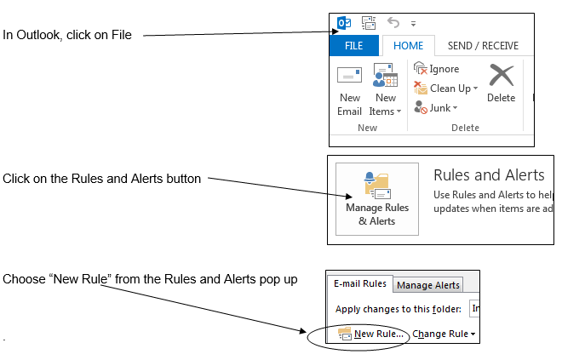
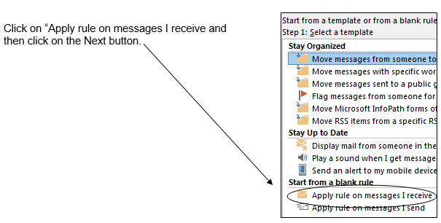

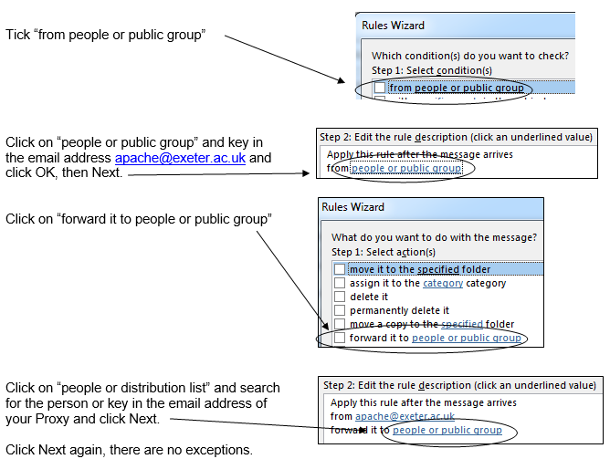
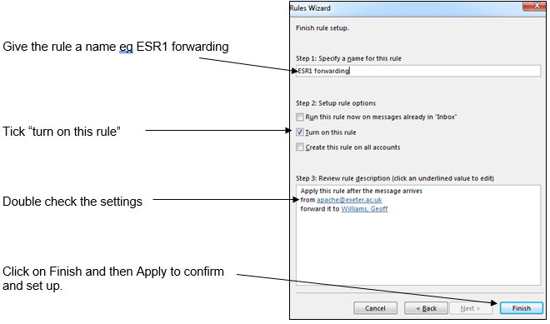
2 Sep 2022

