Reference Guide to Ending a Sickness Absence (on behalf of the your employee)
This guide enables managers/supervisors and sickness co-ordinators to record the end date against a sickness absence where the employee does not have access.
Ending a sickness absence on behalf of an employee:
Log into Trent by clicking here (if you have more than one role select People Manager).
Navigation: From the home screen select (please note, the home screen may look different to sickness co-ordinators).
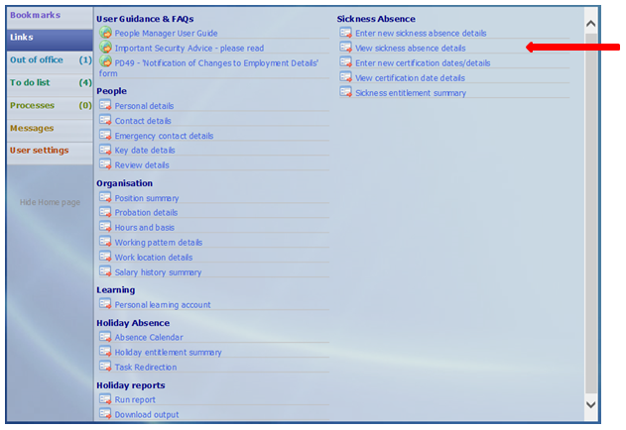

Action:
- Select the current sickness absence period.
- Enter the last day of sickness in the ‘Absence end date’ field
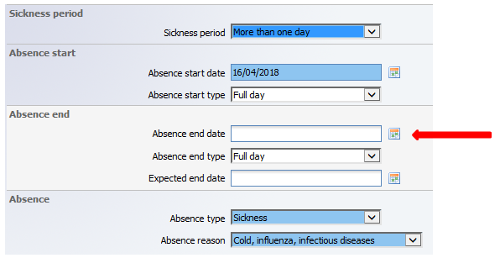
This will trigger an email to the employee advising them that their sickness absence has been closed.
If you experience any problems please contact humanresources@ex.ac.uk.

