Reference Guide to Recording Sickness Absence
This guide enables managers/supervisors and sickness co-ordinators to record the absence of employees due to sickness, and to verify and provide supporting certification.
Logging a new sickness absence:
Log into Trent by clicking here (if you have more than one role select People Manager).
Navigation: From the home screen select (please note, the home screen may look different to sickness co-ordinators).
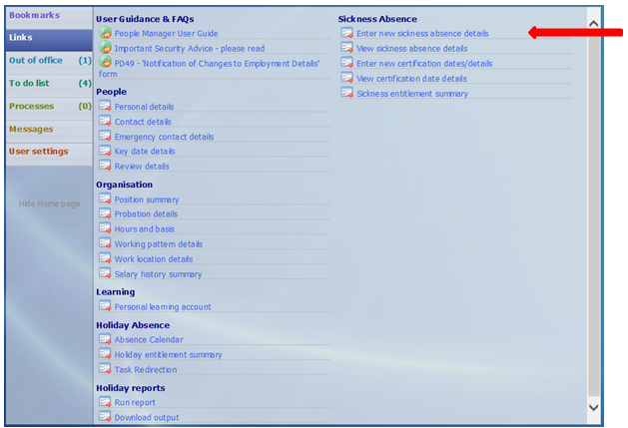
Action:
- You will be prompted to enter the surname of the employee.
Upon doing so there will be two panels – the left-hand side will show a record of any previous absences and the right-hand side will show the screen below.
- ‘Sickness period’ – This defaults to ‘More than one day’. Do not amend – even if the employee is only absent for one day or part of a day as this can be recorded in the following fields.
- Enter the ‘Absence start date’
- Enter ‘Absence start type’ – selecting either ‘Full day’ or ‘Half Day’ as appropriate.
- Do not enter an end date. The record will remain open until the employee returns to work and enters their return date.
- Enter ‘Absence type’ and select ‘Absence reason’
- Click Save
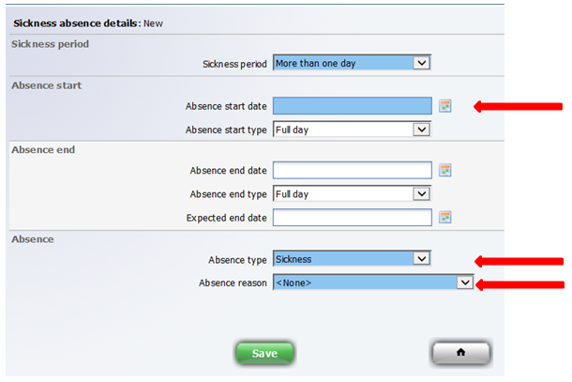
Do not enter an end date. The record should remain open until the employee returns to work and enters the end date.

This will trigger an email to the employee advising them to enter their last day of sickness absence on their return.
For info - If the employee has any other absence recorded eg annual leave, you will get a message similar to that shown below. This is just a warning and there is no need to click on save again.
No further action is required at this stage. The record will remain open until the employee returns to work and enters their return date.

Employee has no access to enter an end date?
If the employee does not have access to enter an end date against their sickness absence, the manager/supervisor or sickness co-ordinator can enter it on their behalf. Additional instructions on how to do this can be found here.

- Following 7 days absence the manager/supervisor and employee will receive an email reminding them of the requirement for a Drs certificate/fit note/medical certificate.
- Following 28 days absence the manager/supervisor will receive an email advising them that the employee is on a long term absence and to contact their HR Advisor.
If you experience any problems please contact humanresources@ex.ac.uk.

