# **HR Census Report**

The My Team report can be found here: <http://www.exeter.ac.uk/staff/mi/staff/hr/>

The report now has a section called *HR Census Review*:

New Census section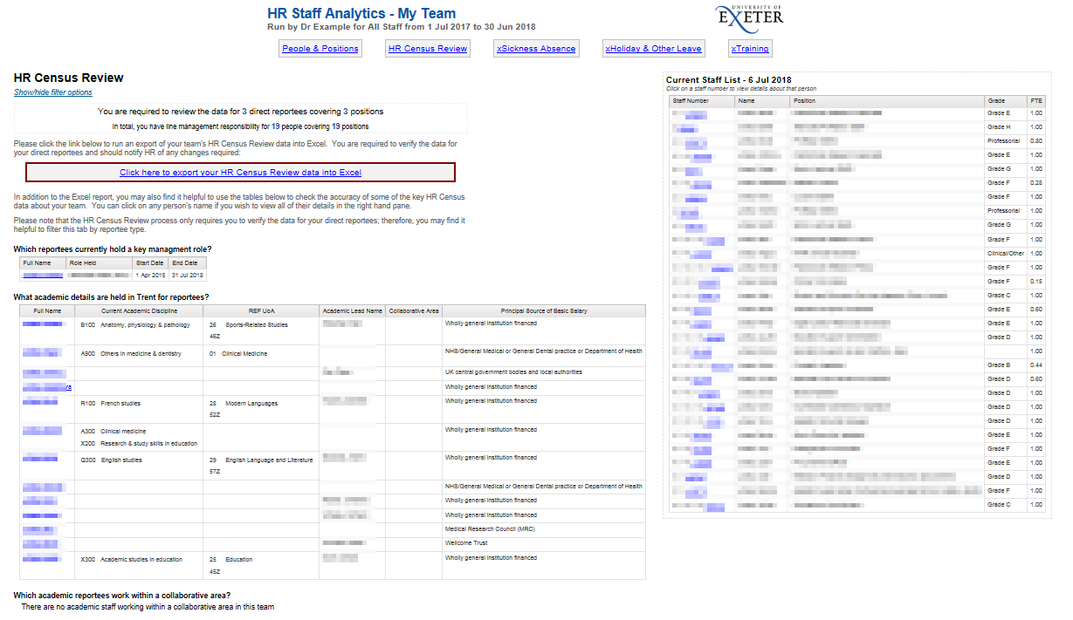

The HR Census Review has at-a-glance summaries of key management roles held within your team and important information we hold for academic staff:

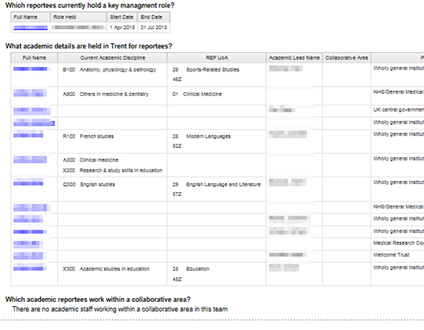

To fully review all Census data for your team click the export link:



This will download an Excel document which will contain all HR Data relevant to the Census with your direct reports at the top (and shaded):

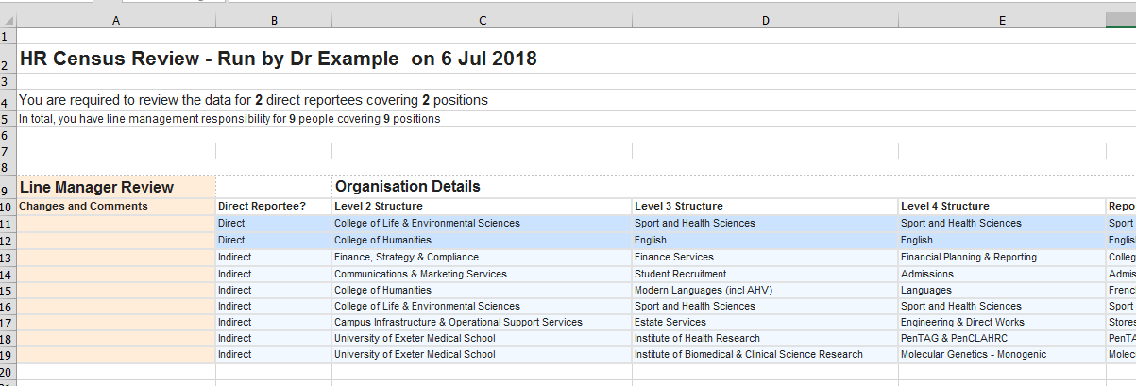

Changes should be recorded in this column only

You should check all data returned is correct as at the date you ran the report. Any corrections or comments should be noted in column A. It is expected managers will review information for their direct reports only, but indirect reportees are included for when that’s not practical/desired.

It is important to remember this is not a substitute for the ESR1 and any changes of a contractual nature e.g. related to hours, pay etc., should be notified using the ESR1 in the usual way.

If any changes are required the completed document should be emailed to [humanresources@exeter.ac.uk](mailto:humanresources@exeter.ac.uk?subject=Census%20Correction) with “Census Correction” in the subject line.

If the information is correct then you need take no further action.

Please contact [hrreports@exeter.ac.uk](mailto:hrreports@exeter.ac.uk) if you are having any problems accessing the report.

# GLOSSARY of Report Headers

|  |  |  |
| --- | --- | --- |
| **REPORTEE** | | |
| **Column Title** | **Details** | |
| **Manager** | Your own name | |
| **Direct** | The names of your direct reports – these are the people in your team whose information you are responsible for reviewing | |
| **Indirect** | You are not required to review the data for members of your team that do not report to you directly. | |
| **ORGANISATION DETAILS** | | |
| **Column Title** | **Applies to** | **Details** |
| **Level Structures**  **Reporting Unit** | All | Details of College/Service and position in the structure |
| **Location** | All | Options are Exeter – Streatham, Exeter – St Luke’s, Exeter – RD&E, Cornwall – Penryn, Cornwall – Truro, Overseas |
| **Position Address** | All | This should be the usual working location of the employee. If mobile this should be the address of the central reporting unit.  For employees who work outside the UK on a permanent basis then, in addition to recording their actual non-UK work address, their *Location* should be identified as ‘Overseas’ |
| **Collaborative Area** | All | Those currently recorded on the Trent HR system are LSI, ESI & ESIF. They are recorded as a suffix to the job title e.g. *Research Fellow (ESI)* |
| **PERSONAL DETAILS** | | |
| **Column Title** | **Applies to** | **Details** |
| **Name, title, gender** | All |  |
| **POSITION DETAILS** |  |  |
| **Column Title** | **Applies to** | **Details** |
| **Job Family** | All | Professional Services  E&S = Teaching only  E&R =Teaching and research  Research only |
| **Position** | All | Job title |
| **Type** | All | Shows the contract status of the employee. Options are Open ended/permanent, Open ended – time limited funding, Fixed-term contract |
| **Expected occupancy end date** | All | If applicable, the date the employee’s current fixed-term contract role is expected to end |
| **Expected Occupancy end reason** | All | Reason for fixed-term contract |
| **FTE** | All | The Full Time Equivalent period worked by the employee, with 1.0 equating to full time. |
| **Grade** | All | The employee’s current grade |
| **Current Academic Disciplines + Codes** | Academics only | These are used in HESA reporting |
| **REF UoA** | Academics only | Used in HESA reporting and across other university systems |
| **Principal Source of Basic Salary** | All | Used in HESA reporting but also a clearer and more accessible indicator of funding type than cost code analysis. In most cases this will be “Wholly general institution financed” but where positions are externally funded this needs to reflect that. |
| **MANAGER / ACADEMIC LEAD / MENTOR** | | |
| **Column Title** | **Applies to** | **Details** |
| **Line Manager + Position** | All | Your details should be recorded against the records for your direct reports. |
| **Academic Lead/PDR Mentor** | Mostly academics | Used internally and to assign Reviewer for academics in ePDR |
| **KEY MANAGEMENT ROLES** | | |
| **Column Title** | **Applies to** | **Details** |
| **Key Management Roles (ALL COLUMNS)** | Mostly academics | Generally, these are rotational roles held by individuals in addition to their substantive role. A full list of the roles recorded by HR can be found below.  Start and end dates must also be supplied. |

|  |
| --- |
| **List of Key Management Roles** |
| Academic Dean of Students |
| Associate Dean (Education) |
| Associate Dean (International & Development) |
| Associate Dean (Postgraduate Research) |
| Associate Dean (RKT) |
| Associate Director (LSI) |
| Director of Education |
| Director of International & Development |
| Director of Research |
| Director of the Land, Environment, Economics & Policy Institute (LEEP) |
| Head of Discipline |
| Pro-Vice-Chancellor |