Reference Guide to Recording Medical Certificates
This guide enables managers/supervisors and sickness co-ordinators to record dates and details of medical certificates in respect of sickness absence.
The employee should provide you with an original hard copy certificate signed by a medical professional for sickness absences exceeding 7 days.
Log into Trent by clicking here (if you have more than one role select People Manager).
From the home screen select (please note, the home screen may look different to sickness co-ordinators).
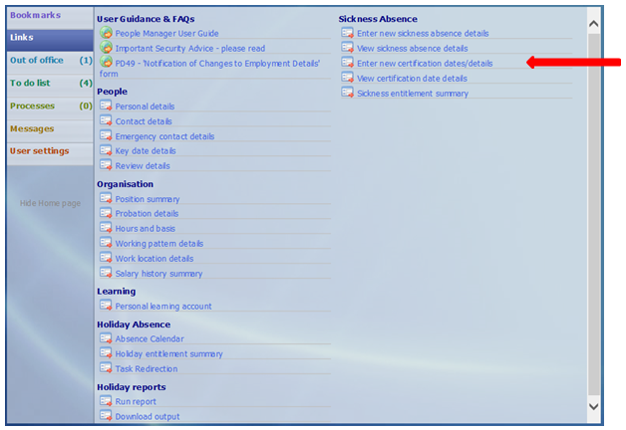
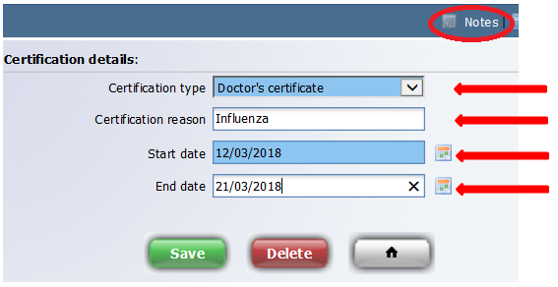

Action
- You will be prompted to enter the surname of the employee.
Upon doing so there will be two panels – the left-hand side will show a record of any absences, historic and current, and the right-hand side will show as the image above.
- Select the appropriate sickness absence period (from the left-hand side).
At this stage you will prompted for an effective date at the top left-hand side of the screen – enter the start date of the sick certificate.
- Select appropriate Certification Type.
- Reason – this is a free text field where you can record further details (maximum of 80 characters).
- Enter Start date and End date as shown on the certificate.
- Click on Save.
Once the certification details have been recorded you should email a scanned copy of the certificate to humanresources@exeter.ac.uk and return the original to the employee.
If the ‘May be fit to work’ box on the certificate has been ticked or the medical professional has recommended reasonable adjustments, you should contact your HR Advisor.
If you experience any problems please contact humanresources@ex.ac.uk.

