Guidance to set up your workstation
Display Screen Equipment (DSE) Self-Assessment

Setting up your workstation correctly is vital to ensuring you reduce the risk of pain and ill health that can be associated with DSE use. It is the responsibility of all DSE users within the University to ensure they have followed the DSE policy, set up their workstation and completed a DSE self assessment. By following the steps below, you can adjust the layout of your workstation to ensure you are working safely. Remember, if items are bulky or heavy you should not attempt to move them on your own. The correct set up of your workstation may not feel right at first but it will encourage correct posture and safe working practices. If additional equipment is needed, please request this via your line manager.

Step 1 - Your Chair
- Adjust the height of your chair so that when you put your fingers on the middle row of the keyboard your hands and forearms remain horizontal.
- Your elbow joint should be at 90 degrees.
- There should be no angled wrist – keep straight
- This may mean your feet are dangling (don’t worry, we will address this next)
- Your knees must also be at about 90 degree angle
- You may require a foot rest in order to ensure that there is no pressure on the bottom of your thighs
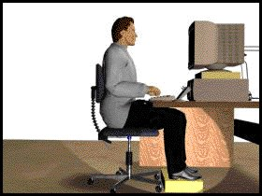

Step 2 – The Monitor
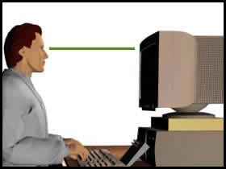
- Adjust the height of the monitor to ensure that you are looking horizontally at it.
- Your eyes should be level with the top of the screen
- You can adjust the height of your monitor by using a monitor stand or maybe even a strong box or book. Please ensure that this is safe
- The same should be applied to all screen types (flat screen and normal monitors)
- Ensure your monitor screen is clean
- Check the distance of your eye to the monitor
We recommend that your eye should be between 450mm and 650mm from the screen, whichever distance is most comfortable – this is about an arm’s length
- If these distances are not comfortable
consider referring to the eye and eyesight test section of the DSE policy
- Also consider the screen quality or settings
- Tilt monitor between 5-15% from the vertical line

Step 3 – Your Backrest

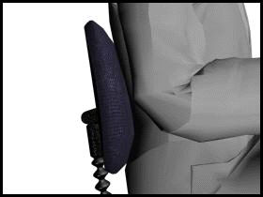
- Adjust the angle of your back rest and chair seat or seat pan to ensure that your back is supported in your work position
- If you cannot sit back and upright without your knees touching the front of the seat you may need to change your chair to one with a shorter seat.
- Adjust the back rest support so that it supports the small of your back
- If the back rest does not fit into the small of your back, you may benefit from a back support
- Ensure that your feet are flat on the floor and your knee is at a 90 degree angle
- If your feet don’t reach the floor you may need a footrest

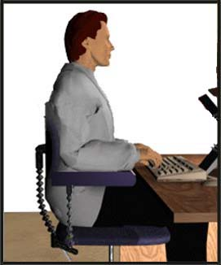

Step 3 – Arm Rests
- If you cannot get close enough to your desk because of the arm rests you may have to have them removed
- Your elbows should hang straight down under your shoulders
- Do not rest your arms on arm rests whilst typing

Step 4 – The Desk
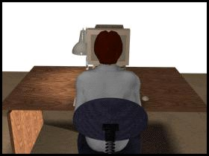
- Ensure that you are sitting directly in front of the monitor and keyboard
- Sit close to your desk, allowing for your wrists to be supported by the desk when you are not typing
- Never put anything between the keyboard and you
- If you often have to refer to documents whilst typing, you may benefit from a document holder
- This should be placed at the same height and distance as your monitor or between the keyboard and screen
- Do not let cables trail from the desk
- Avoid using extension leads
- Never use pieces of equipment you have brought in from home – Estate Development Services will need to check them

Step 6 – The Mouse
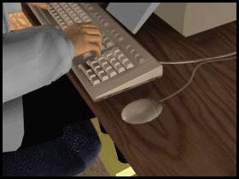
Step 5 – The Mouse
- The mouse needs to be positioned as close to you as possible
- Aim to use your mouse with your elbow vertically under your shoulder and right by your side
- If you have a laser mouse you don’t need a mouse mat, if you have a mouse with a ball you will need a mouse mat
- Position any additional equipment e.g. phones, paper trays and notes in an accessible place to avoid twisting and overstretching

Step 6 – Environment
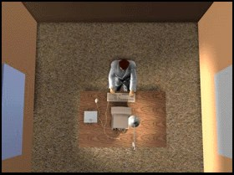
- Temperature and humidity should be adjusted to ensure you are comfortable
- If you suffer from dry eyes you should seek medical attention
- Eliminate glare or reflections on your screen, close blinds or, if possible, move workstation so that it is at right angles with the window

Step 8 - Carry out the DSE self assessment
- See DSE user self assessment (DSE Policy Appendix 3)
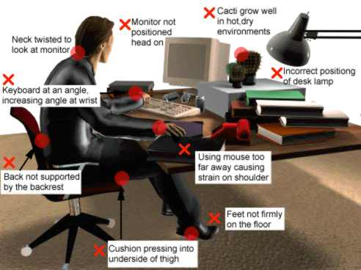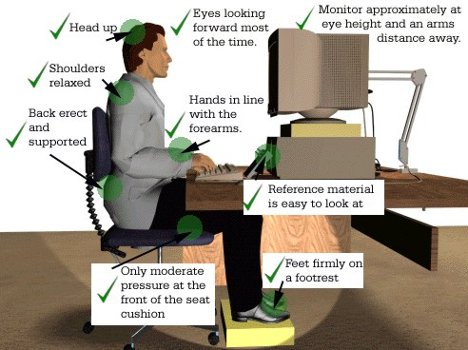

Graphics, www.openerg.com

Guidance for setting up your workstation safely
DSE Self-Assessment (portable/laptop users)

Guidance for laptop and portable computer users to be followed in addition
to “setting up your workstation”
Using portable equipment over a prolonged period can cause discomfort in the short term, but much more damage to the neck and shoulders in the longer term. The same principles should be applied to using portable equipment as with all other DSE. There are several options to ensure that you keep good posture.

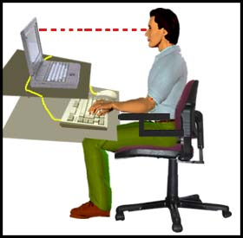
Option 1
Use a separate keyboard and mouse; with most laptops you can just plug them in. You will then need to raise the screen level up to the normal position of a monitor – top of the screen level with your eyes. This solution is good so long as your screen is large enough.

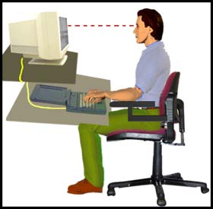
Option 2
The second option is to use a separate monitor and use the laptop’s keyboard. You must ensure that your eyes are the correct 450mm-650mm (about arms length) from the screen and that your screen is straight in front of you.

Option 3
You could consider using a separate monitor and keyboard. This is the most expensive option, but for those people using the laptop for all daily work, it could be the most comfortable.

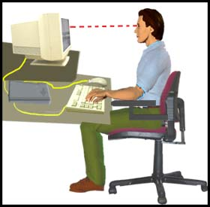
DSE User Self Assessment Form

To be completed by the DSE user after implementing the guidance given in the “Guidance for setting up your workstation safely”.

Answer all of the questions, and for those with NO as your answer, please add the points together giving you a total score at the end of the assessment. Use your total score to determine if any action needs to be taken.

If you needed to mark any questions with an asterisk (* ) please contact your manager despite the score who will assess and make any necessary referrals to the Safety Service.

Name of DSE User College / Service / Dept

Date of Assessment

DSE Component |  | NO | Action Required / Comments

Desk
Is there enough space on your desk top for the flow of work? | 1
Have you got enough leg room? | 2
Is the desk deep enough for you to have the monitor set between 450mm and 650mm from your eyes, when you are seated in the correct position? | 2*
Is there enough room for a space between your keyboard and you for your wrists to rest on the desk (4-6 inches / 10-14cm recommended) between typing | 2*
Is your desk surface free from reflection? | 1

Chair
Is your chair at a height where the bottom of your elbows are at the same height as the keyboard when using the keyboard? | 2
Does the back rest support the small of your back in an upright posture? | 1
Can you sit back into the chair seat fully without any pressure behind the knees? | 2
If fitted, are armrests set up correctly i.e not preventing adequate movement of the chair? | 1
Can you get close to the desk to type with the elbows vertically under the shoulders? | 2
Is the chair comfortable? | 1
Is the chair stable and all adjustment levers working? | 2
With seat height adjusted correctly for the elbows, can you place your feet firmly on the floor without compressing the underside of your thighs? | 2
If a footrest is required, have you got access to one? | 2

Monitor
Is the monitor / screen between 450mm-650mm away from your eyes (arms length) | 2
Is the monitor directly in front of you? | 2
Are your eyes level with the top of the screen? | 1
Is the screen free from glare / reflections? | 2
Is the information on the screen well defined and easy to read? | 1
The image is flicker free? | 2
Do you clean the screen regularly? | 1
Is the monitor tilted between 5 and 15% off the vertical? | 1
Can you adjust the brightness and contrast easily? | 1
Keyboard
Is the keyboard at the correct angle to prevent any up or down bending of the wrist? | 2
Is your keyboard far enough away from you to ensure your elbows are directly under your shoulders when typing? | 2
Do you always move your keyboard out of the way when you are using only the mouse? | 1
Is the keyboard clean? | 1
Are the digits clear and not faded? | 1
Mouse
Is the mouse close enough to avoid extending the arm at the elbow? | 2
If you have a roller ball mouse (laser mice do not need a mouse mat), do you have a mouse mat? | 1
Does the mouse run freely on the mat and work accurately? | 1
Do you regularly clean your mouse and internal mouse ball? | 1
Do you reduce the time using your mouse to the lowest period possible by using keyboard short cuts? | 2
Document Holder
Do you have a document holder (if required)? | 1
Can you refer to documents and papers without having to move your head? | 1
Other Equipment
Is all equipment and items around you necessary?  (or can it be removed to give you more desk space?) | 1
Is all other equipment (phone etc) in a position to ensure that you can maintain your posture when using them? | 1
Space and environment
Can you move in and out of your workstation easily? | 2
Is there adequate space to manoeuvre your chair? | 2*
Is the area free from trailing cables which pose a trip hazard? | 2
Is lighting adequate? | 2
Do windows have blinds to prevent glare and reflection? | 1
Do you find the work station quiet enough? | 1
Is the temperature comfortable for most of the time? | 1
Are you free from any upper body pain/soreness or any soreness in your hands or wrists | 2*
About You
Have you had an eye test in the last 2 years? Please follow this link to eye test information | 2
Do you organise your work to ensure you take a 5 minute break for every hour you are using the DSE? | 2
Is your workstation set up to ensure that you have a flow of work (you don’t have to keep getting up or twisting for things)? | 1
Do you feel you understand and can effectively use all of the computer programmes you have to use as part of your job? | 2
Do you have an existing medical issue that you feel is being aggravated by your workstation? | Y* = score 2
Do you suffer from dry or sore eyes when using your DSE? | Y* = score 2
Do you feel you require extra DSE information or training? | Y* = score 2

Total Score

0 – 15 Workstation is ok, however if you have any concerns raise these with your manager

16 – 30 Contact your manager for help and advice. Are there any actions you can take easily that will improve your score (e.g. clean the screen, set up your chair?)

31+ Contact the Safety Service (safety@exeter.ac.uk) to arrange further assessment

Action Plan
Please indicate in the section below what action is required to address the hazards identified in your assessment.
It is important that any key information is passed onto your line manager to ensure that action can be taken. All actions should be given a date and a person must be assigned to deal with each action. Action plans must be monitored and completed within reasonable time.

Actions Required | Responsible Person | Date for Completion
Copy of the DSE assessment must be sent to Line Manager. Place in personal file. | DSE USER | IMMEDIATE
Date set for next assessment (annual re-assessment required)

