Casual Claims Registration Guide

Table of Contents
Casual Claims Registration Form 2
Creating a User Account 2
Personal Details 4
Bank and P45 details 5
Recruitment Monitoring 6
Line Manager 6
Further Details 7
Declaration 8
Summary 8
Submitting the Registration form 9

Casual Claims Registration Form

Creating a User Account

Please follow this link : http://www.exeter.ac.uk/staff/employment/tempworkers/casual/worker/ and follow Step 1 to register onto the Casual Claims payroll.
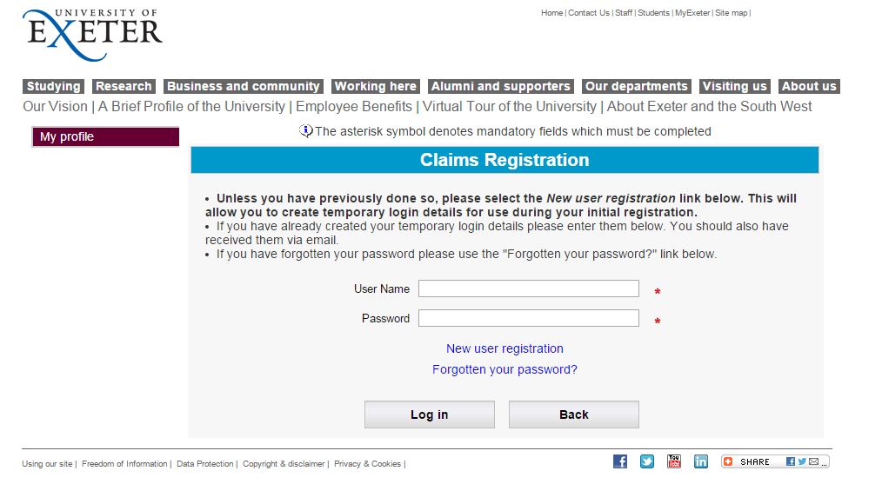
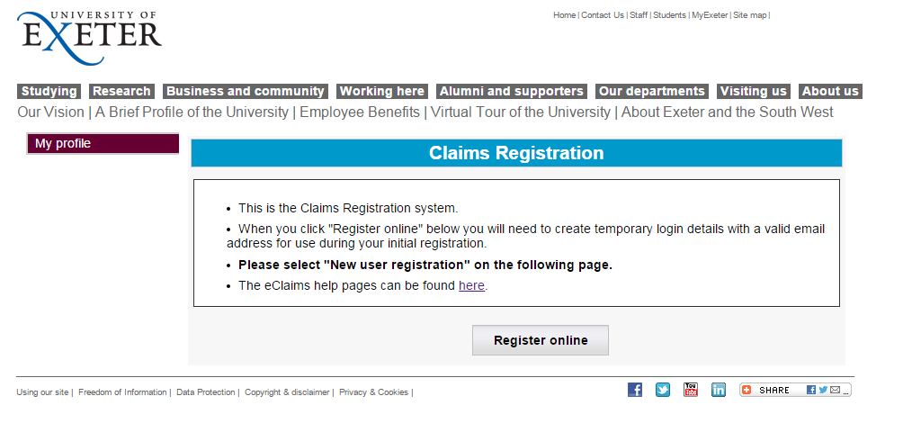
- Here you can login if you have already started your registration, create a new user registration or request forgotten your password. Please note: If you have registered before but have since left the university you will need to use a new email address.

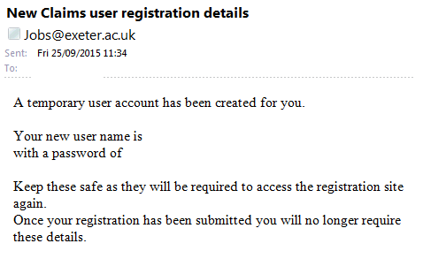
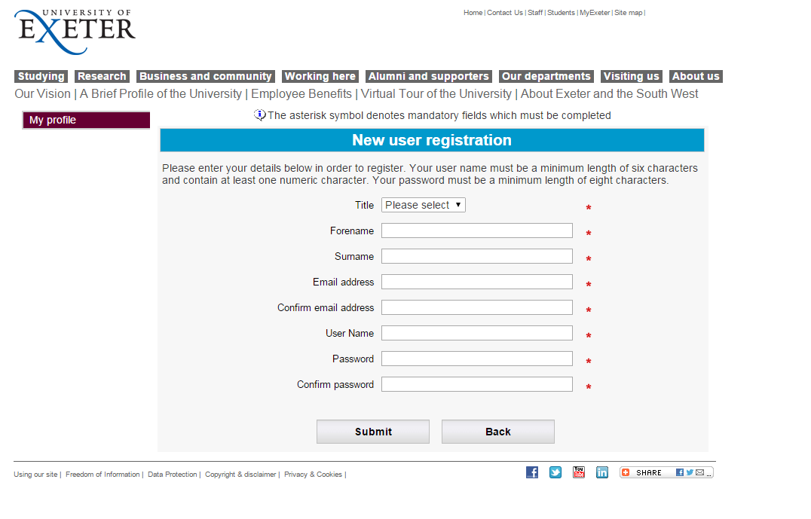
- You will then receive a confirmation email from the system confirming your account has been created and your user details are. Please note: These login details will not be used for eClaims and this is a separate username and password.

- Once you click submit on the new user registration form you will be taken to the Summary page

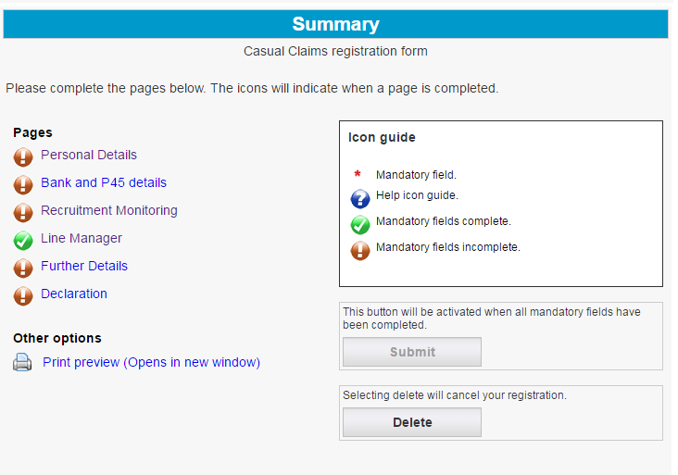
- Clicking on each title will allow you to enter the information for that section (Personal Details, Bank and P45 details, Recruitment Monitoring Line Manager, Further Details and Declaration)

Personal Details
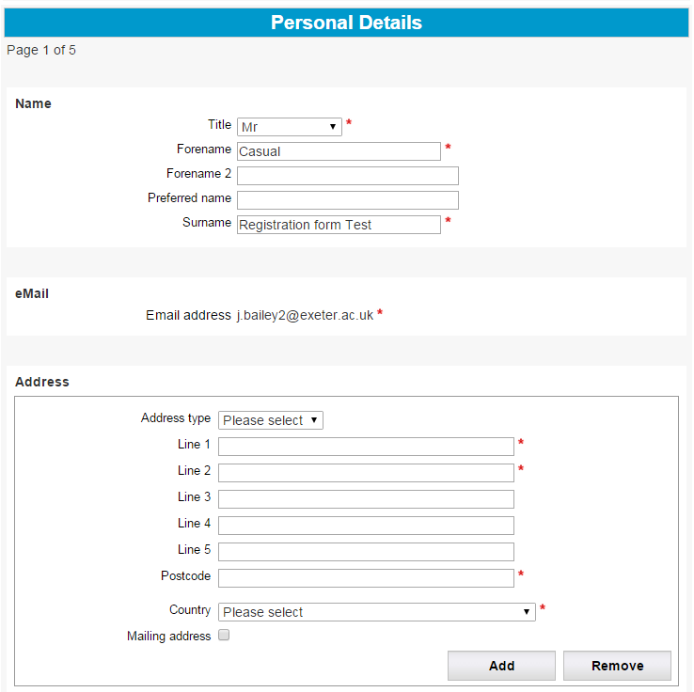
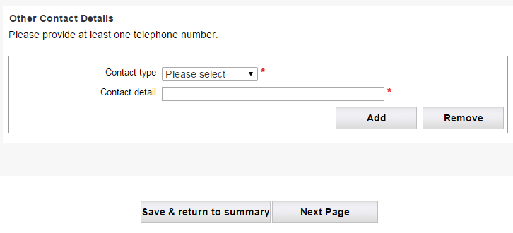

- Clicking Save & return to summary, takes you back to the summary section and this will show which sections have been completed click next page will take you to the next section in the registration form.

Bank and P45 details
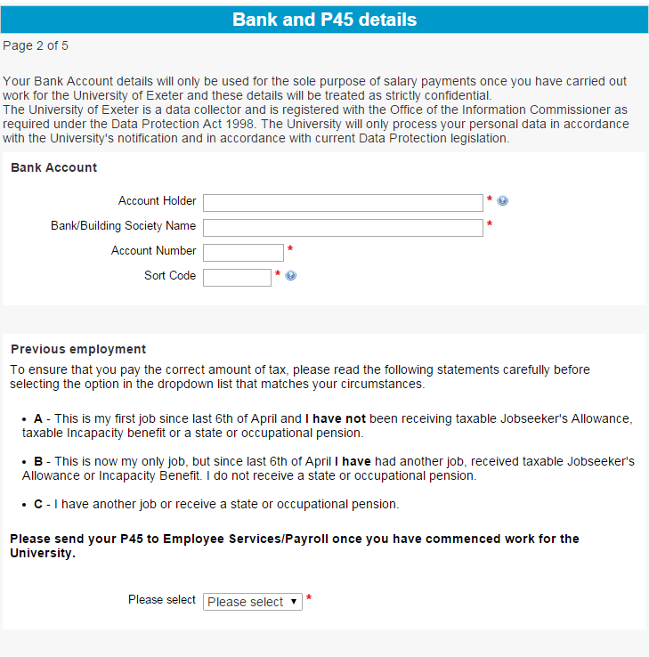
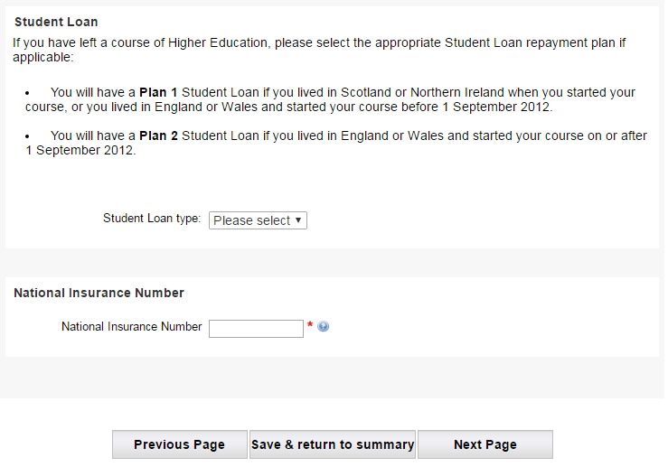
- Please enter your details for a UK bank account as we can only pay people with international bank accounts by Cheque. If using an International account please Enter Cheque in the Bank/building Society Name and in the Account number/Sort code fields enter Zero’s (0)

Recruitment Monitoring
- Please complete all mandatory fields accordingly.
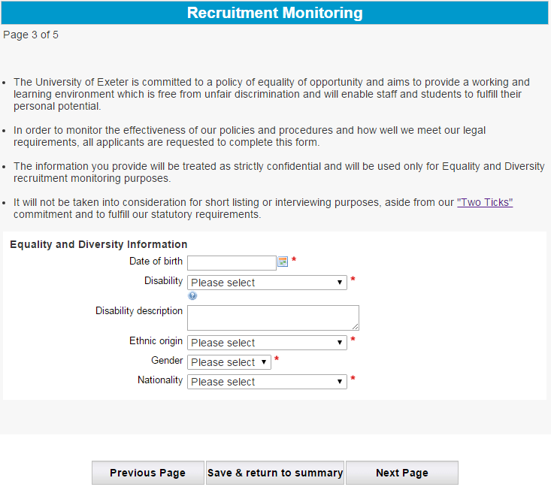
Line Manager
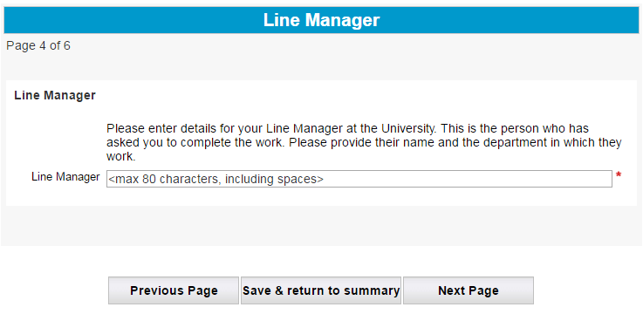
- This should be the person who has asked you to do the work. Please input their full name and where they are based at the University of Exeter
Further Details
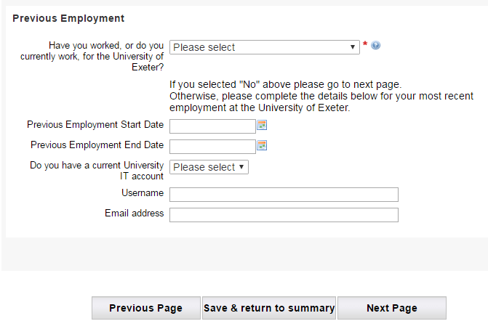
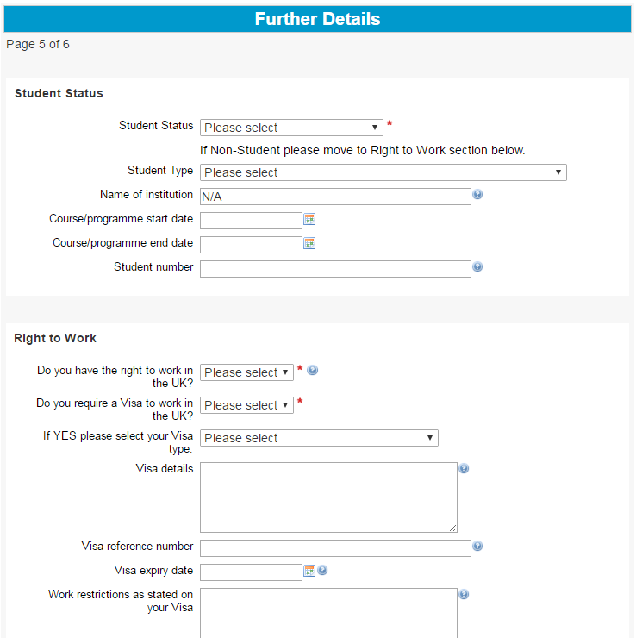
- Please complete all mandatory fields and provide as much detail as possible.

Declaration
- Please read this carefully and you will need to agree to the declaration before you start working at the University of Exeter

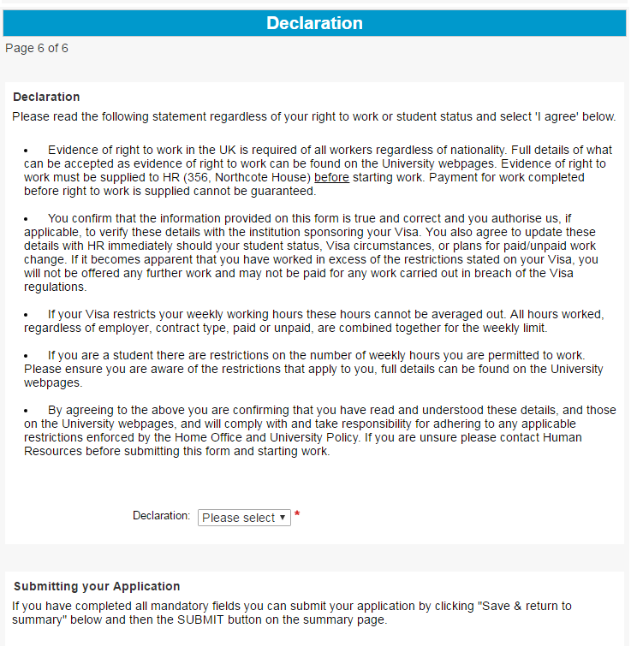

Summary
- Once you have completed all the sections of the registration form you will have all the green ticks next to all the pages in the registration form and be able to submit this for processing.

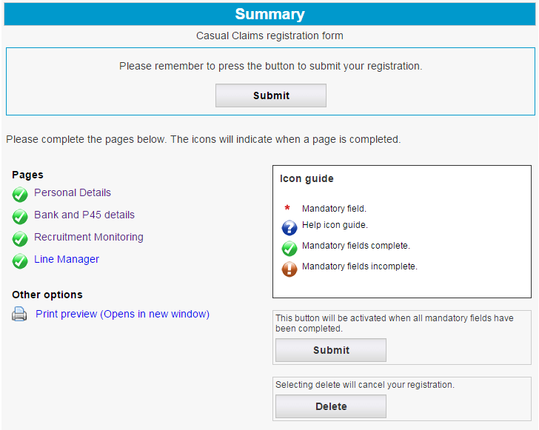
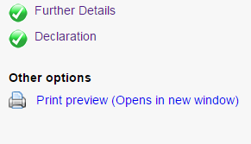

Submitting the Registration form
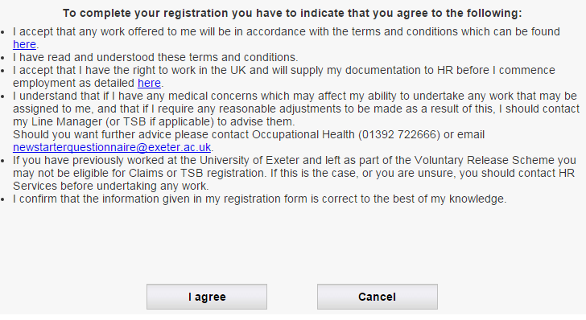
- Once you have clicked Submit, you will need to confirm the terms and conditions
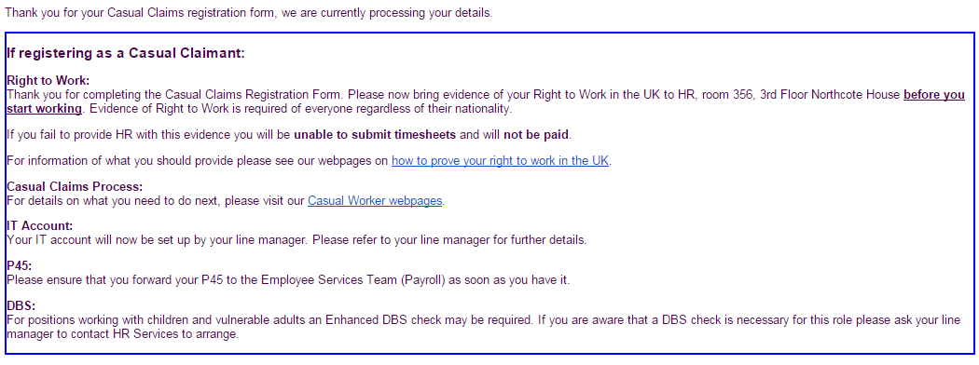
- The applicant then receives another email saying we are currently processing the application form. In this Email please ignore the section regarding applying for the Temporary Staff Bank. This section below is what is applicable.
- Once the form has been processed by payroll the line manager will then be notified to create an I.T. account for the respected user.

- In the meantime please provide HR with your right to work evidence please take this to room 356 in Northcote House.

