eClaims – Approver/ Super User Quick guide:

- My Account Page Approval process
* We recommend that you approve your timesheets weekly to ensure a deadline is not missed. *

Filtering via a Job Role, Claimant or Search

- If you are searching for a Job Role please click the Bag icon. If you are searching by Claimant please click the Claimant Icon. If you are searching for a specific Job Role, Claimant or Claim ID you can type this in the search field.
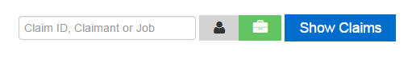
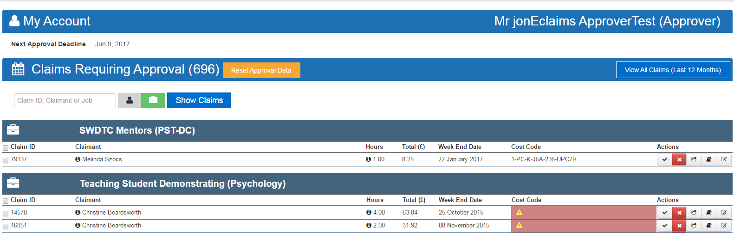
- Then Click Show Claims and it will filter the list accordingly.

Key of Approver Icons
Icon | 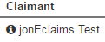 | 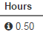
Function | (i)Shows Information on Claimant | (i)Shows breakdown on hours | Approve Claim | Reject Claim | View Full Claim | Add Costcode | Add Notes
Extra functions | This Shows Student/Visa Status, Hours Restrictions and Right to Work Check date. | The eye iconAlso shows any edit’s on hours | Can also Approve on bulk by Claim ID check box | Add a rejection reason to the claim. | Opens claim in a new internet browser window | Add costcode to one claim or copy to multiple claims | Can also see historic notes added to the claim.

Approving a Claim with costcode
- You can approve a claim in two ways by clicking the Tick (best used for individual claim approval) in the Action section, or by clicking the ticks next to the Claim ID (best used for approving claims on bulk)

Using the Approval Tick in the Actions column
- Identify the claim you want to approve (by filtering the claim if required). Once you have selected the claim you want to approve, click the tick icon under actions and the tick icon will go green
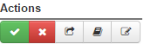

- The claim will stay on the screen to allow time for a costcode to be added
Please Note: If you refresh/re-filter your browser, this claim will move on to the next approval level. If you are not the last level of approval the claim will stay on this screen until a valid costcode is added.
- To add a costcode to this claim click on the book icon in the Action section.

- Once clicked, a costcode window will display where you can add a costcode to this claim for approval. (If the costcode is active the validator will provide a green tick. If un-active a red cross will be displayed).
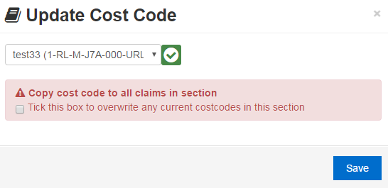

- Once you have clicked Save. The costcode field will populate before the claim is then removed from view. The claim will have either gone on to the next level of approval or been fully approved (if you are the final/only level of approval)
Please Note: This process can be done either way. You can approve a claim and then add the costcode or add the costcode and then approve the claim.

Using the Claim ID tick box for approval
- Identify the selection of claims you want to approve (by filtering the claims if required). Once you have selected the claims you want to approve, click the tick icon next to the Claim ID.
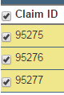
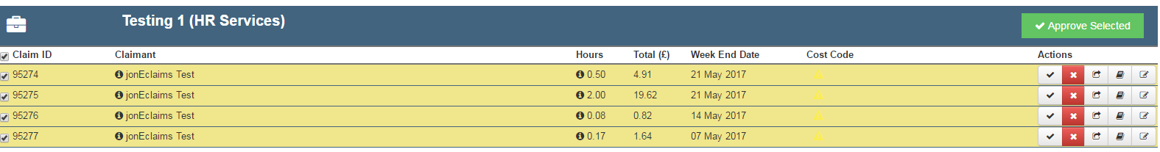
- Once this has been ticked the claim row(s) that are selected turn yellow to show that this has been highlighted. As consequence an Approve Selected box appears in the top right hand corner of that section to allow multiple claim approval.

- To add a costcode to this selection click on the book icon in the Action section

- Once clicked, a costcode window will display where you can add a costcode to this selection of claim for approval.
- Once this is confirmed as an active costcode you can then tick the Copy costcode to all claims in section box and click Save.
Please Note: Ticking this will overwrite any current costcodes in this section

- Once Saved, the rows of the claims selected will populate with the costcode
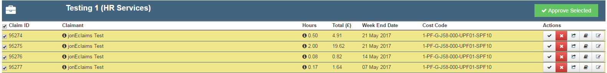
To approve these selected claims in one go, click Approve Selected and then confirm approval

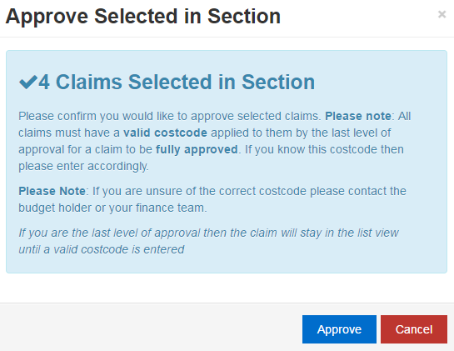

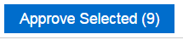
- Once approved the claims will then go from the view and the count at the top of the screen will be recalculated accordingly once the page has been refreshed.
Please Note: if you have clicked the Claim ID option over multiple Claimants or Job Roles you can do a bulk Approve Selected from the bottom of the screen (with the same confirmation as the above screenshot) This option will also display a count of how many claims have been selected.

Rejecting a claim
- It is recommended that you view the claim first before rejecting a claim by either clicking the (i) next to the hours, or the view claim option in the Actions section. To reject a claim click on the X within the Action section.

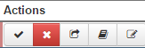

- Once you have clicked this, a pop up window will display that will allow you to enter a rejection reason that is sent to the Claimant and also stored in the notes against the claim

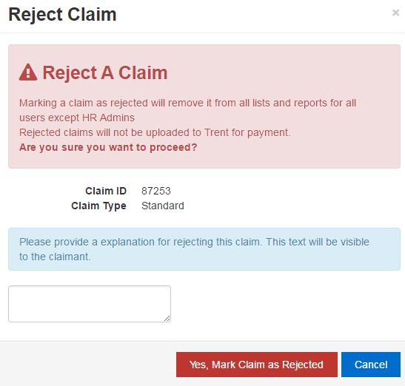

- Once you click Yes, Mark Claim as Rejected this claim will then disappear from your list view for claims to be approved and your count next to the claims requiring approval at the top of the screen will decrease accordingly on next refresh of the my account page. Please Note: The rejection message is a mandatory field

Viewing a claim
- To see the full details of a claim click the view full claim icon in the middle of the Action section. Clicking this icon will open a new internet browser tab of the claim view.
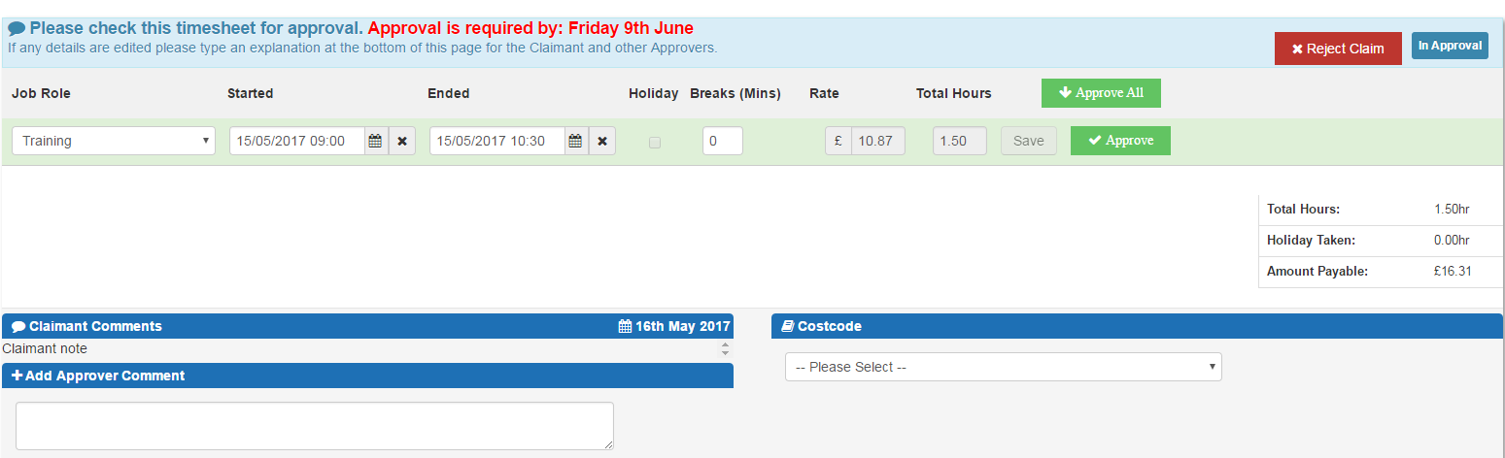
- You can use this screen to still approve/reject the claim as normal
Please Note: If you do approve the claim or reject the claim from this new internet browser window the claim will still be show on the account page until that page has been either refreshed or re-filtered this view.

Adding a note/viewing historic notes
- To view historic note and to add new notes, click the pen and paper Icon on the far right of the Action section. When you click this Icon a window displays with any historic notes that have been inputted. Please Note: If this appears blank then no notes have been inputted.

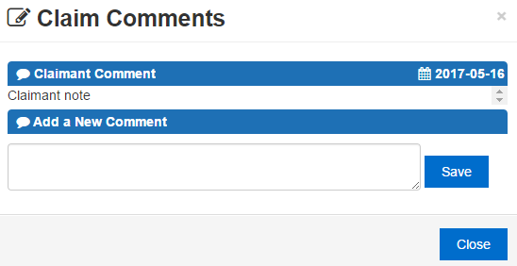

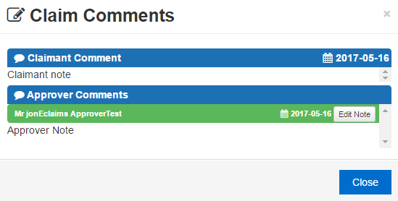
- To view/edit the note you have inputted you can click on the Pen and Paper Icon again and click edit to make changes

Paused Claims
- Paused Claims will be displayed under either the relevant job role or claimant depending on how the account page has been filtered.
- The Claim will display with the paused claim badge and highlighted in Red. The ability to approve or reject the claim will be greyed out until HRBP approval has been received.

