eClaims Approver Guide:

- Creating Claimant User Profiles &
- Adding Claims on behalf of a Claimant

Table of Contents
Hours and Breaks 2
Logging into eClaims 3
My Accounts page for Approvers/Admin’s 3
Creating a claimant user job role profile 4
Creating a Hours Timesheet for a user 6
Approving a Hours claim 10
Creating a Set Fee Timesheet 11
Approving a Set Fee claim 14
eClaims System Notification emails. 14
Claimant’s Notification emails. 14
Approver’s notification emails 15

Hours and Breaks
All Claimants
Must take a minimum uninterrupted break of 20minutes if working more than 6 hours each day – breaks are not paid
Must have a rest period of 11 consecutive hours in each 24 hour period.
Must also have at least one day off a week; this can be averaged over 2 weeks.
All Claimants should not be exceeding a 36.5 hour working week.
Any claims inputted over 48hours will be paused and require further approval.
All claimants cannot submit a claim longer than 12 hours per day.
Workers aged 16/17
If a young worker is required to work more than four and half-hours at a time, then they are entitled to a break of 30 minutes. A young worker is also entitled to twelve uninterrupted hours in each 24-hour period in which they work. Young workers are also entitled to 2 days off each week and this cannot be averaged over 2 weeks.
Visa Restrictions
Those users on a Tier 4 General visa are not able to work more than 10/20hours per week depending on the stipulations of their visas.
PhD Students
Those users who are doing a PhD at the university will not be able to exceed more than 15hours a week due to university guidelines.

Logging into eClaims
- Your College/Service super user should set your access up to the system. You should log into eClaims with your normal University of Exeter I.T. account details

My Accounts page for Approvers/Admin’s

- Every time you login to eClaims you will be now taken to the My Accounts page
- On here you will see when the next approval deadline is and also claims that require your approval rather than All Claims
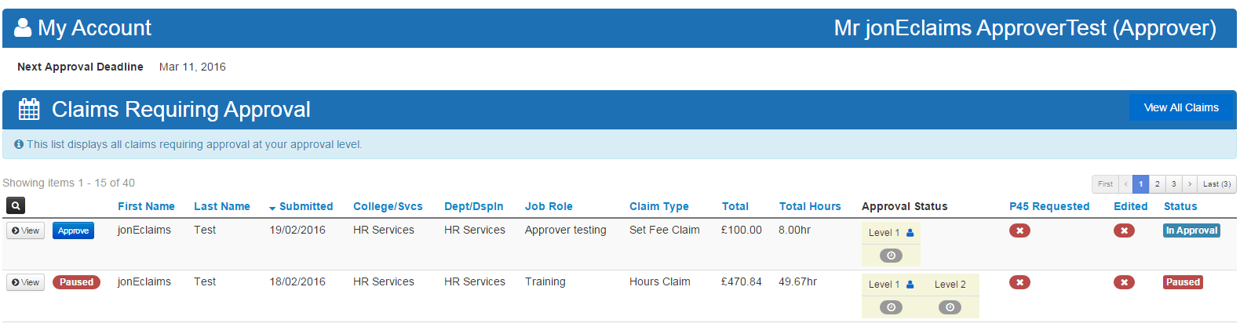
- On this page you will see all claims require approval as well as any paused claims that might be in view.
- If you login and you have no claims awaiting your approval you will see this message on the “My accounts page”.
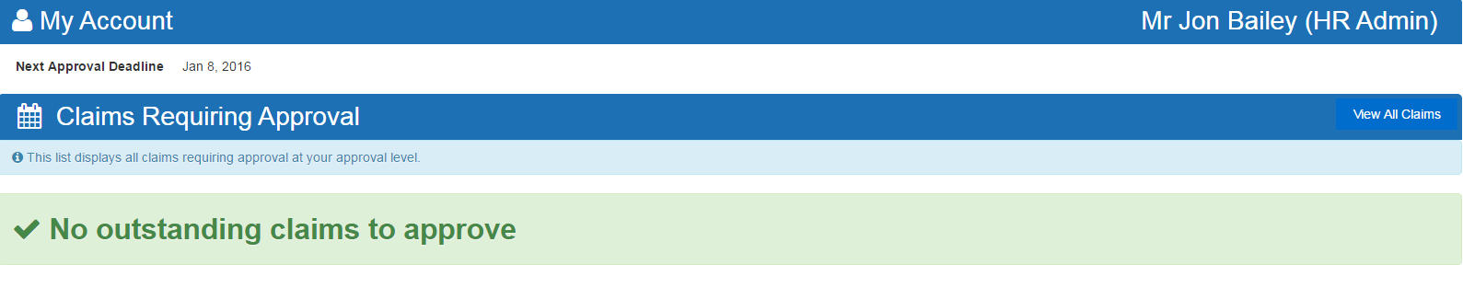
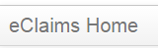
- To See all claims or to export any reports then please click on eClaims Home

Creating a claimant user job role profile

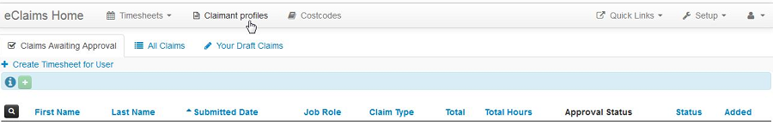
- Click Claimant Profiles.

- Click Add Profile.
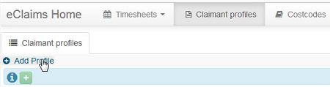

- Select if the claimant profile is for an Hours Claim or Set Fee Claim. Set Fee claimant profiles are not linked to a specific pay scale.
- Start typing the users first or last name into the User Name field to initiate a search.
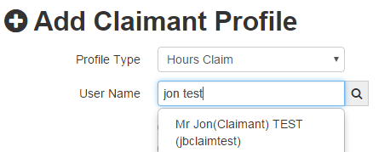
- A list of search results will appear. Click on the user you wish to setup a claimant profile for.

- Use the radio buttons to select College or Service.
- Fill in all the additional details and add Notes if required.
- Click Save Profile when completed.
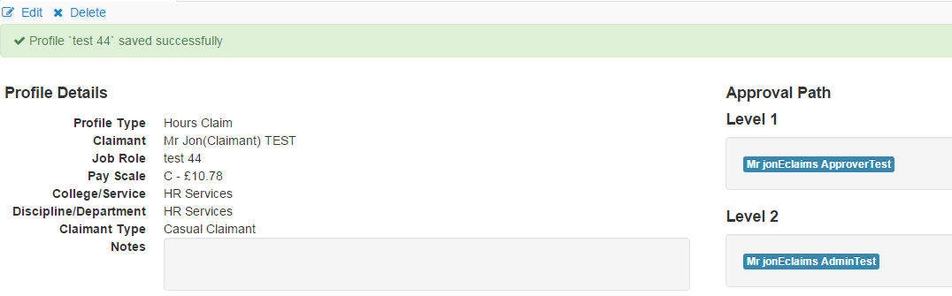
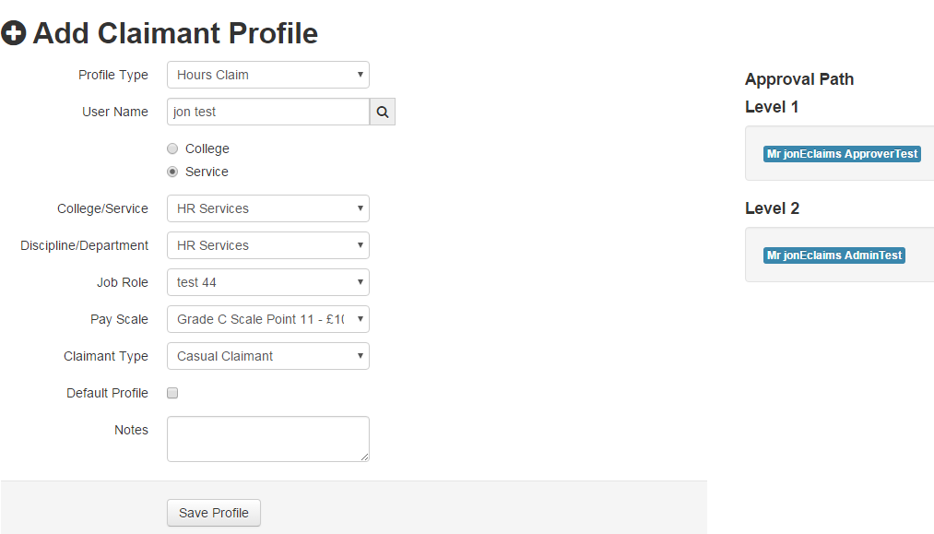
- Once a Claimant Profile is setup you will be taken to an overview of Claimant Profile you have just created.

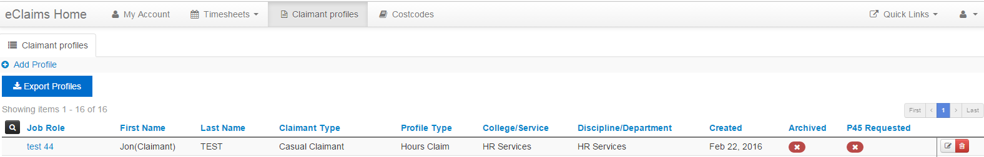
- From the Claimant Profiles overview page you can edit or delete claimant profiles by clicking on the Edit or Delete buttons at the end of each row.
- Once a claimant profile has been added to a claim it can no longer be edited or deleted.

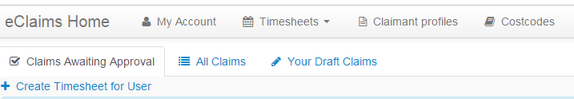
Creating a Hours Timesheet for a user
- Please click + Create Timesheet for User and once clicked you will be asked to select the user question and type of Claim (Hour or Set Fee)
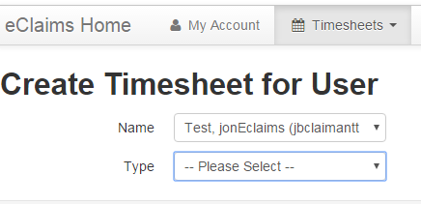

- If the Claimant has a restricted timesheet by their Visa or PhD you will be informed and will not be able to submit a timesheet exceeding these hours.
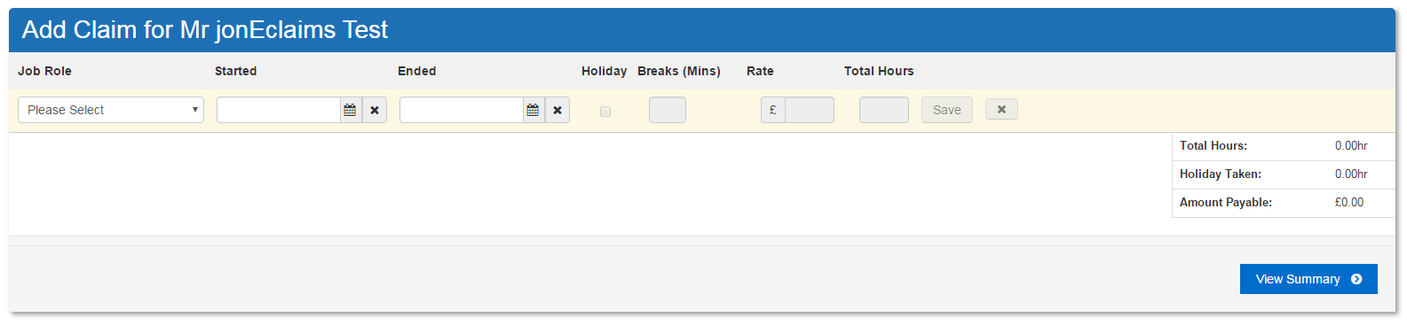
- Please note: Tier 4 General -10/20hrs visa holders will not be able to create set fee profiles or submit set fee timesheets.
- Select the Job Role you wish to claim for from the dropdown list

- Then fill the Start Date and Time followed by the End Date and Time for the Claim period. Please put your claim to the nearest 5 minutes of your shift.
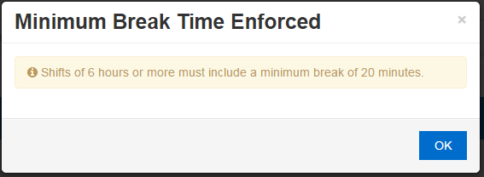
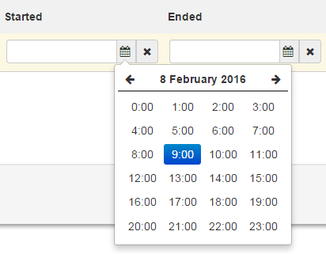
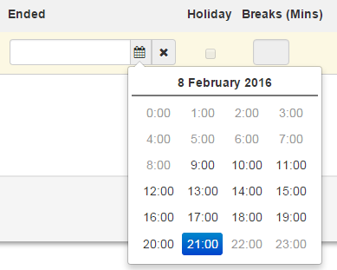
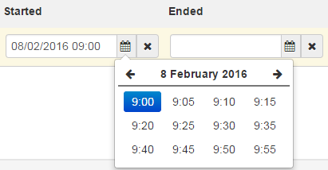
- Please enter any break taken in minutes. Please Note: if you do not enter a break and work over 6hours the system will enforce an automatic unpaid 20minute break.
- Once you have inputted all the information for that Shift, please click Save and a new row will be automatically added to the timesheet if required.
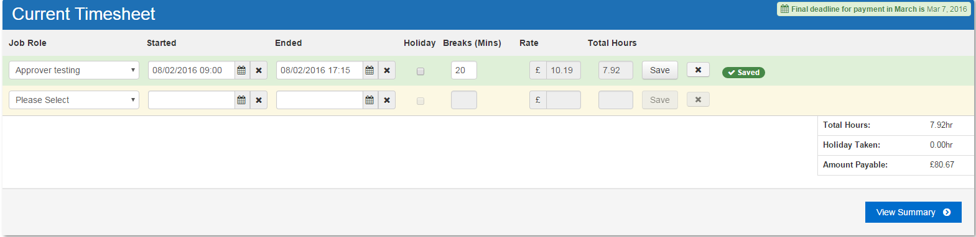
- To remove any of the rows of information please click the X button to delete that Row. Once clicked you will be asked to confirm that deletion.
- The row will then go red and then disappear from the current timesheet.
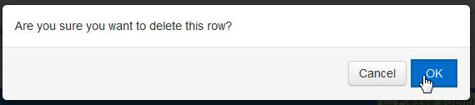

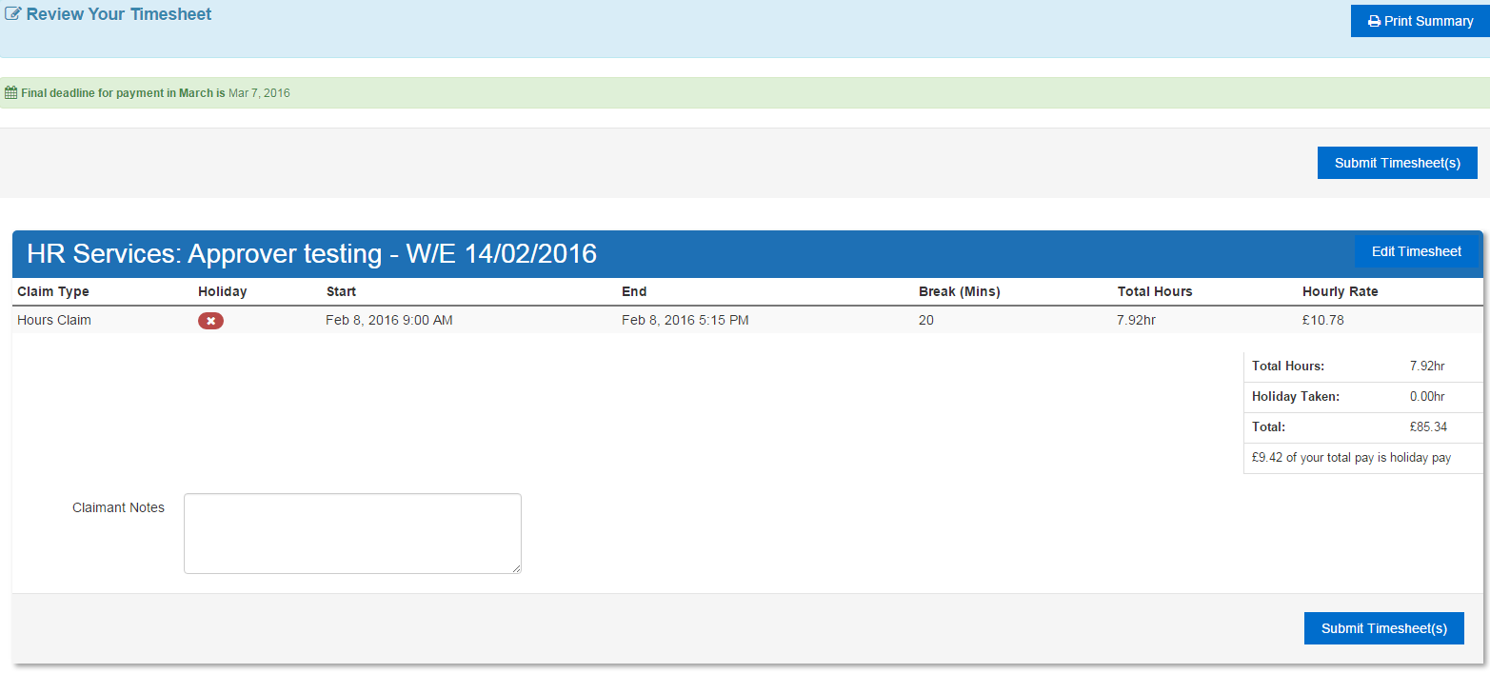
- If you notice you have selected the wrong time or inputted the wrong about of time for you break you can edit this but you will need to click Save again to update the changed.
- If you are happy the timesheet is correct you can then View Summary
- On the summary screen you can Print a copy of this summary, edit the timesheet and submit timesheet(s)
- Once you click Submit Timesheet(s) you will receive this confirmation message
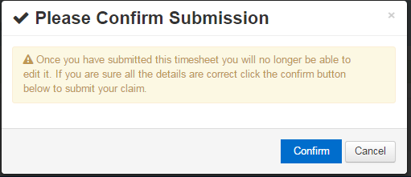
- Please Click Confirm to confirm submission of this timesheet. Please Note: Once you have done this you will not be able to edit this timesheet again, until you come to Approve the claim.

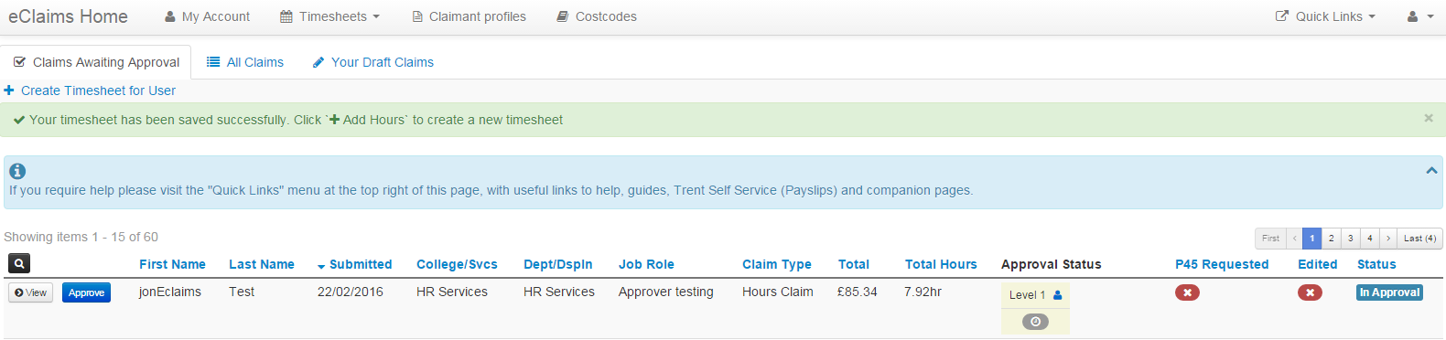
- Your timesheet will then be sent for Approval and you will be return to the claims awaiting approval screen to see that this has been submitted successfully.
- Please note: Claims submitted on different weeks will be split out on the View Summary page as below

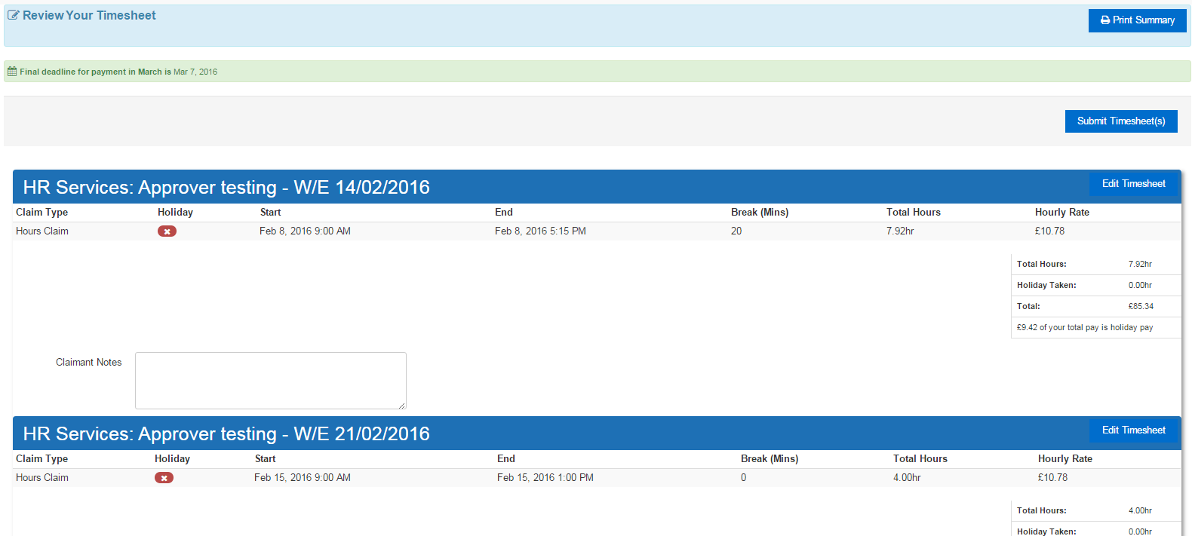

Approving a Hours claim

- Once you have clicked the Go To Approval screen you are able to see the claims in a broken down timesheet split into Shifts. From this screen you can reject the claim, edit the claim, add a comment, a costcode and approve the claim.
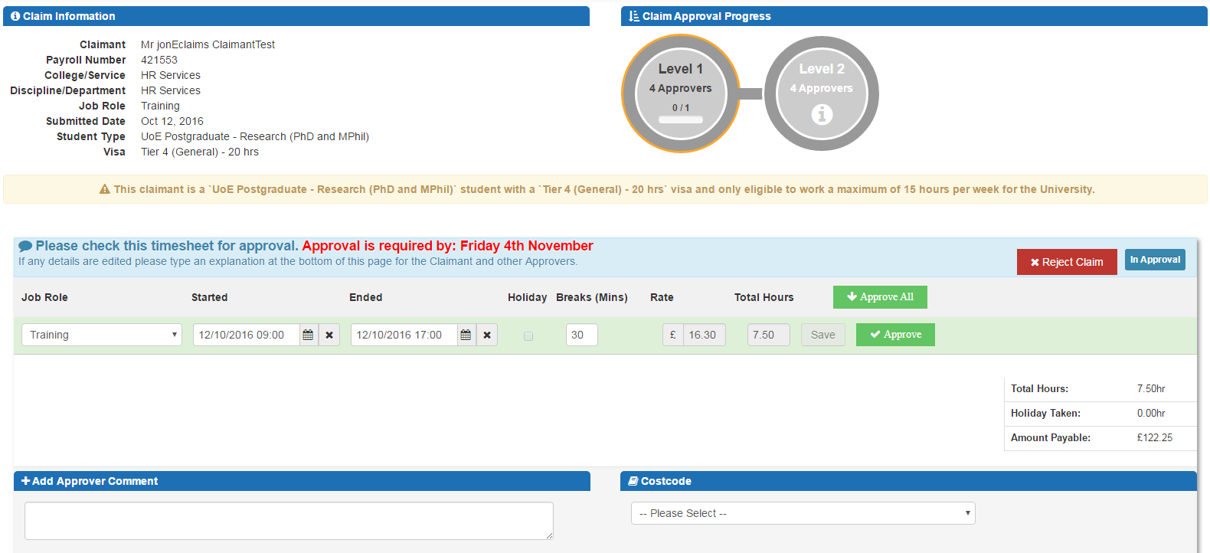
- This screen will also reinforce when the next approval deadline in the middle screen for that month.

- If you edit the claim by clicking in any of the Started, Ended or Break boxes you will need to Save the row before approving the relevant row.

- Once you have made any amendments required (Discuss with Claimant first before making changed) you can then click Approve on each row or Approval All if the timesheet is correct.
- You can then add an optional comment to the timesheet that will be visible to all users.

- If the job role has multiple levels of approval the timesheet needs to have a valid costcode before it can be fully approved, Please Note: other levels of approval can change costcodes if incorrect
- Once are you are happy with the timesheet please Click Save, Once saved you will be returned back to the Claims Awaiting Approval screen to approve any other outstanding claims. Please Note: Once you have saved the claim you will not be able to edit the claim again but your next level of approval can. If you are the last level of approval and notice any issues with the timesheet please contact e-claims@exeter.ac.uk
- If you are the final level of approval and do not enter a costcode and click save on the timesheet you will see this message below and the claim will still be In Approval

Creating a Set Fee Timesheet
- Please click + Create Timesheet for User and once clicked you will be asked to select the user question and type of Claim (Hour or Set Fee)

- If the Claimant has a restricted timesheet by their Visa or PhD you will be informed and will not be able to submit a timesheet exceeding these hours.
Please note: Tier 4 General -10/20hrs visa holders will not be able to create set fee profiles or submit set fee timesheets.
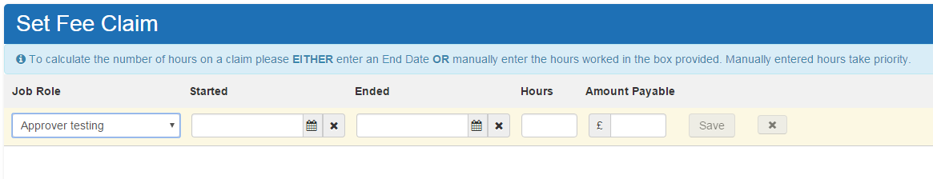
- Select the Job Role you created earlier from the drop down list.

- Then Fill in the Start Date and Time and optionally the End Date and Time.

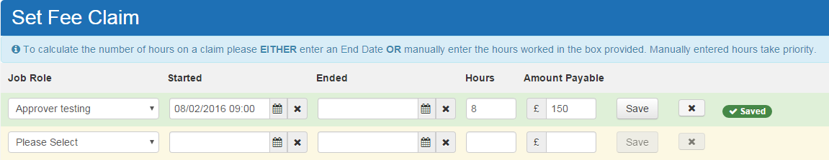
- To calculate the number of hours on a claim EITHER enter an End Date OR manually enter the hours worked in the box provided. Manually entered hours take priority. Enter Amount Payable. Click Save to save the row on the timesheet.

- A new blank row will be added to the timesheet once saved. Continue adding rows to the timesheet pressing save on each row
- Click the X button to delete a row if you don’t require it and you will be asked to confirm this deletion. The Row will then go red and disappear.

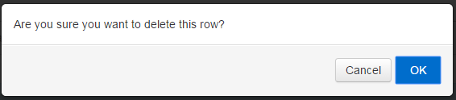
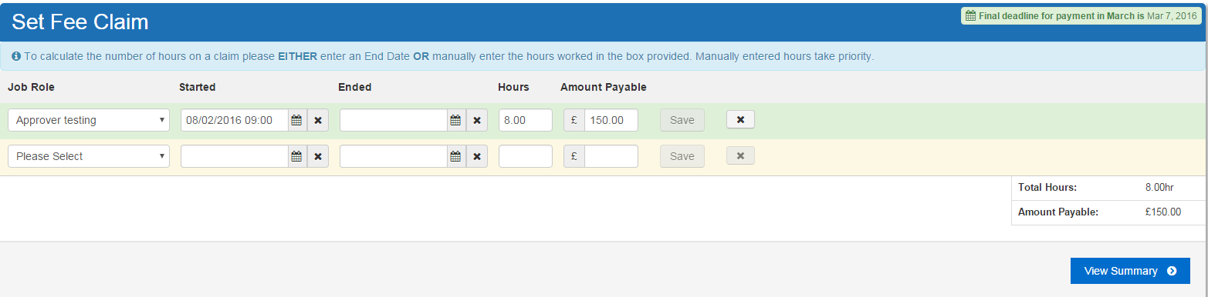
- When you have completed your timesheet please click View Summary
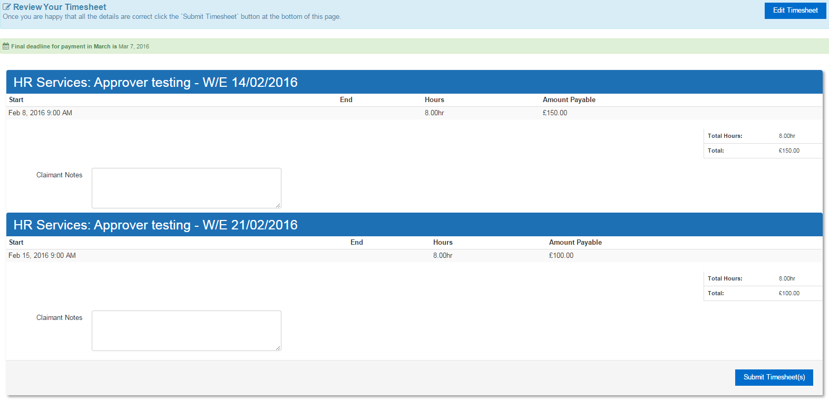
- You will then be taken to a summary screen where you can view all of your timesheets split by week ending dates.
- If you notice an error you are able to edit the claim by clicking Edit Timesheet. If you are happy that these entries are correct please click Submit Timesheet(s)
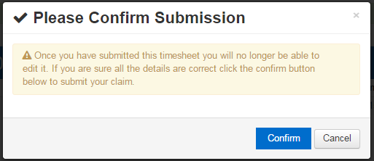
- You will then be asked to confirm submission of these timesheet(s) press Confirm

- Once your timesheet has been confirmed you will not be able to edit this claim again. However you can when you approve the claim if you notice an error.
- You will then be taken to the claims awaiting approval screen to see your claim is now awaiting approval.
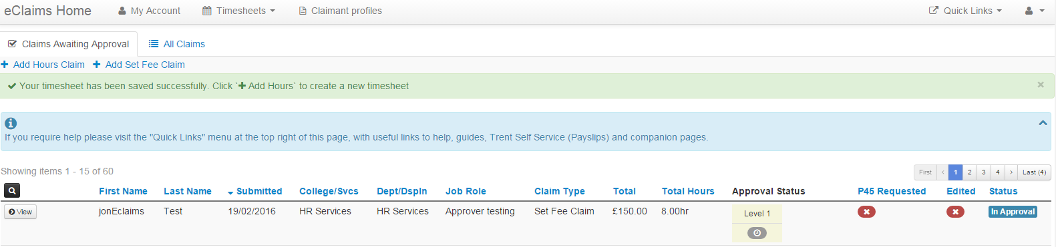

Approving a Set Fee claim
- Approving a Set Fee claim is done in the same way as approving an Hours claim. Please follow the same steps as above.

eClaims System Notification emails.

Claimant’s Notification emails.
- If the claim has been approved by yourself the claimant will receive this notification
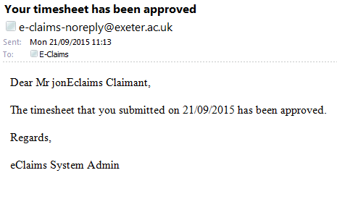

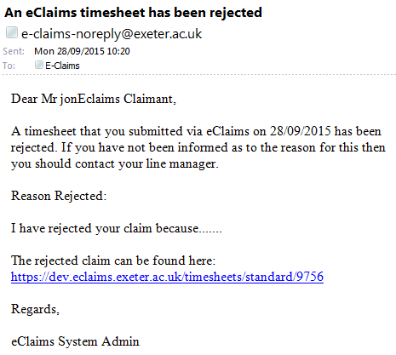
- If the claim has been rejected by yourself the claimant will receive this notification

Approver’s notification emails
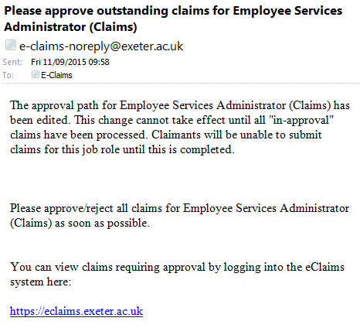
- If a change has been made to an approval path you will receive this notification
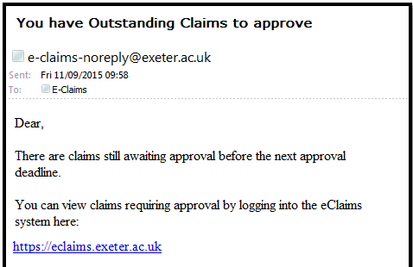
- When approvers are near Authorisation Cut-off date for that months payroll you will receive this notification

- If a claimant exceeds 36.5 hours on their timesheet in a week, you will receive this notification.
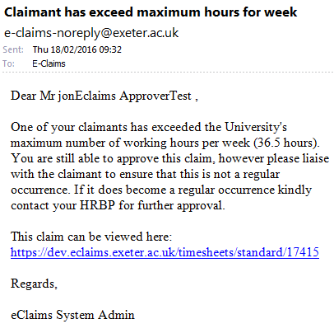

- If a claimant exceeds 48 hours on their timesheet in a week, you will receive this notification.
