eClaims Claimant Guide – Set Fee Claim
Contents
Hours and Breaks 2
All Claimants 2
eClaims 3
Logging in 3
My Account Page 3
Adding a claimant profile 5
Adding additional claimant profiles 6
Creating a Set Fee Timesheet 6
Submitting Your Timesheet 7
eClaims Notification emails 9

Hours and Breaks

All Claimants
Must take a minimum uninterrupted break of 20minutes if working more than 6 hours each day – breaks are not paid
Must have a rest period of 11 consecutive hours in each 24 hour period.
Must also have at least one day off a week; this can be averaged over 2 weeks.
All Claimants should not be exceeding a 36.5 hour working week.
Any claims inputted over 48hours will be paused and require further approval.
All claimants cannot submit a claim longer than 12 hours per day.
Workers aged 16/17
If a young worker is required to work more than four and half-hours at a time, then they are entitled to a break of 30 minutes. A young worker is also entitled to twelve uninterrupted hours in each 24-hour period in which they work. Young workers are also entitled to 2 days off each week and this cannot be averaged over 2 weeks.
Visa Restrictions
Those users on a Tier 4 General visa are not able to work more than 10/20hours per week depending on the stipulations of their visas.
PhD Students
Those users who are doing a PhD at the university will not be able to exceed more than 15hours a week due to university guidelines.

eClaims

Logging in
- With the I.T. account details your line manager has provided you with, you should be able to login to eClaims. If you login with any other type of University of Exeter I.T. account the system will allow you access but you will be asked for a payroll number to be able to submit your claims. If you have forgotten your password you will need to contact the SID desk to get this reset.

My Account Page

- Every user will now be taken to the “My Accounts page” after logging into eClaims
- Here you will be able to easily see if you have successfully provided us with your right to work information, entered your payroll number and provided us with further information regarding the type of Claimant you are.
- If any of your sections appear in a red box and require further information you can click on this symbol within the, my accounts page.
- This page will show you all your Active Job role profiles and a list of current claims (Approved, Rejected, In approval or Draft) will be displayed at the bottom of the screen based on the previous Claimant cut-off date
- Please set your claimant type accordingly because if you do require a Visa to work in the UK your timesheets will be changed accordingly based on the stipulation of your Visa agreement. PhD students also have limited weekly timesheets also
- If you are unsure what any of the sections mean you are able to take a visual tour of the page by clicking this Icon.
- Terms and conditions of the university and working restrictions can be accessed by this Icon

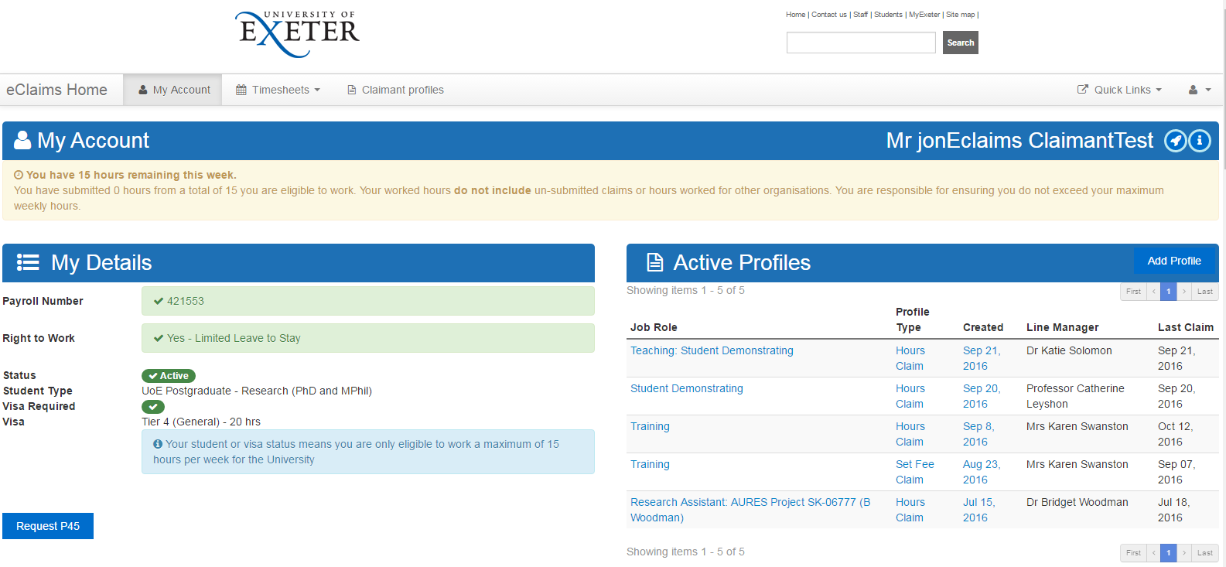
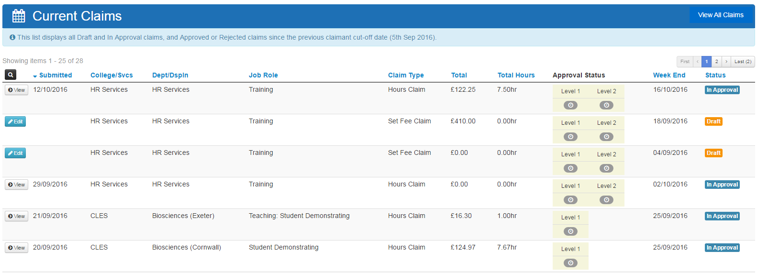
- If you have a restriction on your Account by either your student status or visa restriction this will show at the top of the my account page. And again in the blue box under your student type / Visa requirements.

- If you require to request a P45 this can be done from the My Accounts page under the Request P45 option. You would need to request this and then click Save on your details.
If you select this option you will see that your status will go from active to inactive and you will also get this message. By selecting this option you will not be able to submit any timesheets on the system and will be made a leaver on our payroll system.

Adding a claimant profile
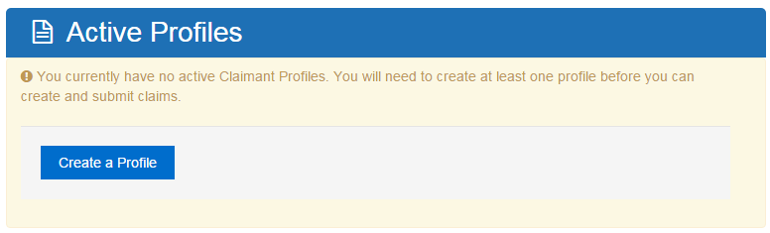
- On the “My Accounts page” under “Active Profiles” you will be able to add a new Claimant profile to the system if it is the first time you have used the system. Or using the Add profile option

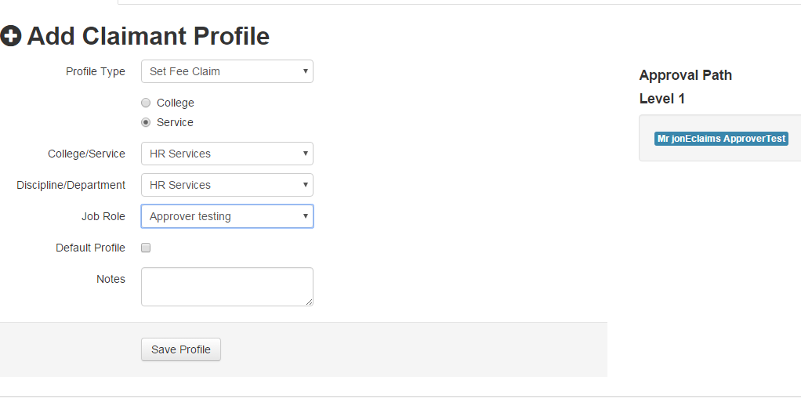
- Your line manager should have provided you with the information to be able to select from the follow drop down to create a Set Fee claimant profile.
- Please Note: You may see additional Approval Path levels, however on Level 1 you should be seeing your line managers name if you have selected the correct options.
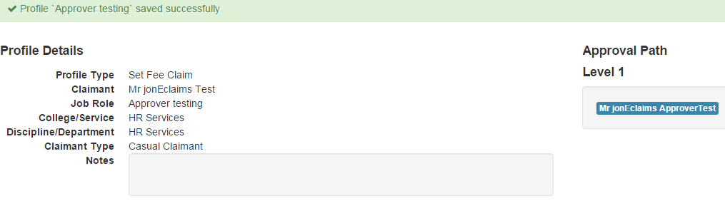
- Once you are happy that your profile is correct please click save profile and you will see this confirmation.

Adding additional claimant profiles
- You can also add additional claimant profiles on the Claimant profile screen as well as the accounts page, if you have other jobs at the University, by clicking Claimant Profiles and then Add Profile

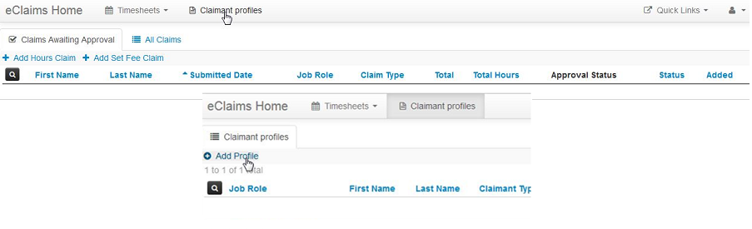

Creating a Set Fee Timesheet
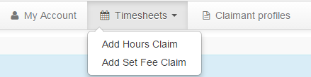
- Click Timesheets and then Add Set Fee Claim
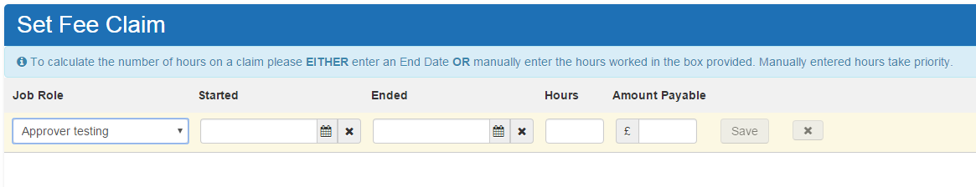
- Select the Job Role you created earlier from the drop down list.
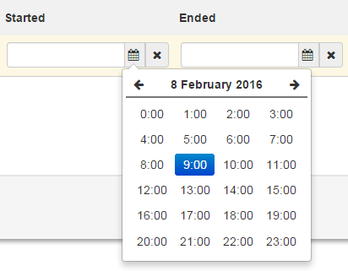
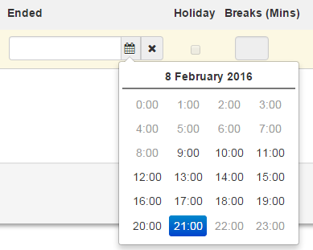
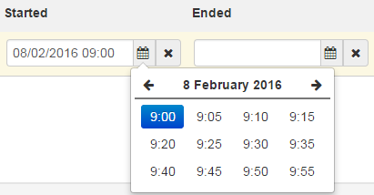
- Then Fill in the Start Date and Time and optionally the End Date and Time.

- To calculate the number of hours on a claim EITHER enter an End Date OR manually enter the hours worked in the box provided. Manually entered hours take priority. Enter Amount Payable. Click Save to save the row on the timesheet.
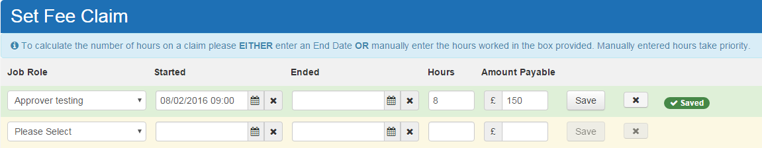
- A new blank row will be added to the timesheet once saved. Continue adding rows to the timesheet pressing save on each row

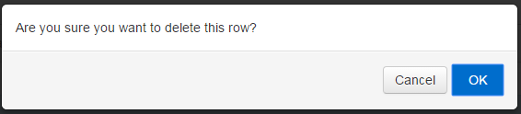
- Click the X button to delete a row if you don’t require it and you will be asked to confirm this deletion. The Row will then go red and disappear.

Submitting Your Timesheet
- When you have completed your timesheet please click View Summary
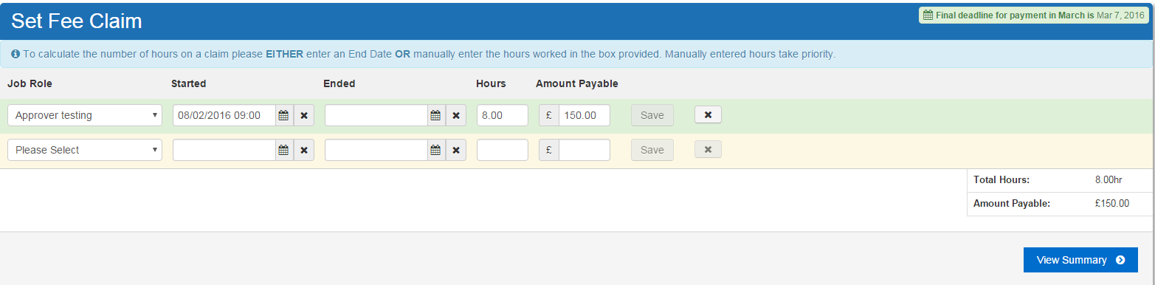
- You will then be taken to a summary screen where you can view all of your timesheets split by week ending dates.
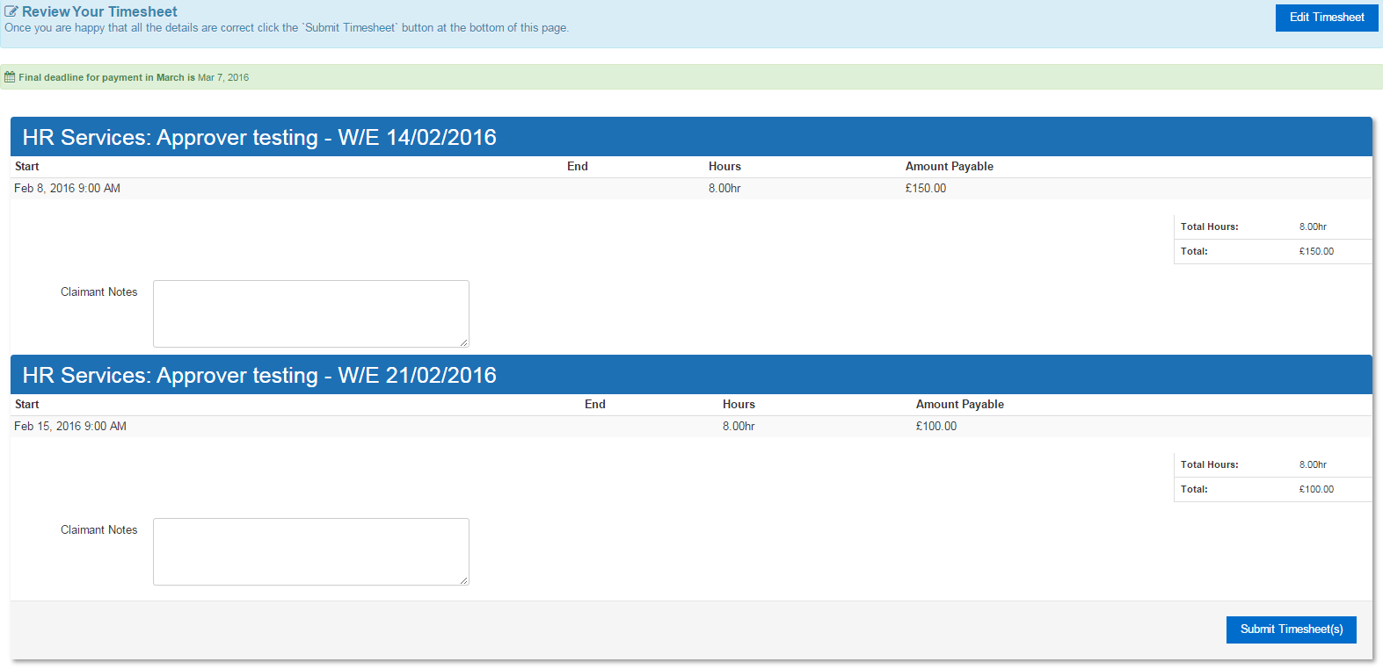
- If you notice an error you are able to edit the claim by clicking Edit Timesheet. If you are happy that these entries are correct please click Submit Timesheet(s)
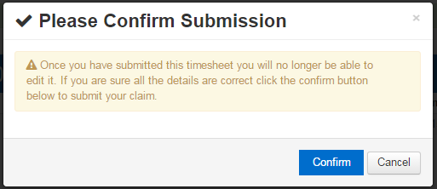
- You will then be asked to confirm submission of these timesheet(s) press Confirm

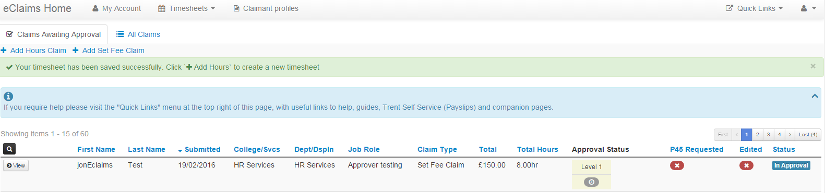
- Once your timesheet has been confirmed you will not be able to edit this claim again. However your approver can, so please contact them if you notice an error.
You will then be taken to the claims awaiting approval screen to see your claim is now awaiting approval.

eClaims Notification emails
- If the claim has been approved you will receive this notification

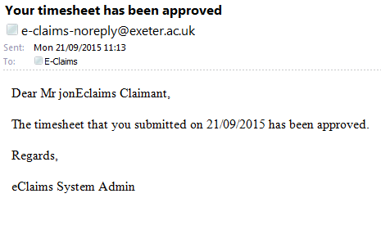

- If the Claim has been rejected you will receive this notification with rejection reason.
