eClaims - Quick Guide to Create an Hours Claims timesheet
* We recommend that you submit your timesheets weekly to ensure a deadline is not missed. *

Please Note: Once your timesheet has been submitted, you cannot change this and your claim would need to be edited by your line manager or rejected to be able to re-submit your claim.

Add Hours Claim
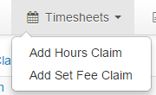

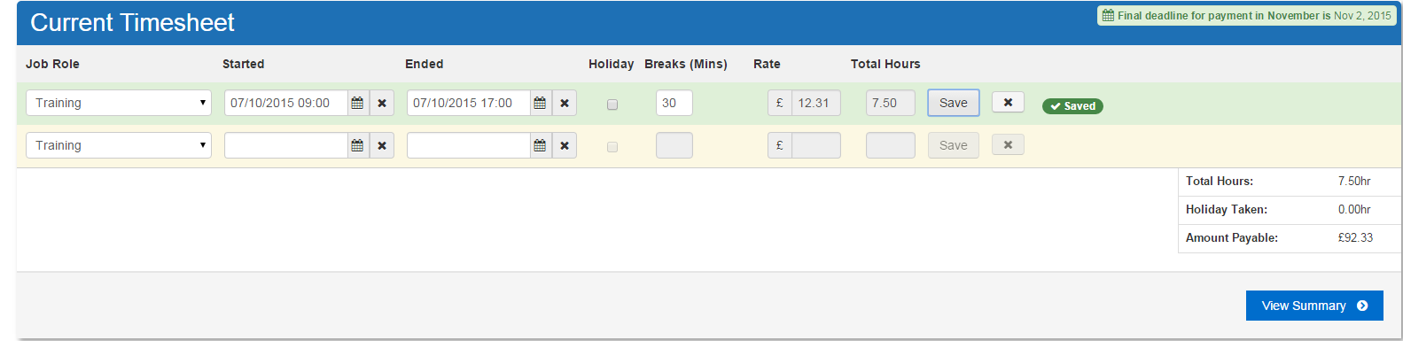
Hour Claim Timesheet
1
2
3
4
5
6
7
8
- Choose your Job Role
- Enter your day’s start date and time
- Enter your day’s Finish date and time
- Enter your Break (You must take a minimum break of 20 minutes after 6+ hours of work each day – breaks are not paid)
- Your Rate and Total Hours will be calculated automatically
- Click Save against every individual row entered
- Once saved a new row will be added (Click X to delete a row)
- When all Rows are enter click View Summary

View Summary
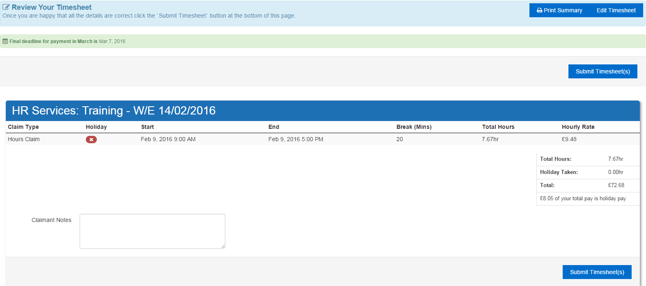
2
3
4
5
5
11
- Confirm that your Summary sheet is correct
- Edit timesheet if it appears incorrect
- Print Summary of Timesheet
- Add claimant notes for your approver
- Submit Timesheet

Please Confirm Submission
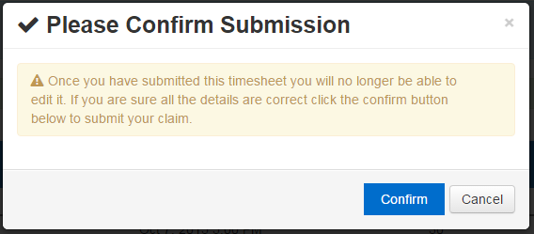
- Once this has been confirmed, the claim has been submitted and will be awaiting approval. You can track the status of this claim from the claims awaiting approval screen and my accounts page.

