Reference guide to recording phased return following
sickness absence
(Sickness Co-ordinator access only)
After a long term absence Occupational Health may recommend that an employee’s return to work be phased in order to help restore confidence and help them readjust gradually to work. A phased return is where less than the contractual hours are to be worked for an initial, defined period (not normally exceeding three months). A phased return must be properly structured and the OHA/HR Business Partner/Manager/Advisor will offer advice and guidance to managers to assist in drawing up a return to work programme for the employee.
A phased return may also be recommended by the employee’s GP on their fit note.
Where a phased return is recommended, issues to be considered by the manager, with the advice of their HR Business Partner/Manager/Advisor, include the nature of the work, the hours to be worked, remuneration and the duration of the arrangement.
Where the Occupational Health Service have recommended a phased return to work, the employee may use any untaken annual leave entitlement or carried forward untaken statutory leave on the days when they will not be attending work. Alternatively this may be counted as sick leave or unpaid leave or as part-time work, according to the circumstances and the employee’s entitlements. (Unpaid leave and part-time work may affect pension contributions). These arrangements should be confirmed in writing.
If the College/Service does not deem a phased return to be reasonable then a discussion needs to take place with the line manager and HR Business Partner/Manager/Advisor to consider business as well as employee needs. There is no right for an employee to have a phased return to work and this option should only be used in exceptional cases.
Recording phased return:
Navigation: From the home screen select
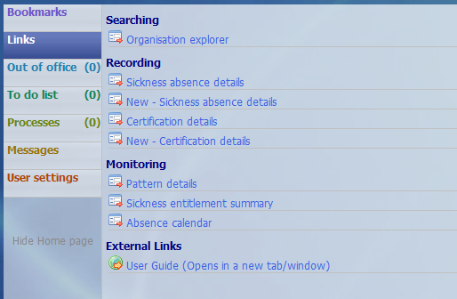
Action:
- For phased returns you will be required to enter each day separately.
- You will be prompted to enter the surname of the employee.
Upon doing so there will be two panels – the left-hand side will show a record of any previous absences and the right-hand side will show the screen below.
- ‘Sickness period’ – If the phased return is for less than the employees full working day select ‘Part day’ otherwise select ‘Full day’.
- ‘Absence start date’ – Enter the appropriate date
- ‘Absence start type’ – select ‘Part day’ (this section will only apply if you selected ‘Part day’ under ‘Sickness Period’
- ‘Hours absent’ – Enter the number of working hours absent in hours and minutes, eg enter 3:18 for 3 hours and 18 minutes.
- ‘Absence type’ – Select ‘Sickness (Phased return)’
- Enter ‘Absence reason’
- Click Save
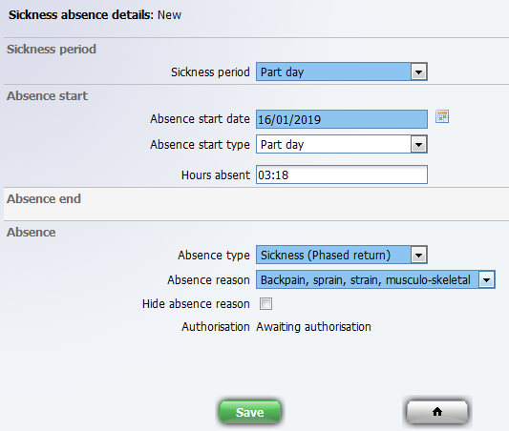

If you experience any problems please contact humanresources@ex.ac.uk.

