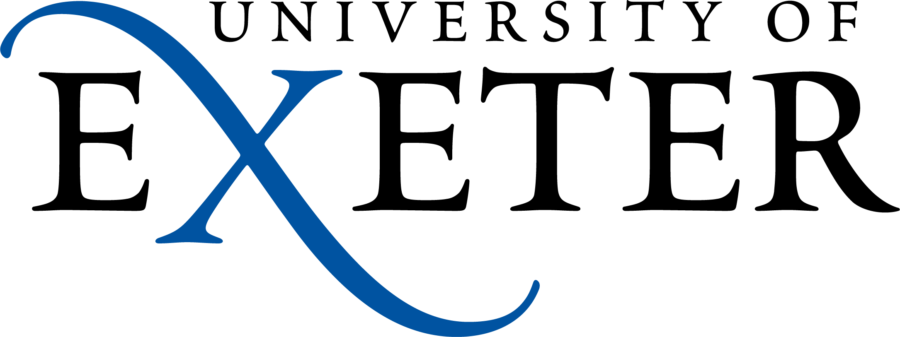

Performance and Development Planning and Review

Name of reviewee:
Job Role/Title:
Name of Reviewer (and job title/role):
Additional Reviewers:

Dates covered:

Performance and Development Planning and Reviews for staff
- This document provides a framework to support ongoing conversations about performance and development in the workplace. This planning form can be used by colleagues to guide conversations and record any decisions or actions as needed.

- The form can be downloaded and amended to suit your conversation and local/personal need. You might not wish to comment on all sections but it provides a guide for those areas that should be discussed, even if it is to confirm no action is required.

- Approach: While it is helpful to dedicate some time to have a longer biannual review, conversations about the topics listed should be held regularly throughout the year – this document can be used to record your comments, thoughts and reviews and in turn inform all conversations, highlighting and noting particular points as required.

- Timings: Consider how timings of the conversations will best work in your role and department. Identifying a 12 month review period can be useful however conversations should happen continuously throughout that period, not just at the start and end. Some objectives might be ‘rolling’ and constantly updating and therefore this information should be regularly revisited.

- Training and guidance is available on the main Staff PDR webpages for all staff, which includes advice about how to prepare for your conversations, either as the manager/reviewer or the reviewee. The PDR booklets for Reviewers and Reviewees are a great place to start and all managers must complete the relevant PDR Training for Reviewers .

- Where to store this form? As a reviewee this is your personal planning form and as such is confidential between yourself and your manager/reviewer. Once you start to populate the form it should be saved in your own area with ‘sharing’ and ‘editing’ access given only to those agreed with your reviewer. A number of collaborative options are available in the Office 365 suit such as:
  - OneDrive
  - OneNote
Ensure you only share the document with those who you want to give access, usually that will be just you and your reviewer, or if you are in a matrix management set up or have worked with another manager on a project you might want to share with more people to enable wider comment.

The following areas should be discussed:

Aspirations for the future:

What might be included in the conversation?: Career ambitions, next step and readiness, work preferences, long term development. Consider your longer term career goals and plans for the next 3-5 year period, remember to include any learning and development needs and to pull them into the Personal Development section.

Useful Resources: The 5 Minute Career Action Plan – this might help focus your thought process and plan for the conversation. The Exeter Professional site offers information about PS careers at the university and the Exeter Academic site does the same for Academic and Research colleagues.

Recording the outcomes:

Area discussed | Key points raised | Action points

Review of objectives, feedback and planning:

What might be included in the conversation?: Consider what went well and why, have you learnt any new skills and how can you develop and use them? What didn’t go quite so well, why not, were there resource constraints, skills gaps or problems with collaboration? How can you build on the knowledge, skills, behaviours and experience you have learnt and developed? Consider the impact of the pandemic on work and career. Remember that feedback should be two way.

Useful Resources: Make feedback work for you . Also see the advice about feedback in the PDR booklets: Reviewers and Reviewees

Recording the outcomes: you might want to comment on specific objectives or more general subject areas of your work.

Objective/Area discussed | Key points raised | Review comments / Actions / development areas identified

Objectives – standing, new or updated objectives:

What might be included in the conversation?: Do you have clear tasks/objectives which are challenging and achievable? Are they SMART? Are you able to deal with your workload? Do you have any suggestions for improving the way your work is carried out? Do you feel encouraged and supported by colleagues and managers in your team? Do you have the information, tools and training needed to carry out your work?

Useful Resources: Consider Strategy 2030 and the University Values. Departmental and College plans. Check your job description – what have you been asked to do? Also see the advice about creating objectives in the PDR booklets: Reviewers and Reviewees . Colleagues who have previously used the Academic Dashboard link in the ePDR system will still be able to view this dashboard from the MI Hub.

Recording the outcomes:

Standing objectives: These might be objectives that are always required of your role and do not change between years:

Agreed Objectives | Detail | Timescale and resources | Updates and reviews

Additional or new objectives: These might be additional objectives, projects, subject areas or work that change or are new each year (or are added throughout the year).

Agreed Objectives | Detail | Timescale | Updates

Wellbeing and Positive Work Environment

What might be included in the conversation?: A positive working environment is a happy, healthy environment where your wellbeing is good, you feel engaged with the University to be the best you can be and you can bring your ‘whole self’ to work. This is an opportunity to raise any element of your working environment that you feel could be improved or any concerns about.

Useful Resources: Positive Working Environment, Health and Wellbeing, Dealing with stress, Managing Wellbeing standard, Workplace Pressures Risk Assessment Tool, Flexible working. Colleagues are also encouraged to read through the differential impact information for Academic and Research colleagues and Professional Services colleagues to better understand the effects of the pandemic on careers.

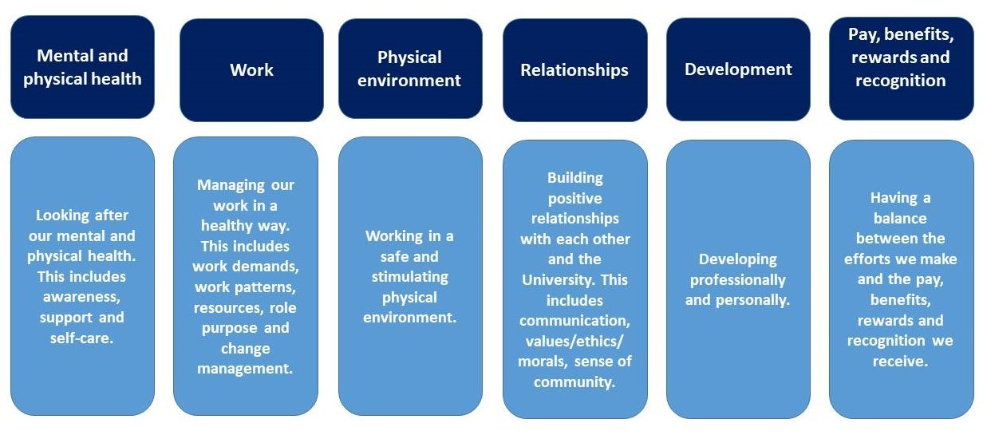

Recording the outcomes:
Area discussed | Key points raised | Action points

Development

What might be included in the conversation?: Consider what development opportunities could help you in your role, in achieving your aspirations for the future and in achieving your objectives. Think about wider development/training on offer, this could be mentoring, on the job training, face to face courses etc. Look back over the other sections of this document and identify any learning opportunities or needs.

Useful Resources: Learning & Development, Apprenticeships, LearnSmart, Mandatory training

Training reports: Click here to access your training report, please ensure your mandatory training is up to date. Depending on your grade and role, there may be other training that is essential to your role.

Recording the outcomes:

Development need | Delivery / learning method | Who will organise it? | When would you like to have completed it? | Resources required? | Update / comments

Additional discussions:
Note below additional areas you might wish to cover, they may be specific to your role, location or personal needs or concerns.

Requirement / Discussion Point | Outcome/Action

Consolidate Actions:
If required you can use the table below to summarise any actions that need to be taken forward:

Action | Date to be completed or reviewed: | Who is leading/organising?

Sign off:
It is advised that you sign the form when the initial objectives are agreed.

Staff member name, signature and date
Manager /person carrying out review name, signature and date

