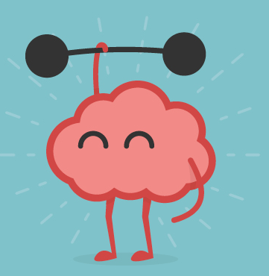
RESEARCH PARTICIPANTS REQUIRED
Are you 12-18 years-old?

Have you had a brain injury?

Are you experiencing low mood because of your brain injury?

It is normal for young people to feel low in mood if they have had a brain injury. Many young people say that their low mood affects their quality of life and their ability to take part in social activities. We want to help!
There is a ‘behavioural’ treatment, where young people get taught some new skills for activity planning and scheduling, which improves their mood. We are trying to see if it works for young people with brain injury too.

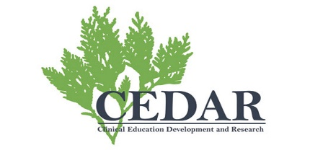
IF YOU ARE SUITABLE FOR THE STUDY AND FINISH IT FULLY, YOU WILL RECEIVE A £50 AMAZON VOUCHER!
INTERESTED?
Please contact Conor O’Brien
Call or text: 07961 621 696
E-mail: co359@exeter.ac.uk

