Student Communications toolkit
February 10, 2022
Hi
Welcome to your first, fortnightly Student Comms toolkit. Below you’ll see a range of messaging you can use in your channels to students.
Further down the email you’ll see some key messages for staff, which will help them to signpost information to students.
We’d love to hear your feedback as to how to improve this to help you and/or if you have any further questions please contact studentcomms@exeter.ac.uk

MESSAGES FOR STUDENTS

Subject: A-Z of student support services
Background: The A-Z is featured on the ‘current students’ section of the University website and links out to a wide range of specific pages to provide information on some of the services and advice identified as important to students across our campuses

Newsletter copy
Where do I find..? Who can I ask about..? How can I contact..?
Looking for information and not sure where to go? Start with the A-Z of support and services on our student webpages. Use the alphabetical list to find the information you need, from accommodation to the health centre, IT to wellbeing support - and everything in between. It’s your first port of call to find useful information and advice.
https://www.exeter.ac.uk/students/az-services/
Images
Attached to email
Devon:

Cornwall images:

Facebook copy
Looking for information and not sure where to go? Start with the students’ A to Z of support and services. From accommodation to the health centre, IT to wellbeing support and everything in between, it’s your first port of call to find useful information and advice.
https://www.exeter.ac.uk/students/az-services/
Twitter copy
Looking for info? Not sure where to go? Start with the students’ A-Z of support and services. From accommodation to health centres, IT to wellbeing and everything in between, it’s your first port of call for information and advice. www.exeter.ac.uk/students/az-services/
Instagram copy
Looking for information? Start with the students’ A to Z of support and services on the University’s website. From accommodation to the health centres, IT to wellbeing and everything in between, it’s your first port of call for information and advice. Search ‘students a-z' at exeter.ac.uk.
Instagram hashtags to be included as the first comment on the post
#Exeter #ExeterUni #ExeterUniversity #LoveExeter #ExeterForever #UofE #UniversityOfExeter

Subject: iExeter
Background: we’re aiming to encourage students to download the iExeter app, and make full use of its functions, for their convenience. If there are particular functions in the app that are relevant to students in your college, you can highlight them here too.

Newsletter copy – PLEASE DELETE Students’ Guild or Students’ Union as appropriate for the relevant campus. (The Students’ Guild is for students based in Exeter and the Students’ Union is for students based in Cornwall.)
iExeter - Your Uni in an app
Have you got iExeter on your phone or desktop? With so much more than just timetables, iExeter is your convenient, pocket-sized portal to your Uni in one handy app.
Simply sign in with your Uni login and you can,
- See your personal timetable
- Access your email, library and career zone accounts
- Book study space on campus
- Find the help, support and feedback channels available to all students
- Access teaching and learning tools including ELE, Teams, BART submissions, absence reporting and past papers
- See what’s happening around campus with events, food, retail and transport information.
- See maps of all campuses, and get directions using GPS
- Check out your Students' Guild/Students' Union and loads more.
If you’re not already using iExeter, download it now, free from iTunes App Store or Google Play and find out more on the University website.
Images
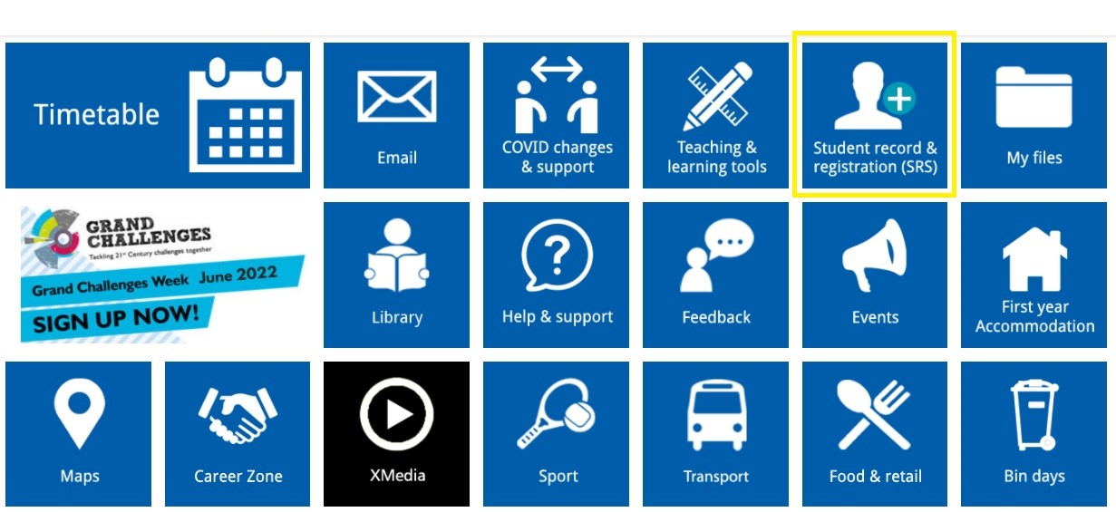
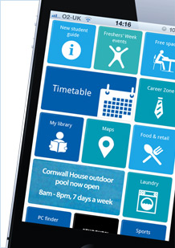

Social posts
Twitter
Have you got iExeter on your phone or desktop? It’s your handy, pocket-sized portal to your Uni in an app. Sign in with your Uni login and get access to your timetable, Uni accounts and loads of study, sport and social info. Download it now at www.exeter.ac.uk/students/iexeter/
Facebook – DELETE Students’ Guild/Students’ Union as appropriate for each campus
Have you got iExeter on your phone or desktop? With so much more than just timetables, iExeter is your convenient, pocket-sized portal to your Uni in one handy app.
Simply sign in with your Uni login and you can,
- See your personal timetable, email, and other Uni accounts
- Book study space on campus and get access to teaching and learning tools
- See what’s happening around campus with events, food, retail, transport, sports and social info
- See maps of all campuses, and get directions using GPS
- Find the help, support and feedback channels available to you
- Check out the Students' Guild/Students' Union pages and loads more.
If you’re not already using iExeter, download it now, for free from iTunes App Store or Google Play and find out more on the University website.
Instagram
Have you got iExeter on your phone or desktop? With so much more than just timetables, iExeter is your convenient, pocket-sized portal to your Uni in one handy app.
Simply sign in with your Uni login and you can get access to your timetable, Uni accounts and loads of study, sport and social info.
Download it now, for free, from iTunes App Store or Google Play.
Instagram hashtags to be included as the first comment on the post:
#Exeter #ExeterUni #ExeterUniversity #LoveExeter #ExeterForever #UofE #UniversityOfExeter
If posting on accounts associated with our Cornwall campuses, please include the following hashtag:
#Cornwall

SOCIAL MEDIA
For the latest messages from the University and its partners, please also like and share posts from our student and corporate social accounts
If you have questions about these, please contact the social media team on Socialmedia@exeter.ac.uk
Students  www.facebook.com/exeterunistudents  twitter.com/exeter_students  instagram.com/uniofexeterstudents | Corporate  www.facebook.com/exeteruni  twitter.com/UniofExeter  Instagram.com/uniofexeter | Cornwall  www.facebook.com/uniexecornwall  twitter.com/uniexecornwall  Instagram.com/uniexecornwall

MESSAGES FOR STAFF
The latest student enewsletter Uni Updates can be seen here. It is sent to students weekly (Mondays) during term time. if you have an event or possible story for inclusion please email studentcomms@exeter.ac.uk (deadline is the Wednesday COB prior to the next newsletter going out)
Signposting to students
Looking to signpost services or information to your students? Take a look at our A-Z guide for students, which is packed with relevant links and should help you find the info you are looking for. If you think there’s something missing, please contact studentcomms@exeter.ac.uk
Mitigation – short film
If you need to explain mitigation to your students, this short film from the mitigation web pages gives a simple, brief summary. It emphasises our advice to students that wherever possible it is best to think about the decision and to speak to someone before applying – be that a personal tutor, loved one or friend, Guild/SU advice team and so on. (We appreciate that in emergency situations this may not be possible).
Share stories with us
The Student Comms and Social Media teams are on the lookout for good student stories, particularly any which relate to our education offer. These might be used on social media, as website articles or as podcasts (subject to permissions). Share your ideas at studentcomms@exeter.ac.uk and/or socialmedia@exeter.ac.uk
The next toolkit will be shared with you on Thurs 24 February.

