Student Communications toolkit
24 February 2022
This is your fortnightly Student Comms toolkit. Below you’ll see a range of messaging you can use in your channels to students.
Further down the email you’ll see some key messages for staff, which will help them to signpost information to students.
We’d love to hear your feedback as to how to improve this to help you and/or if you have any further questions please contact studentcomms@exeter.ac.uk

MESSAGES FOR STUDENTS
Subject: NSS
Newsletter copy:
Filled out the National Student Survey yet?
If you’re a finalist and you’ve yet to fill out the National Student Survey (NSS) we’d be glad if you would take the five minutes to do so. It’s an anonymous survey and an opportunity to reflect on the whole of your time with us. We take it very seriously and staff from your department will read the results to see how we can improve things. You can access the survey here.
Images:
Devon
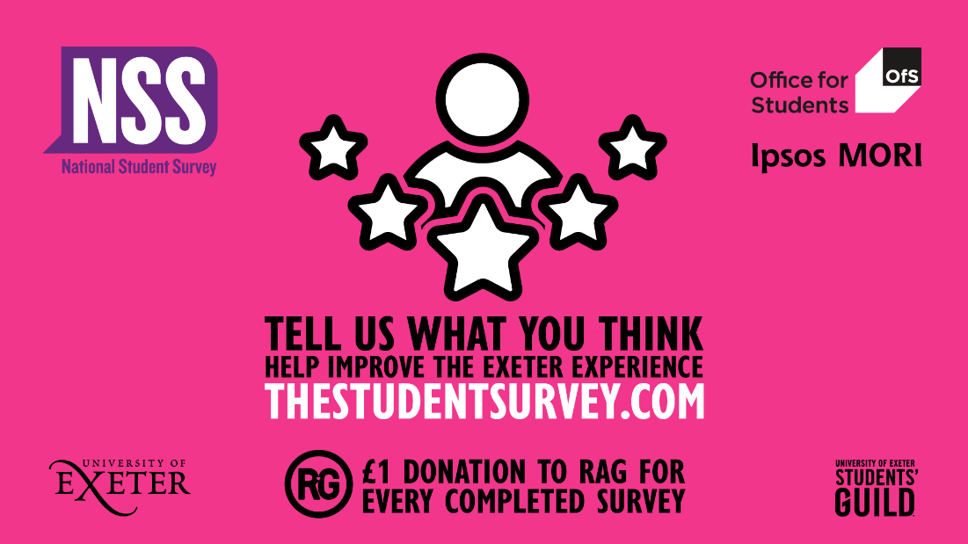

Cornwall
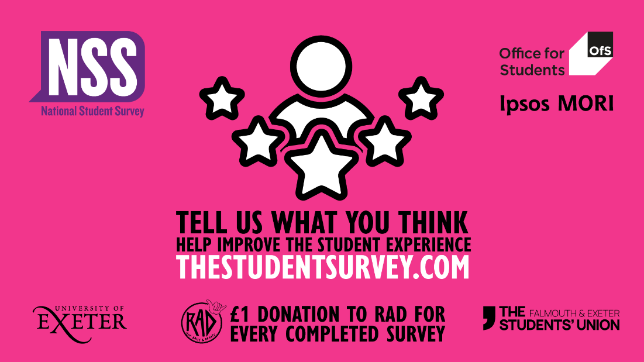
Twitter copy:
UG finalist? Can you spare 5 minutes to fill out the NSS? It’s a chance to reflect on your whole Uni experience and staff in your department read the anonymous results, to see how we can improve things. https://www.thestudentsurvey.com/
Facebook copy:
Take 5 and fill out the NSS
Are you a UG final year student? Could you spare 5 minutes to fill out the National Student Survey? It’s a chance to think about your entire time at the Uni and let us know what you think. Your anonymous feedback is read by staff from your department, College and the Vice-Chancellor. https://www.thestudentsurvey.com/

Subject: Mitigation
Newsletter copy:
Can't sit an assessment or exam because of illness or an emergency?
We know that sometimes a situation might occur which means you can’t complete an assessment or exam. We have a process that is here for you during these times called mitigation. This year there are two mitigation options available to you.
1) Evidence-free extension. For coursework assignments, you can add an extension of one week directly within the BART submission system. You don’t have to provide any evidence to support this extension.
2) Evidence-based mitigation. For exams and longer extensions, you will need to apply for evidence-based mitigation. The two main types of evidence-based mitigation we provide are a standard extension (up to three weeks) or a deferral.
Before you make any final decision, we recommend talking about it with someone. Please see our mitigation webpages for more info. If you have any questions, get in touch with your Hub/Info Point.

Images/Videos:
Mitigation

Twitter copy:
Can’t complete an assessment or exam through illness or an emergency? We have a process that can support you during these times called mitigation. This year there are two mitigation options available to you. Before you decide, we recommend talking about it with someone. Watch our short film or visit our webpages for more info: https://www.exeter.ac.uk/students/infopoints/yourinfopointservices/mitigation/

Facebook copy:
Have you had an illness or an emergency which means you can’t complete an assessment or exam? We have a process that can support you during these times, called mitigation.
This year there are two mitigation options available to you; an evidence-free extension in BART or evidence-based mitigation, which takes the form of either a longer extension (up to three weeks) or a deferral.
Before you make any final decision, we recommend talking about it with someone. Please see our mitigation webpages for more info: https://www.exeter.ac.uk/students/infopoints/yourinfopointservices/mitigation/
Instagram copy:
Can’t sit an assessment or exam through illness or an emergency? We have a process that can support you during these times called mitigation.
This year there are two mitigation options available to you; an evidence-free extension in BART or evidence-based mitigation, which takes the form of either a longer extension (up to three weeks) or a deferral.
Before you make any final decision, we recommend talking about it with someone. Please search ‘mitigation’ at exeter.ac.uk for more info.
Instagram hashtags to be included as the first comment on the post
#Exeter #ExeterUni #ExeterUniversity #LoveExeter #ExeterForever #UofE #UniversityOfExeter
If posting on accounts associated with our Cornwall campuses, please include the following hashtag:
#Cornwall

SOCIAL MEDIA
Upcoming social media campaigns:
- NSS - every Monday
- International Women’s Day - 8th March
We have a centralised communication plan for these campaigns, we would encourage you to share our posts. If you have anything you’d like us to share from your teams that you feel we can use in these campaigns, please drop us an email. Likewise, please let us know if anything you have planned so that we can work together.
For the latest messages from the University and its partners, please also like and share posts from our student and corporate social accounts
If you have questions about these, please contact the social media team on Socialmedia@exeter.ac.uk
Students  www.facebook.com/exeterunistudents  twitter.com/exeter_students  instagram.com/uniofexeterstudents | Corporate  www.facebook.com/exeteruni  twitter.com/UniofExeter  Instagram.com/uniofexeter | Cornwall  www.facebook.com/uniexecornwall  twitter.com/uniexecornwall  Instagram.com/uniexecornwall

MESSAGES FOR STAFF
The latest edition of University Updates can be found here. It goes out to all students every Monday during term time. If you have an event/info for Uni Updates please send it to studentcomms@exeter.ac.uk (deadline is 5pm on the Wednesday before the next edition).
International Women’s Day (8 March). If you have something you’d like shared or included on our central social media channels, please can you let the social media team know in advance (you don’t need the final copy or materials at this time) as this will help them to plan the day. It’s hard to accommodate requests on the day itself. Contact them at socialmedia@exeter.ac.uk
Remember the A-Z guide. The A-Z guide is shared with students to help them find info and services they need and you might find it handy if you’re trying to signpost your students too. If there’s something you think should be included, drop the student comms team a line at studentcomms@exeter.ac.uk
Share stories with us
The Student Comms and Social Media teams are on the lookout for good student stories, particularly any which relate to our education offer. These might be used on social media, as website articles or as podcasts (subject to permissions). Share your ideas at studentcomms@exeter.ac.uk and/or socialmedia@exeter.ac.uk
The next toolkit will be shared with you on Thursday 10 March.

