Finding the Training Suite on Level 1 of the Forum
The easiest way to access the Training Suite is via the Great Hall Piazza entrance to Level 1 of the Forum. Follow the curve of the path round until you see the push button double doors (picture 2 below).
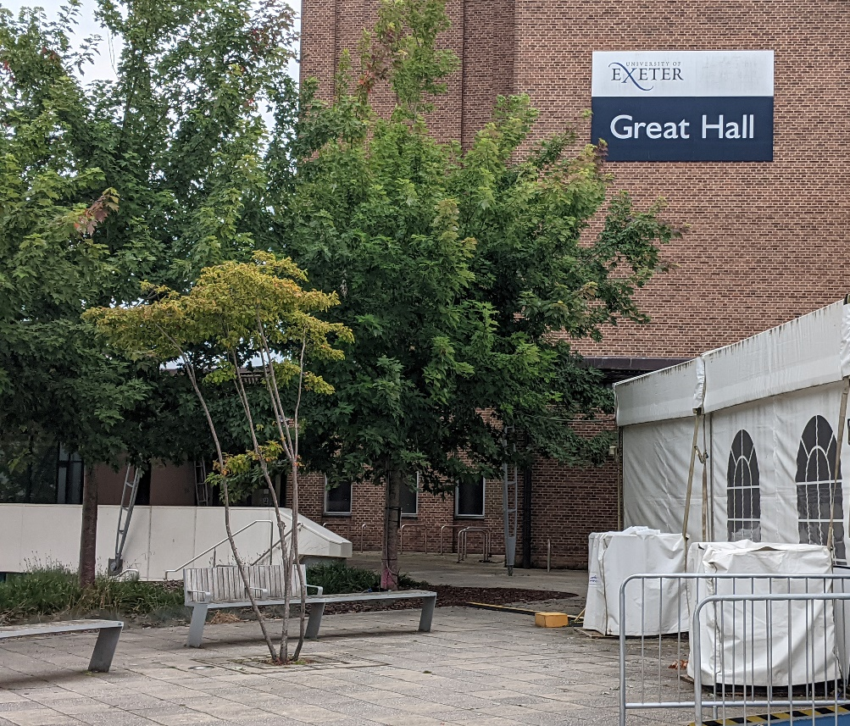

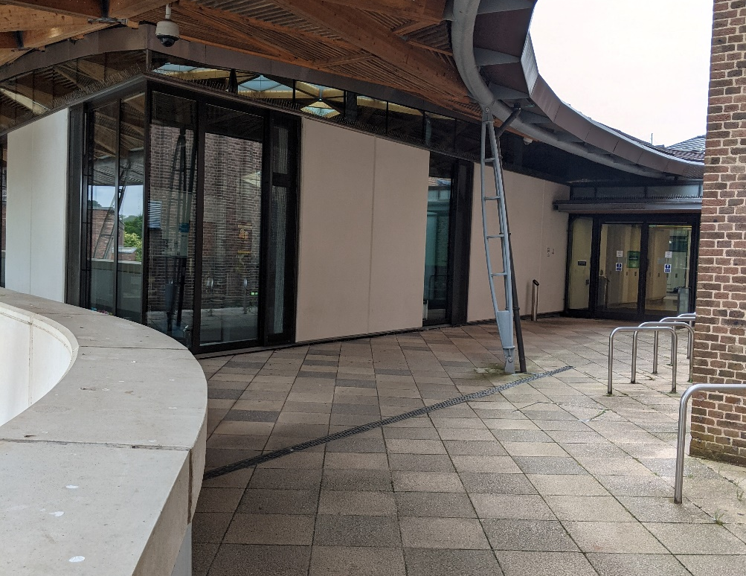
Enter through the doors, go straight on and then take the first available left turn (next to the Forum Information Point desk).
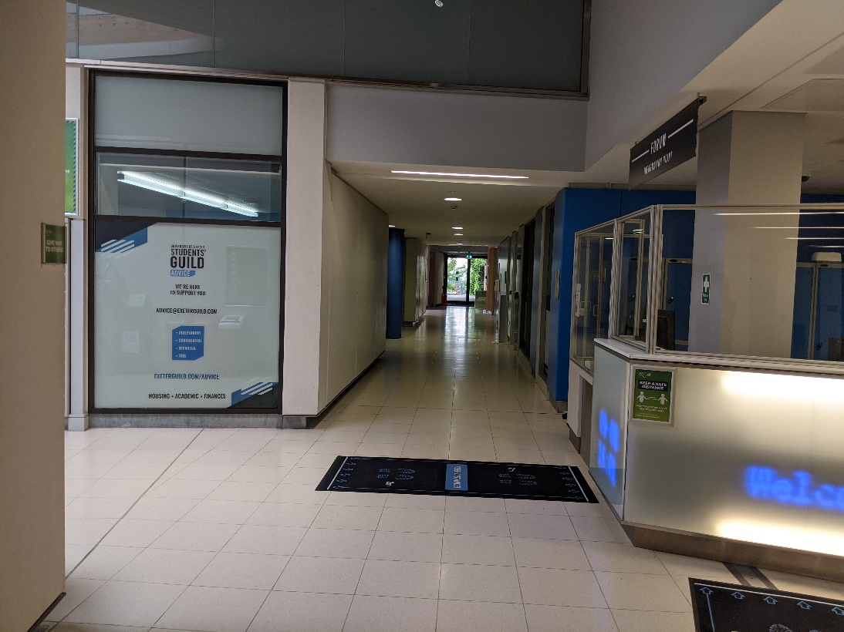
Go through the door marked below and then through another door straight ahead of you, and the entrance to the Training Suite will be on your right. We will put additional signs up on the door below to help guide you.
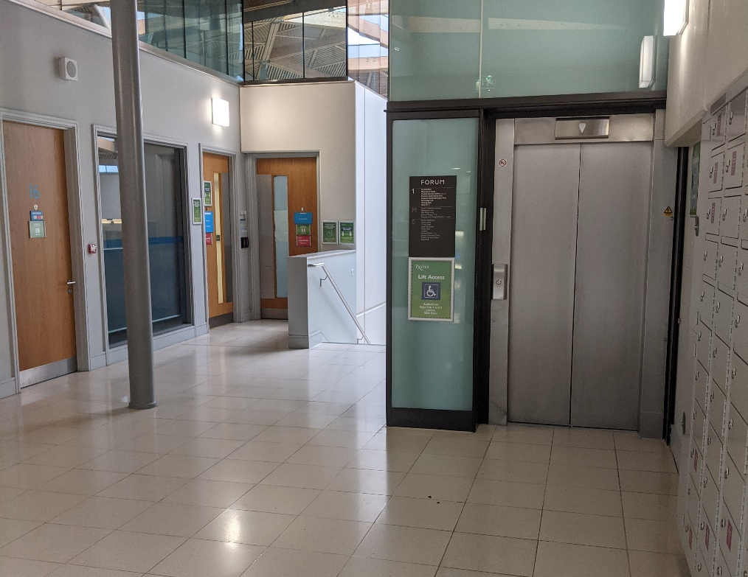
An alternative route is from the ground floor (floor 0) of the Forum. You can take the lift which is to the left of the SID desk up to level 1 and emerge as above, or you can use the set of stairs next to the entrance to the library. Turn left at the top of the stairs and if you follow the walkway and go up the next set of stairs, you will emerge next to the doors above.

