Welcome to the December EduExe newsletter!

The EduExe Newsletter is a new initiative for all colleagues involved in education, focusing on news, updates and all things educator development and enhancement. This monthly newsletter will include relevant articles and resources according to the time of the academic year, updates on strategic projects, reminders of key deadlines (i.e. for module amendments) and much more!
This issue we have articles and resources on:
- Update on the first meeting of the PTA co-ordinators forum
- Spring registration for LTHE
- Supporting students with exams and assessment
- Self care for educators
- NSS 2024
- Useful guide to finding academic and pastoral support
- Faculty and department support from Educator Development
- On EduExe socials this month
- Five days of feedback round up
- EduExe wordle challenge - the answer and a special christmas challenge!

Update on the first meeting of the PTA co-ordiantors forum
We launched the PTA Co-ordinators Forum in October 2023, following the recommendations of the NSS Assessment and Feedback project. The purpose of the PTA Co-ordinators Forum is to:
- share best practice across faculties and departments
- stay up to date with emergent practice across the university
- raise concerns through reporting to the Learning Futures Institute Steering Group, and in turn the Education and Student Experience Executive Committee
- provide a supportive space for PTA Co-ordinators to develop their practice.
- provide a conduit for information to and from the PTA community
At out first meeting we discussed a range of issues, including:
- The scope of the PTA co-ordinator role, and practices across the university
- The relationship between central mandatory training for PTAs (LTHE) and local training
- The need to clarify the rules and regulations around LTHE completion and undertaking teaching for PTAs
We hope to keep you updated on the activity of the group, which will meet termly.

Spring registration for LTHE
Places are available for the Spring term Learning and Teaching in Higher Education (LTHE) programme, running from January – March. If 2024 is the year where you, your colleagues, or your PGR students are looking to take some initial steps into teaching, then the LTHE programme is here to support.
LTHE offers an active, practical and enjoyable environment to learn from, and collaborate with colleagues from across the university. The programme’s five short units offer an introduction to a range of teaching essentials, including:
- Developing student-centred, inclusive and constructively aligned teaching sessions
- Assessment, marking and feedback practice
- Reflective practice and developing your identity and values as an educator
Although our on-campus programme at Streatham is now full, we have several places remaining on our Penryn course, as well as on our online version of the programme, which will also be running next term.
For more information on LTHE, or to register for the programme, please visit our SharePoint site.
“What a fabulous course for educators!”
“Being able to work with my colleagues was very valuable”
“The feeling of having a community really makes me want to engage more”
“Everyone was so friendly and willing to share and discuss”
“I liked the group discussions to share different teaching practices. It was helpful that these perspectives came from different disciplines as this created more diversity of ideas”
“Excellent presentations and leading of discussions”

Supporting students with exams and assessment
Study Zone Digital have some excellent resources that can support students in preparing for their January exams and assessments, including:
- Preparing for exams and assessments
- Creating a revision timetable
- Revision strategies
- Preparing for effective revision
- Guide to open-book exams
- Practising exam questions
- Exam questions - written answers
- Exam questions - MCQs
- Reviewing past exam performance
There are also exame support resource for Academic Personal Tutors on the EduExe Toolkit.

Self care for educators
While teaching is extremely rewarding, there is no question that it can also be hard. It is important to recognise that, and to ensure that you make time to look after yourself. Here are 5 ways to wellbeing at Exeter from Dr. Karen Kenny, Senior Educator Developer:
- Connect - there are lots of ways to connect with colleagues, and to meet new people across all campuses. Take a look at the Activities and Groups advertised via Staff Life
- Be active - consider taking up a sport, there are lots of different memberships available across our campuses., Or if that isn't your thing, maybe join the gardening or walking groups, that can help you to Connect while being active.
- Take Notice - Taking notice can be simply paying attention to your surroundings during your walk across campus, and we do have beautiful campuses. Streatham, St Lukes and Penryn campus maps can give you some ideas, or follow the Sculpture Walk. There are also mindfulness sessions that you can sign up for, to help you to find focus. Our three campuses also have nature walks, why not block out some time in your schedule to take a relaxing walk around Streatham and St Lukes or Penryn.
- Learn - well we are a university, there are lots of opportunities to learn! But learning doesn't need to be academic, why not learn a language, take up a new sport, take up knitting or crochet, take a free course from the Open University, or look at the possibilities at Exeter Phoenix or check out Falmouth Creates
- Give - volunteering across the Southwest is an amazing way to boost your wellbeing while at the same time you are supporting those in our community who are most in need. There are lots of possibilities in Exeter and Penryn, from volunteering in a charity shop (counter work, sorting vintage donations, or helping with admin), to befriending or advocating for those in need. If historic buildings are your passion, why not find one near you and enquire, for example, Poltimore House near Exeter would love to have more volunteers. Some of us are suited to the more challenging work of the Samaritans.
You may also find this book chapter interesting from Kelly-Louise Preece, our Head of Educator Development, on self-care and resisting the culture of overwork in Higher Education
Find out more about self-care and staying well on the University website

The National Student Survey 2024
The University will launch the National Student Survey (NSS) 2024 on Monday 15 January with an email from the Vice-Chancellor. The NSS is open to all finalist undergraduates to complete until Tuesday 30 April. Eligible students can choose to enter a prize draw, with a first prize of £500 and 10x £50 prizes. £1 will also be donated to charity for every completed survey, which led to £4,351 being donated last year.
There will be publicity and promotional stands across the University, however we welcome colleagues promoting it to their students. If you do promote it, you must understand what you can and can’t say – what constitutes inappropriate influence. There is a recording of a Teams presentation which outlines what you can and can't do and you can watch that here. The inappropriate influence guidance is on the website within the promotion section. Please note, this information is for staff only. If you run a meeting where completion rates are discussed, you must email studentcomms@exeter.ac.uk stating why it was discussed, when and who attended.
Have a question about promoting the NSS? Slides for lectures will be on the website soon and/or get in touch with the Student Communications team at studentcomms@exeter.ac.uk
If you can delay sending emails to final year undergraduates on Monday 15 January that would be appreciated.

Useful guide to finding academic and pastoral support
As part of the wider Student Academic Support project, an infographic poster for colleagues and students that signposts support services across our campuses, has been created in collaboration with colleagues from across our University. The infographic, which covers issues around both personal and academic information, has been developed in conjunction with a pilot initiative for pastoral support in Physics, and in the Department of Humanities and Social Sciences (HASS) Cornwall with an ambition to expand to other departments. For any questions around the infographic, please contact Ciaran Stoker.
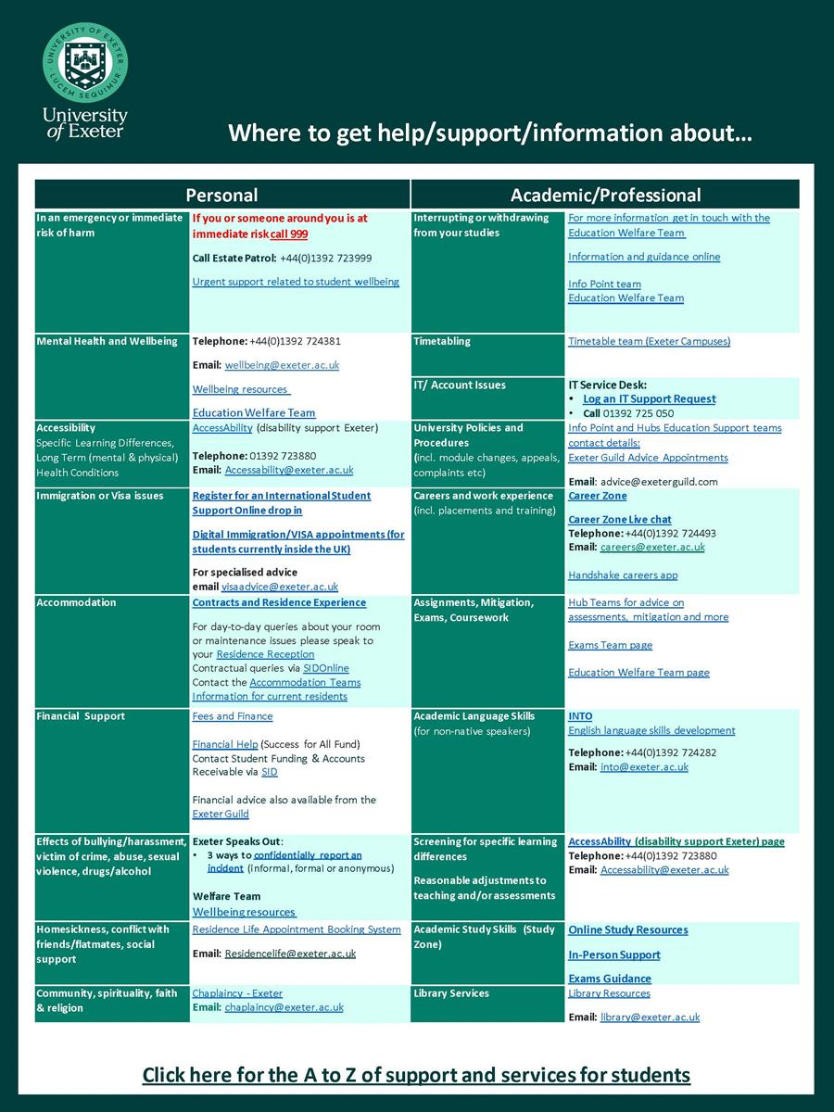

Faculty and department support from Educator Development
The Educator Development team provide in-faculty support in a wide range of formats. This can include bespoke workshops, writing retreats, consultations and resource development! Each Faculty has a named liaison contact they can approach for advice and support:
- HASS - Dr. Eleanor Hodgson E.M.H.Hodgson@exeter.ac.uk
- HLS – Craig McEwan C.McEwan@exeter.ac.uk
- ESE – Kelly-Louise Preece k.preece@exeter.ac.uk
- Professional Services - Dr. Karen Kenny Karen.Kenny@exeter.ac.uk
We are in the process of developing a series on 'menus' of support we can offer. We currently have the following:
- Menu APT
- Menu assessment and feedback
- Menu reflective
- Menu doctoral supervision
- Menu AI
- Mneu Inclusive
- Menu Innovative
- Menu transformative
If you would like us to support your department in these or any other areas, please get in touch with your named Faculty Liaison on email us on eduexe@exeter.ac.uk.

On EduExe socials this month
EduExe continues to grow our social media presence, sharing updates, best practice and discussing current issues in Higher Education. This month we shared blog posts on:
- Taking account of student experiences of eco-grief and eco-anxiety when incorporating sustainable development goals into teaching - Julie Pepper and Katherine Ashbulby
- Becoming an expert learner - Caroline Keenan
- Embedding professional skills development into module/programme design - Nicky Thomas and Fiona Hartley
- Gamifying review sessions: helping students integrate their learning in a supportive, enjoyable environment - Alison Hill and Nic Harmer
- ‘Melanin Matters’ - A student-led skin diversity project - Natasha Syed
Don't forget you can follow us on LinkedIn for updates!
Read the EduExe blog
Listen to the EduExe podcast

Five days of feedback roundup
In case you missed it, here's a round up of our five days of feedback advice and guidance as articles on our LinkedIn page:
- Day 1 - Constructive
- Day 2 - Specific
- Day 3 - Consistent
- Day 4 - Scalable
- Day 5 - Kind

The EduExe Wordle Challenge - the answer
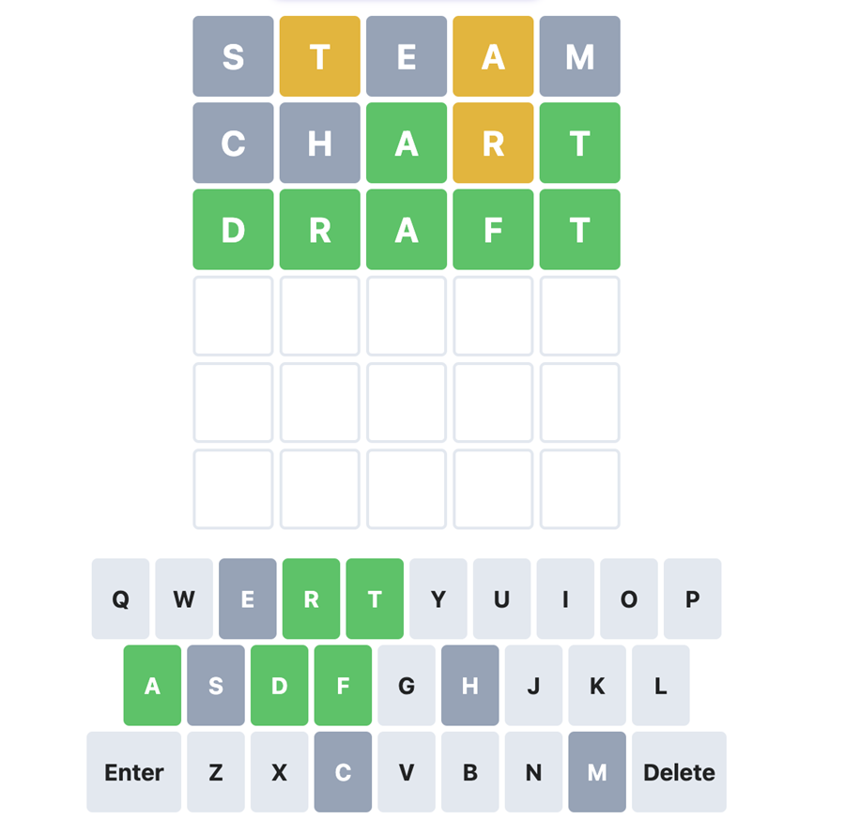

Christmas Linkee Challenge
Linkee is a trivia-based game where players answer four questions and then find the link between those answers to identify the keyword (the Linkee!). We've designed a special Christmas Linkee - here are your four questions:
- What is the new name for the Exeter Education Innovation Institute?
- What team supporting the delivery of the ASPIRE Framework?
- What is the name for the scheme where students get involved in projects to improve their university experience?
- What's the name of the form to approving new degree programmes?
So...what's the Linkee? You can play online!
If you know the Linkee, email us on eduexe@exeter.ac.uk to claim your free EduExe coffee cup or lanyard in exchange for the correct answer!
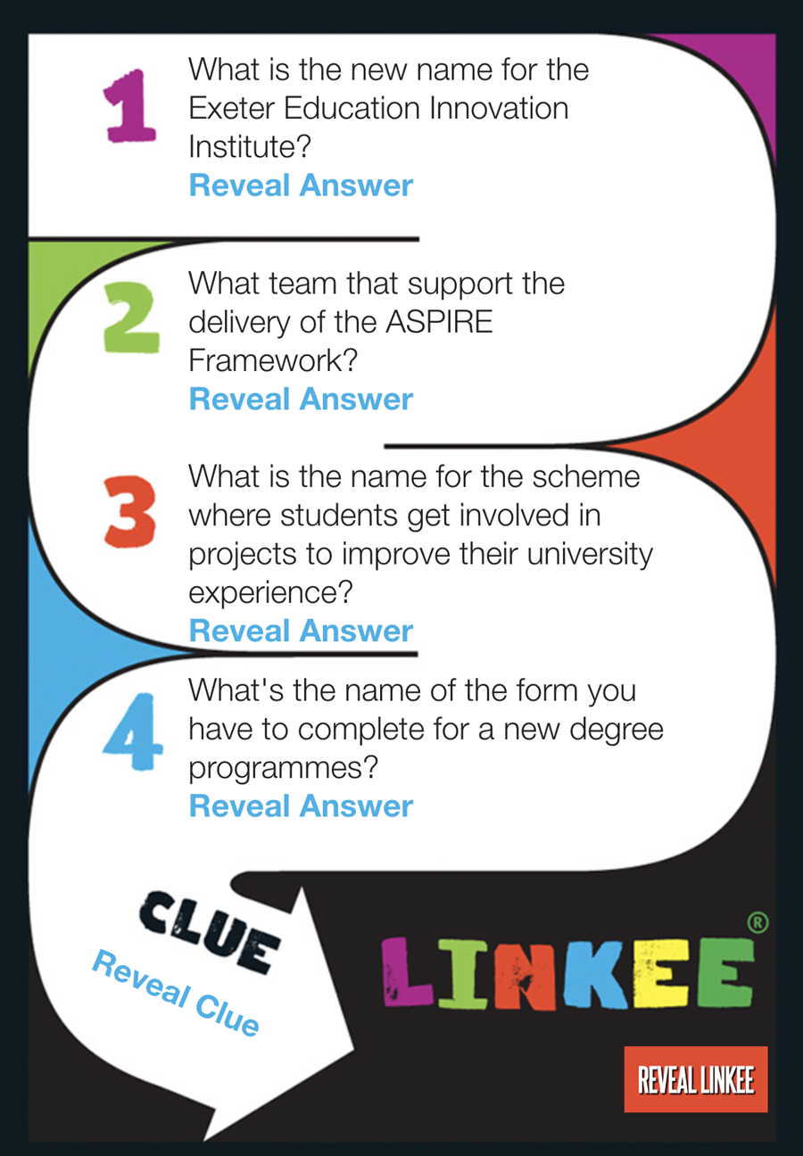
Play our Christmas Linkee now!

Interested in contributing to the newsletter?
We will have rolling deadlines for submissions each month, so please get in touch with eduexe@exeter.ac.uk if you would like to contribute!
We want your feedback!
The EduExe newsletter is a new initiative, and we would love to hear from you if you have any feedback! You can share it with us anonymously on our feedback form or by email to eduexe@exeter.ac.uk.

Follow us on social media or visit our website to find out more about educator development and enhancement at Exeter!

Join the EduExe teams site for connect with educators across the University

