Welcome to the February EduExe newsletter!

The EduExe Newsletter is an initiative for all colleagues involved in education, focusing on news, updates and all things educator development and enhancement. This monthly newsletter will include relevant articles and resources according to the time of the academic year, updates on strategic projects, reminders of key deadlines (i.e. for module amendments) and much more!
This issue we have articles and resources on:
- Curriculum for Change (C4C) design principles
- LGBTQ+ History Month - resource spotlight
- Feedback festival
- Using assessment feedback - student resource
- Some reflective questions to set your students post-feedback
- Preparing for module amendments - reimaging assessment in the age of AI
- Innovative assessment case studies
- ASPIRE PRP deadlines 2023/2024
- Doctoral Supervisor training programme launch
- Space travel - inspirational learning spaces
- Annual Review of Teaching Scheme (ARTS)
- BME network workshop
- THE campus call for content
- Upcoming events
- On EduExe socials this month
- Taskmaster challenge - the winner
- February challenge!

C4C Design Principles
Our Education Strategy set a priority to articulate a distinctive model for education at Exeter. With the introduction of Strategy 2030, this has evolved into Curriculum for Change (C4C) – a model that reimagines our curriculum to enable our students to become the global change agents needed to create a fairer, greener and healthier future. A key first step has been to develop the C4C Design Principles, which will be incorporated into all taught degree programmes. Having been approved by EdSEEC and UEB, we are delighted to announce the principles that will inform the C4C work as we moved forward.

C4C Design Principles
- Future Positive (fairer, greener, healthier, transformative education, global citizenship)​​
- Market-Leading (market demand, clear USP, internationally attractive)​​
- Skills Aligned (aligned to skills in demand, mapped to tangible skills, measuring gain in skills, skills portfolio, graduate outcomes)​​
- Efficient and Cohesive (hybrid, multi-modal, larger modules, module reuse across programmes, centrally created – locally deployed, reduced and smoothed assessment load through standardisation, interdisiplinary)​​
- Authentic and Experiential (based in real world challenges, flipped classrooms with active learning, problem-based, portfolio building, authentic assessment)​​
- Inclusive and Student-centered (partnerships with students, driven by student experience, EDI, belonging/mattering)​​
- High-quality (TEF, NSS, Aspire, student experience, quality rubrics/assessment criteria)​​
- Data-driven (Market data, student choice, NSS, cost to deliver, reputational impact)​
- Digitally-enabled (drawing the best of our EdTech, inclusive assessment, digital skills)
The next stage of work will be to develop course and assessment design principles to guide the further development and enhancement of student learning experiences. These will be announced in a future EduExe newsletter.

LGBTQ+ History Month - resource spotlight
To celebrate LGBTQ+ History Month, we wanted to remind colleagues of the LGBTQ+ Toolkit which can support educators in addressing gender identity and sexual orienation within learning environments. This resource is specifically designed to help educators create inclusive and supportive classrooms for LGBTQ+ students at Exeter, incorporating valuable insights from students and staff. This comprehensive guidance addresses key areas and essential topics like understanding LGBTQ+ terminology, pronoun usage, titles, and collective terms to ensure respectful communication.
Access the LGBTQ+ toolkit

Feedback festival 2024
The Feedback Festival will take place in the w/c 26th February. The festival complements the 5 days of feedback communications that went out to staff in w/c 11th December, and focuses on student-facing resources and activities to promote feedback literacy and engagement with feedback. It is also an opportunity to extend the work of the NSS Assessment and Feedback project, and collect data on student perceptions of feedback. The festival supports the work and communications around the NSS and is being led by the Educator Development team in collaboration with Faculties, Student Voice and Change and Academic Skills and will be delivered online and in person across our Streatham, St. Luke’s and Penryn campuses.
Detailed communications will be sent to staff and students throughout February with information about the events and activities running and how to sign up!
Visit the Feedback Festival website

Using Assessment Feedback Study Zone Resource
In Summer 2022, the Educator Development team worked with Academic Skills team to create a resource for students on Using Assessment Feedback. To find out more about this resource, and what it can offer to students, you can watch this short video from Dr. Eleanor Hodgson, Senior Educator Developer.
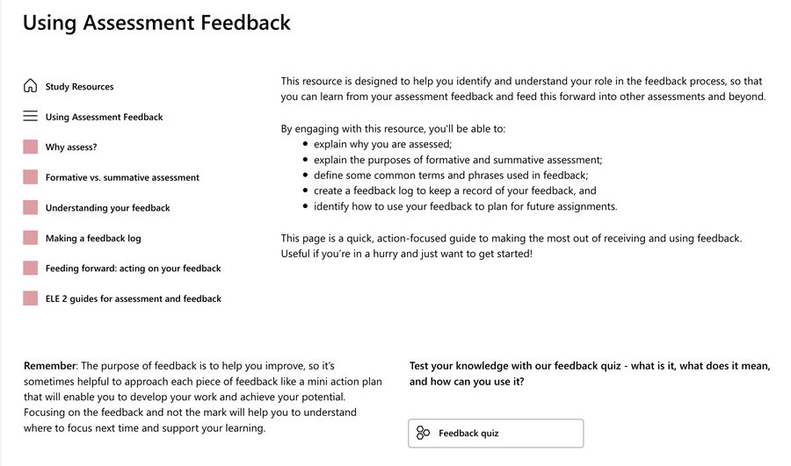
Watch the video
Access the resources

Some reflective questions to set your students post-feedback
The questions below have been recommended by educator Phil Race. You probably won’t have time to cover or assign all of these questions, but you can pick and choose which questions will work best for your students and your context. Keep in mind that longer and more in-depth reflection exercises are especially useful at the end of a module as students can review what they learned and whether they have achieved the ILOs.
- How has this assignment helped me to develop my knowledge and skills?
- Which were the most difficult parts of the assignment, and why?
- Which were the most straightforward parts, and why?
- What was the best thing I did, and why?
- What worked least well for me, and why?
- With hindsight, how would I go about this assignment differently if doing it again from scratch?
- What advice would you give to a friend about to start on the same assignment?

Preparing for module amendments - reimagining assessment in the age of AI
The emergence of generative AI – a type of AI that can produce or generate content in a variety of media - is going to be a catalyst for re-imagining assessment. This tool will support you to do just that – taking you through a series of tasks and reflective questions to get you to consider:
- What are you assessing, and why?
- What assessment methods are you using?
- How will you design your assessment tasks?
In doing so, this tool will prepare you to make any module amendments needed for 2024/2025 (the central deadlines are UG 2/3/4: Friday 1st March 2024 and UG 1 / PGT: Friday 26th April 2024, with the Faculty specific deadlines published in the last EduExe Newsletter). This guidance and deadlines for module amendments are also available via the TQA Manual’s forms page, here.
Different educators will play different roles in this process, depending on your role (e.g., module tutor, module lead or programme lead). Make sure when looking at this document, and before you make any changes, you discuss your ideas with your programme lead and/or Director of Education and Student Experience.
We have developed a full version of the tool, which we advise you use as part of an away day (which the Educator Development team could deliver!), and a short version.
We regularly deliver bespoke, in-department workshops. If you are interested in us delivering this tool as an interactive workshop, CPD event or away day, please get in touch. Similarly, if you have any questions or feedback on this tool, please contact the Educator Development team on eduexe@exeter.ac.uk.
Access the module amendment deadlines for 24/25
Visit the Reimagining assessment in the age of AI toolkit page
Download the Reimagining assessment reflective tool

Doing assessment differently
As you prepare to make any module amendments for the next academic year, we wanted to share a series of case studies of colleagues doing assessment differently across the University:
- Alternative blue plaques as assessment
- Exploring social media as a form of assessment
- Video creation as an assessment
- In pursuit of pukka assessment: bringing together Generation Z and Generative AI
- Empowering students with innovative assessments: Decolonising medicine
- Rethinking assessment in the face of AI – example of an in-year change
- Assessment as learning in Medical Sciences
- How we designed an authentic assessment for online learners in Educational Psychology
This guidance and deadlines for module amendments are also available via the TQA Manual’s forms page, here

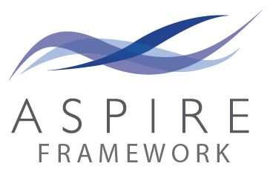

ASPIRE PRP deadlines 2023/2024
As we move through our reaccreditation of ASPIRE PRP with Advance HE, colleagues should be aware that the last deadline for PRP applications in this academic year will be 30th June. We will pause submissions over the summer while we transition to the new PSF 2023 framework, moving to six submission points a year. Our first submission point is yet to be confirmed, but will be late September or early October - more details to follow. For more information on how to notify us of your intention to submit, please see the relevant fellowship pages on our ASPIRE PRP Sharepoint.

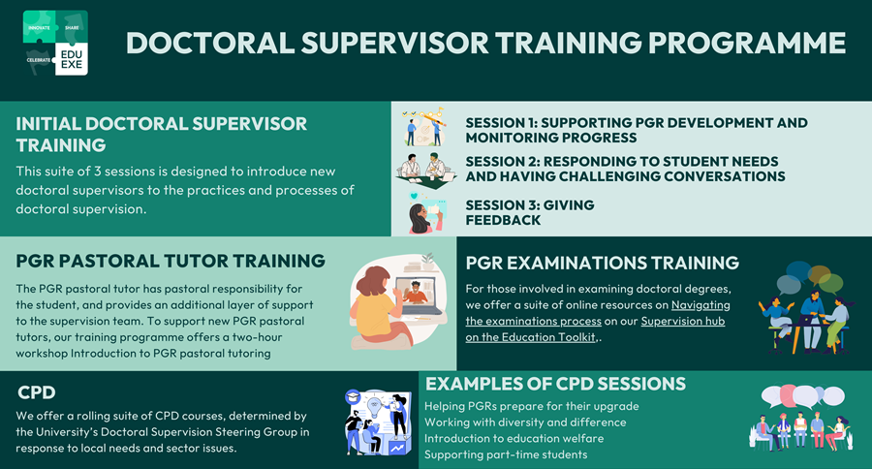

Doctoral Supervisor training programme launch
In January 2024 we launched a new programme of Doctoral Supervision training. This new programme was developed with the University’s Doctoral Supervision Steering Group, alongside engagement with current scholarship and best practice in the sector. The programme consists of:
- Initial supervisor training
- PGR pastoral tutoring training
- CPD for supervisors
This programme, which expands our previous provision, ensures that our doctoral supervisors are prepared with the knowledge and skills they need to deliver high quality doctoral supervision, and have the opportunity to develop their practice with regular CPD opportunities.
If you have any questions about our Doctoral Supervision training programme, please contact the Educator Development team on eduexe@exeter.ac.uk.
Find out more about the Doctoral Supervisor training programme

Space travel – inspirational Learning Spaces
The Space Travel Discovery Grant team, Karen Kenny, Sue Prince, Stephen Hickman, and James Anthony-Edwards are exploring space. We want to have our say in how the university designs spaces for teaching and learning. Will you join us?
Please sign up to join us for an exploration and reflection on the use of our learning and teaching spaces on campus and how they can best meet the demands of current and future education.
Funded by the Exeter Education Incubator, this small project is hosting a series of focus groups, to find out what our community thinks makes an inspirational learning space.
Do you have a favourite room or space in which to study or learn? Do we still need lecture theatres, or could our spaces be more attractive for new ways of learning or for encouraging hybrid in-person as well as online experiences?
Please join us and add your voice to the conversation. We promise to have lots of fun along the way.

Sign up here:
Streatham Campus - Creative Quadrant Wed 21st Feb 12:00
Penryn Campus - Collaboratory 28th Feb 10:30

Peer dialogue
Peer dialogue is a key dimension of academic and professional life at the University of Exeter, as outlined in the TQA Manual. Through engaging in peer dialogue, often referred to as the Annual Review of Teaching Scheme (ARTS), we can find the most creative and successful ways of teaching and assessing our students, of developing academically inspiring, demanding and research-rich curricula, and of ensuring that students have the highest quality guidance and support. This applies through all levels of the curriculum, from first year undergraduate to postgraduate research programmes.
Find out more about ARTS on our new EduExe Toolkit page

BME Network Workshop
The BME Network is re-launching and are excited to bring together staff and students who identify as Black, Asian, and dual heritage at the university for an enriching session of creative play and discussion – a collaborative space to connect and share our aspirations for the future of the BME network.
Join us at the Creative Quadrant in the Business school on Monday 26 February from 13:30 to 16:00. Lunch will be provided, and you are welcome to bring a snack or dish to share with the community. You don't need to be an existing member of the network to participate.
Disclaimer: We are aware the term ‘BME’ is contested, outdated, and might not reflect how you identify. We acknowledge the importance of language, so as part of the relaunch of this network, we are hoping to get everyone’s perspective on the terminology we adopt moving forward, which celebrates our identities and reflects the diversity of our community. For the purpose of this event, we are using the original terminology of the network BME (Black & Minority Ethnic).
Your voice is vital in reshaping the network, so please come along and be part of the conversation.
Complete this form to confirm your attendance and let us know if you can contribute to the lunch.

THE Campus call for contributions
Through our partnership with THE Campus, we receive regular calls for content, as well as a rolling call for contributions on THE Campus key topics:
- Teaching and learning
- Equity, diversity and inclusion
- SDGs
- Early career research
- Internationalisation
- Research management
- Student success
- Leadership and strategy
- Digital transformation
THE Campus publish two key forms of content:
- resources offering advice and insight for fellow faculty, university leaders and support staff looking to improve their teaching and learning, equity-diversity-inclusion work, research management, internationalisation, work towards the SDGs and early career research, taking in all the more holistic elements of university life such as student support, well-being and community building.
- opinion pieces commenting on different topical issues or challenges relating to the successful delivery of higher education – these need to also propose some practical solutions to the issue they raise
With resources, the aim is to offer quick, practical and applicable advice for academics and other university staff – to go away with actionable take-aways and tips, If you are interested in contributing to THE Campus, please contact eduexe@exeter.ac.uk with your pitch and download the Campus editorial guidelines.
Send your pitch to the EduExe team!

Upcoming events
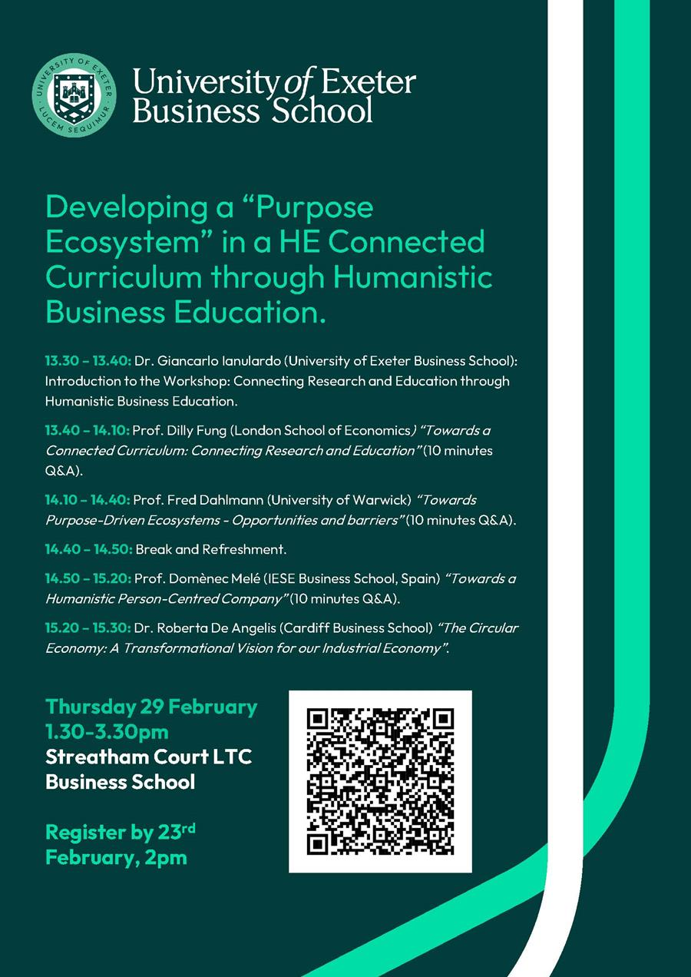

On EduExe socials this month
EduExe continues to grow our social media presence, sharing updates, best practice and discussing current issues in Higher Education. This month we shared blog posts on:
- Authentic assessment video creation as an assessment - Gavin Buckingham, Dominic Farris, Luciana Torquati and Genevieve Williams
If you are interested in contributing a case study of your practice to the EduExe blog, please contact us on eduexe@exeter.ac.uk!
Don't forget you can follow us on LinkedIn for updates!
Read the EduExe blog

Taskmaster challenge - the winner!
Last month's activity was in the style of a Taskmaster challenge. We were looking for colleagues to send us words beginning with E to eduexe@exeter.ac.uk - the second longest word sent to us wins an EduExe mug or lanyard!
The winner of the challenge is Victoria Sadler with ESTABLISHMENTARIANISM (21 letters)!

February challenge!
For this months' challenge, we have turned the EduExe logo in to an online jigsaw! Send us a screenshot of your completed jigsaw to receive an EduExe lanyard.
Complete the EduExe logo jigsaw

Interested in contributing to the newsletter?
We will have rolling deadlines for submissions each month, so please get in touch with eduexe@exeter.ac.uk if you would like to contribute!
We want your feedback!
The EduExe newsletter is a new initiative, and we would love to hear from you if you have any feedback! You can share it with us anonymously on our feedback form or by email to eduexe@exeter.ac.uk.

Follow us on social media or visit our website to find out more about educator development and enhancement at Exeter!

Join the EduExe teams site tp connect with educators across the University

