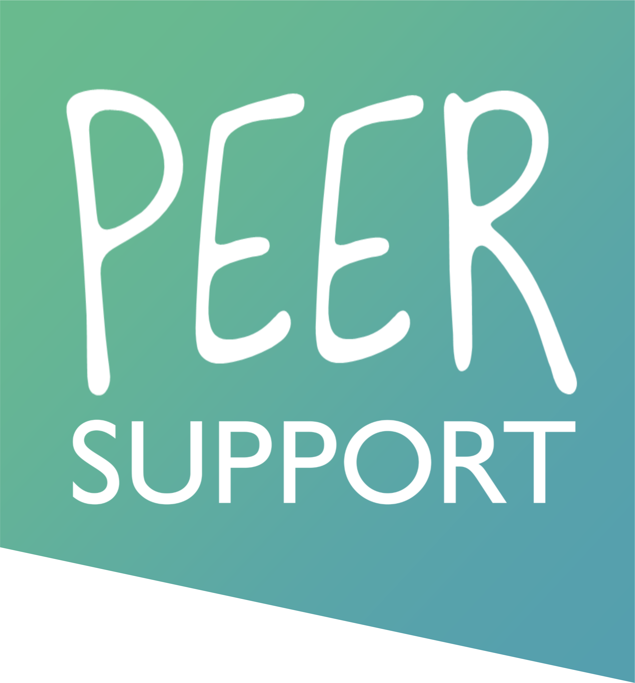

Topic:

Aim:
The aim of this session is

Intended Learning Outcomes

By the end of the session, mentees will be able to:

Preparatory task(s) before the session
Time (mins) | Mentor Activities |  | Mentee Activities | Aids/Resources
Consolidation task(s) following the session

Measures to ensure the Intending Learning Outcomes have been met

