Green Futures Student Solutions

Context
The University of Exeter is looking to support the progression of innovative sustainability initiatives that are seen as high priority by our students. The University is looking to fund projects across our campuses that improve our sustainability and reduce the environmental impact of university activity. Project expenditure can be on resource, personnel, products, or services to deliver a sustainable outcome. All project funding must be spent before 31/07/2023.
To submit a proposal for a project, please fill out the below proforma and return to sustainability@exeter.ac.uk before 30/11/2022.
The projects will be reviewed by our review panel, made up of members of the E&CE team, our Academic Climate Taskforce, and the Student Guild.

Challenges Faced
The challenges that we experience as part of the journey to Net Zero can be found in the accompanying documents at the back of this proforma:
- Environment and Climate Emergency 5-Step Journey
- Environment and Climate Emergency Policy Statement

Project Summary
Please summarise the project in the space provided. Please give details of the significant changes this project will provide, and how they benefit the Environment and Climate Emergency Response.

Project Team
Please provide details of the team that has been put together dedicated to delivering this project. Please include the appropriate contact details of the Project Lead and outline the roles and names of the project team members.
A staff project sponsor is not essential but is likely to significantly increase the confidence in your ability to deliver. Confidence in delivery is one of the assessment criteria.
Project Lead:

Staff Project Sponsor:

Project Team:

Project Aims
Please outline the significant aims this project seeks to achieve.

Project Benefits
Please outline all the benefits that this project will seek to achieve. Please focus on sustainability and environmental protection, but if there are also cashable benefits or benefits relating to the student experience.

Alignment to E&CE Priorities
Please comment on how your project aligns to the 5-Step Journey and E&CE Policy Statement included at the back of this proforma.

Carbon Emissions Savings
Please estimate the annual carbon emissions savings that your project will achieve. Please use our Team SIGMA Data Warehouse Dashboards to refer to our carbon footprint and categoric carbon emissions when presenting your emissions savings. Guidance on navigating the dashboards can be found at the back of this proforma.

Environment Impact
Please detail the environmental impact reduction that this project will realise. Extra credit is awarded where numerical metrics are referenced and evidenced.

Project Timeline
Please detail the delivery timeline for the project, under consideration that all invoices must be received from any suppliers you intend to use by 30/11/2022.

Project Expenditure
Please detail the total cost of the project and a breakdown of how that money will be spent over the project lifetime, inclusive of which suppliers you intend to use and any members of the team you intend to pay for their time. The maximum budget allocation to a single project is £5,000 inc. VAT. This should not be viewed as a target, and expenditure associated with each project will be assessed to ensure projects are cost-effective.
For hourly payment contributions to budget development please determine the number of hours required for task completion and multiple by £12.51/hr to allow for employer contributions. This is not a guaranteed rate of pay for the team members as hourly rates are subject to change and this rate includes employer contributions paid elsewhere.

University of Exeter 5-Step Journey:
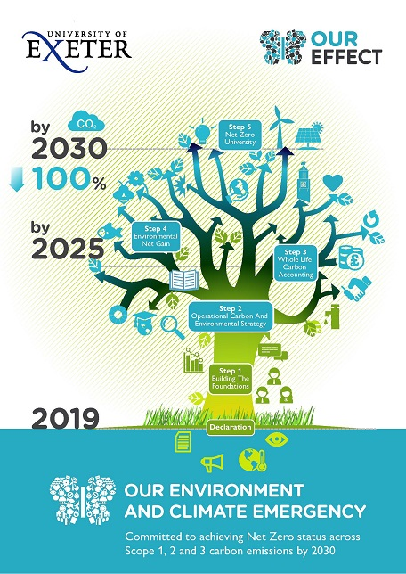

University of Exeter E&CE Policy Statement:
