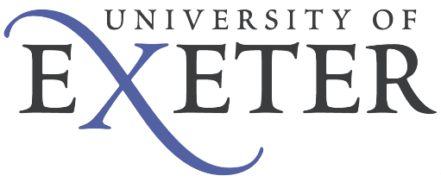

Post: Digital Learning Assistant

Reference No: HR to complete

Grade: B

Reporting To: TBC

Organisational Context
The University of Exeter is a Russell Group university that combines world-class research and teaching, with high levels of student satisfaction. Our vision is to become one of the most successful universities in the world, one that makes the exceptional happen by challenging traditional thinking and defying conventional boundaries.
Main Purpose of the Job
As a Digital Learning Assistant, you will play an important role in enabling the university to continue to deliver high quality teaching, resources and support to its students, during these unique times.
Working in college focused teams alongside Graduate Digital Learning Developers, and members of the e-Learning and Academic Development teams, you will help the University to translate existing face to face, as well as blended learning course content into the online learning environment.
Collaborating with a variety of stakeholders from a range of disciplines, including academic and professional services colleagues, you will integrate quality content onto appropriate online platforms, ensuring that it is user friendly. You will also support the user research process and the further development, as well as quality assurance of these online materials, based on feedback.

This role is required from 29th June 2020 in the College. Where possible, you will be allocated to colleges or disciplines relevant to your area of study.

Main duties and accountabilities:

- Contribute to the implementation and delivery of digital learning and online courses, working closely with colleagues across the College Focused Digital Support Team.

- Effective implementation of content plans that enable high quality viewing of, and engaging with, online teaching and learning.

- Work with the Graduate Digital Learning Developer and other stakeholders to import and integrate materials into the appropriate online learning platform.

- Input teaching requirements into the appropriate templates and online tools, ensuring that resources are user friendly.

- Import and integrate high quality, accurate content that ensures consistency and adheres to the agreed frameworks, as well as quality assurance processes.

- Apply a user centred approach to work flow to ensure that online content is both suitable and engaging.

- Organise resources and teaching materials to ensure they are accessible online and easy to locate.

- Source appropriate images, handling and logging licensing data as required.

- Record copyright permissions for content used within online courses.

- Collect user feedback data and collate this into a presentable format for analysis. Assist the Graduate Digital Learning Developer in the analysis of this information, as required.

- Respond to email or telephone queries and resolve basic requests relating to the import of content, as required by the Graduate Digital Learning Developer.

- Keep accurate records and update databases for selected programmes.

- Raise risks or issues to the wider team.

- Support the work of the College-focussed Digital Support team and provide support on digital learning or similar related activities across the University as required.

- Complete any training, as required by the Academic Development and e-Learning teams.

- Provide other general assistance within the college as appropriate to the grade and as required.

This job description summarises the main duties and accountabilities of the post and is not comprehensive: the post-holder may be required to undertake other duties of similar level and responsibility.

Person Specification

Competency | Essential | Desirable
Attainments/Qualifications | Current student at the university
Skills and Understanding | Excellent IT skills, particularly in Word and Excel.  Attention to detail.  Aptitude for proof reading and producing high quality, accurate work/content.  Excellent interpersonal and communication skills.  Able to manage a varied and demanding workload and to work to quickly changing deadlines.  Excellent planning, organisation and time management skills. | Interest in the pedagogy of e learning and leading edge web based course design approaches.
Prior Experience | Familiar with online learning environments. | Experience of supporting learning.  Awareness of the issues of copyright and digital media.
Behavioural Characteristics | Self motivated and enthusiastic.  Work effectively in a team.  Reliable.  Creative approach to problem solving.
Circumstances | Right to work in the UK for the duration of the post.

