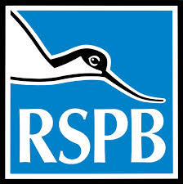
Will you join the RSPB from £28 a year and help to secure the future for the UK's wild birds?

Dear Friend,
Perhaps, like me, you have paused to listen to the haunting melody of a song thrush at dusk, or enjoyed the noisy and energetic squabbling of house sparrows under the eaves. But have you ever considered how eerily still our parks and gardens would seem without their reassuring sounds? Or how empty life would be if we rarely caught a glimpse of once-common birds? Without your help this terrible vision of the future could become reality. Time could be running out for some of our wild birds.

UK-wide decline

The figures are appalling and it is some of our most loved birds which are under threat. Despite a small recent improvement, there are less than half the number of song thrushes in the UK than in 1970.In Kensington Gardens, central London, there were over 2,600 sparrows in 1925, but this dropped to 544 in 1975. There were only eight sparrows in Kensington Gardens in 2000.Some serious drops in the population are harder to appreciate. Skylarks are still heard in many parts of the UK, but their numbers have fallen by 52% since 1970. We must act now in order to keep these birds in all our lives. Without your help, birds like house sparrows could disappear from some parts of the UK altogether.

Take action now and help our wild birds

The fall in numbers of some of our wild birds is not unstoppable. There is something you can do right now to help address this terrible situation. You can join the RSPB today for £28 a year which works out at just £2.33 a month. Your membership could help time stop running out for some of our inspirational wild birds.

