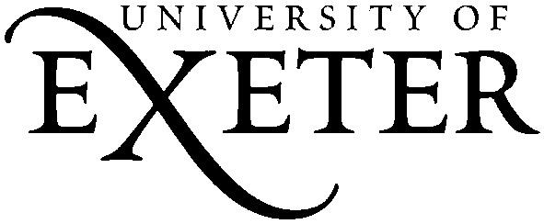 Metatalk for Writing 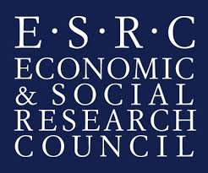
Phase 1 Parent Information and Consent Form
Dear Parent,
Your child’s class is going to be involved in a research project on talk about writing – what we call ‘metatalk’ - and this letter is to inform you about the project, your child’s involvement, and your parental right to withhold consent.
Information about the Project
This research is looking at how talk about writing, or ‘metatalk’, can improve students’ attainment in writing. We are interested in watching how teachers and students talk about writing in lessons, and in looking at how this talk makes a difference to what students write. There are 3 phases of research, spanning a 2 year period. In this first phase of the research, two of your child’s lessons will be audio and video recorded, and samples of students’ writing will be collected. The lessons taught will not deviate from the curriculum so will not disadvantage your child’s learning; in fact, we hope that taking part will be beneficial.

We have asked your child if he/she would be willing to participate as a ‘sub-sample’ student. There will be 4 sub-sample students, working in pairs, during the observed lessons. As a sub-sample student, your child will wear a small recorder so that we can capture talk with a partner. The project and the role of sub-sample students has been discussed with your child and they have been asked to give their consent.
All the information we collect will be used to write reports and articles, perhaps a book, about metatalk for writing. The audio and video recordings of the two lessons will be stored safely by the researchers, and will only be seen by the researchers and a small team of teachers. Writing samples and lesson observation transcripts will be anonymized and stored safely, and may be stored for other researchers to use in the future. The research team will treat all personal information as confidential and make every effort to preserve anonymity. We hope that your child will enjoy being involved.
If you are happy for your child to participate as a sub-sample student, and for recordings featuring your child and samples of your child’s writing to be used and stored for the purposes of this research, please sign the form below and return to school.
If you would like further information about this project, please contact r.m.c.newman@exeter.ac.uk
Yours faithfully,
Dr. Ruth Newman
Principal Investigator, Metatalk for Writing

Metatalk for Writing: Parental Consent

I CONSENT to my child participating as a sub-sample student in the Metatalk for Writing project, and for my child’s data to be used for research purposes
I DO NOT consent to my child participating as a sub-sample student in the Metatalk for Writing project
If you DO NOT consent, an opt-out form will then be sent home concerning your child’s general participation in the project.

Parent/Carer Signature…………………………………………………………………………….

Date…………………………………

Child’s Name……………………………………………………………………………………………………………………………

Child’s School…………………………………………………………………………………………………………………………

