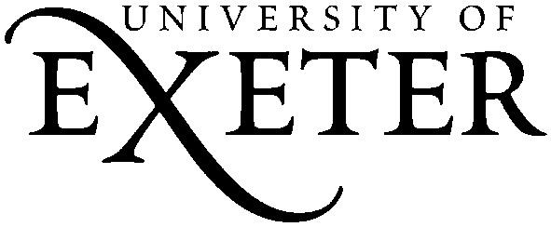 Metatalk for Writing 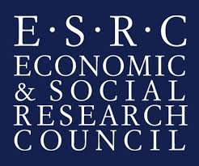
Phase 2 Parent Information and Opt Out Form
Dear Parent
Your child’s class is going to be involved in a research project on talk about writing – what we call ‘metatalk’ - and this letter is to inform you about the project, your child’s involvement, and your parental right to withhold consent. The project has been discussed with your child and they have been asked to give their consent.
Information about the Project
This research is looking at how talk about writing, or ‘metatalk’, can improve students’ attainment in writing. We are interested in watching how teachers and students talk about writing in lessons, and in looking at how this talk makes a difference to what students write. In this second phase of the research, nine of your child’s lessons will be audio and video recorded, and samples of students’ writing will be collected. The lessons taught will not deviate from the curriculum so will not disadvantage your child’s learning; in fact, we hope that taking part will be beneficial.
All the information we collect will be used to write reports and articles, perhaps a book, about metatalk for writing. The audio and video recordings of the nine lessons will be stored safely by the researchers, and will only be seen by the researchers and a small team of teachers. Writing samples and lesson observation transcripts will be anonymized and stored safely, and may be stored for other researchers to use in the future. The research team will treat all personal information as confidential and make every effort to preserve anonymity. We hope that your child will enjoy being involved.
If you are happy for recordings which may feature your child, and for samples of your child’s writing, to be used and stored for the purposes of this research, you do not need to do anything. However, if you do change your mind later on, please get in touch with the researcher below, using the contact details provided. Thank you for your help with this project.
If you would prefer for your child’s data to be omitted from the research, please complete the enclosed opt out form and return to your child’s school. Pixilation will then be used so that your child is not visible in the recordings, and your child’s data will not be used in the project.
If you would like further information about this project, please contact r.m.c.newman@exeter.ac.uk
Yours faithfully,
Dr Ruth Newman
Principal Investigator, Metatalk about Writing

Metatalk for Writing: Opt Out Form

If you DO NOT want your child’s data to be part of the Metatalk for Writing project, please return this form to your child’s school asap.

I DO NOT want my child’s data to be shared for use in the Metatalk about Writing Project

Parent/Carer Signature…………………………………………………………………………….

Date…………………………………

Child’s Name……………………………………………………………………………………………………………………………

Child’s School…………………………………………………………………………………………………………………………

