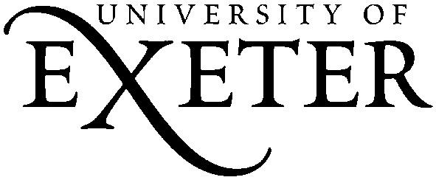 Metatalk for Writing
Phase 1 Student Consent Form
Dear student,
Thank you for being willing to help us with our project. We are interested in learning more about how talking about writing can help students to improve their writing. This is why we would like to watch two of your lessons and take a look at some of the writing that you and your peers produce. The things that we see will be used to write reports and articles, perhaps a book, about talk about writing – what we call ‘metatalk’. We hope that you will enjoy being involved.
In this letter, we ask you to confirm that you are happy to be involved, and that you have been fully informed about the aims and purposes of the project, by reading the statement below and signing to confirm your agreement.
I understand that:
- For the purposes of the project, two of my lessons will be video and audio recorded;
- These audio and video recordings will be stored safely by the researchers, and will only be seen by the researchers and a small team of teachers;
- If I do not want to be included in the video, I can request to be ‘pixilated’, which means that it won’t be possible to see me in the videos;
- Some of the writing I do in these lessons will be copied, anonymised, and stored in a safe place;
- I give permission for anonymised samples of my writing to be used for the purposes of this research project, which includes publications and presentations, and may be stored for other researchers to look at in the future;
- Anonymised transcripts of the lesson observations will be used for the purposes of this research, which includes publications and presentations, and may be stored for other researchers to look at in the future;
- I have the right to refuse permission for the publication of any information about me;
- All information I give will be treated as confidential, unless I disclose any issue which needs to be reported to the school Safeguarding officer.

I agree that I am happy to participate in this project.
Signed: ………………………………………………………
Date: ………………………………………………………….
Dr Ruth Newman – Principal Investigator
R.M.C.Newman@exeter.ac.uk

