How to Find Your Allocated Desk Within the Exam Room
Each year you will be issued with a 6 digit ‘Candidate Number’ which can be accessed via your ExeHub portal. You will need this number to locate where you should be sitting in the exam hall and it will also need to be clearly detailed on the front cover of your answer book.
The Exam Hall is located in the Du Maurier Building and it occupies Seminar rooms H, I, J, K, L, M, N plus Lecture Theatres A & B. The walls are collapsed to make one large room which currently houses 14 rows of 14 desks; access to the exam hall is via the lobby to the seminar rooms.
Seating plans will be displayed on the wall outside the Exam Hall, see below; each square will have an individual candidate number displayed in it (e.g. 079360). The candidate numbers will be arranged per exam in different colours, each exam then arranged alphabetically by your surname. If you have specific requirements for exams, you will receive a personal email from the Exams Office a few weeks beforehand detailing the location and timings of each exam.
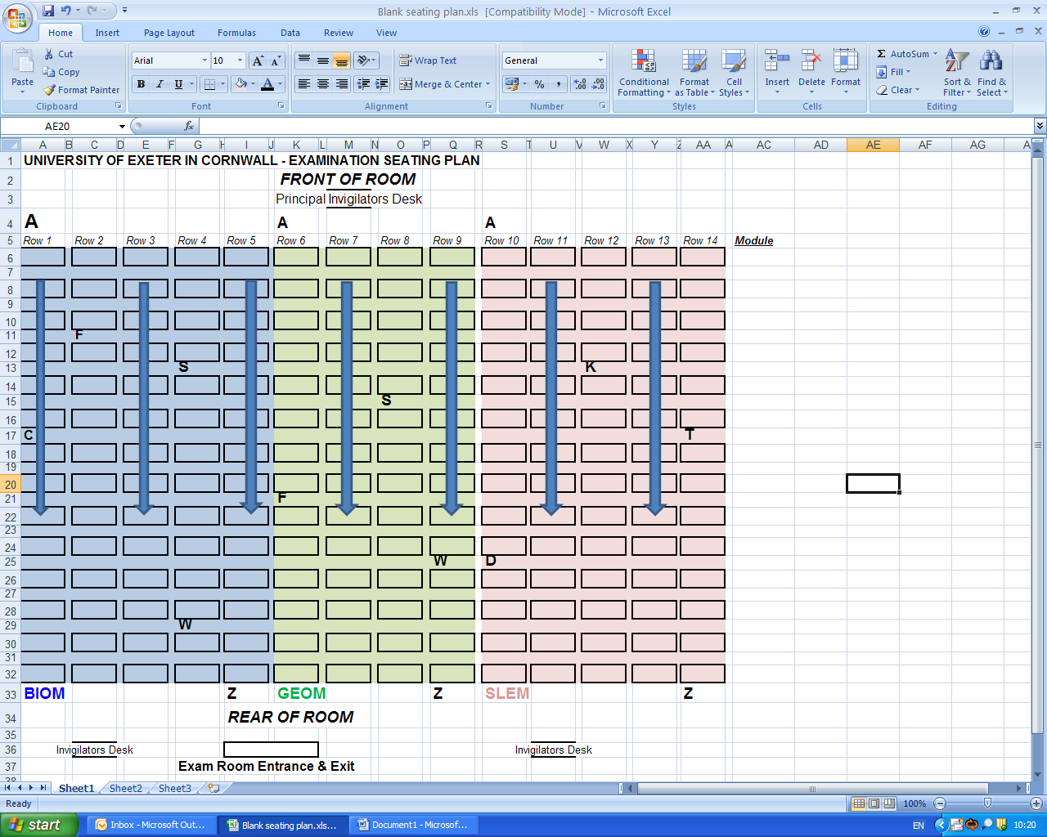
Before entering the exam hall you should endeavour to locate your candidate number on the seating plan so that you can proceed to your allocated desk as quickly and quietly as possible. If you experience any problems in locating your desk, please speak to one of the invigilators as soon as possible and they will assist you.
On the desk will be a Candidate Card which will contain your Student ID number, Name and Candidate number, and Module Code. This card must remain on your desk for the duration of the exam and should not be removed from the room.

