iTrent Self Service PGR User guide

Contents
iTrent Self Service PGR User guide 1
Welcome 2
Navigation of iTrent Self Service 3
Absences (inc holidays, sickness, compassionate, armed forces reservist leave, jury service, study leave) 5
Recording Annual Leave 6
Recording Sickness Absence 7
Recording Other Leave (such as armed forces reservist leave, compassionate leave, jury service or study leave). 8
Viewing scheduled holiday dates, sickness absences and other types of leave 9
Booking Learning Events 10
How to book a course 10
Viewing booked and completed courses 11
How to cancel a course 12
Recording special requirements (dietary/access requirements) 14

Welcome
This is the PGR User Guide for iTrent Self Service. This is a tool that allows PGR students to record holiday, sickness and other absence.

To log in to the iTrent Self Service system, click here.
Use your Student username and password to log in.
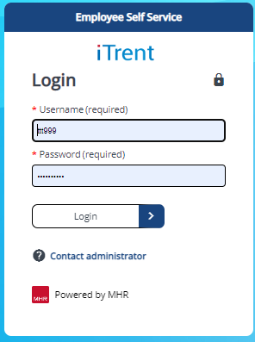

iTrent Self Service is available on all mobile devices.

IMPORTANT SECURITY ADVICE

As this Self-Service system includes some very sensitive information about you it is important that you use it responsibly to ensure that the security of your personal information is maintained. You should therefore always log out of Self Service once you have finished using it and should never let anyone know your University username & password.
To log out of Self Service always click on 'Sign out' which can be found in the Utility menu in the top right-hand corner. Alternatively, please ensure you close the browser or tab as this will log you out automatically.

For information on how we manage and store data click here.

Navigation of iTrent Self Service
When first logging into iTrent Self-Service you will be met with the Home screen which brings together news and useful information and absence details.
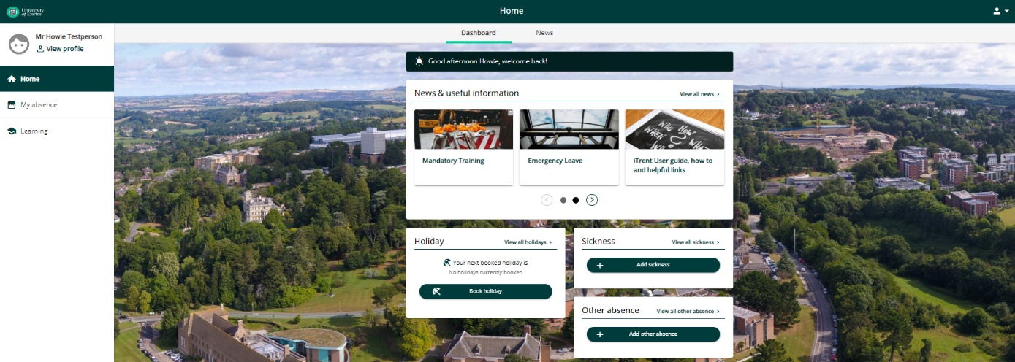
From there you can view your profile, book annual leave, sickness and other leave.
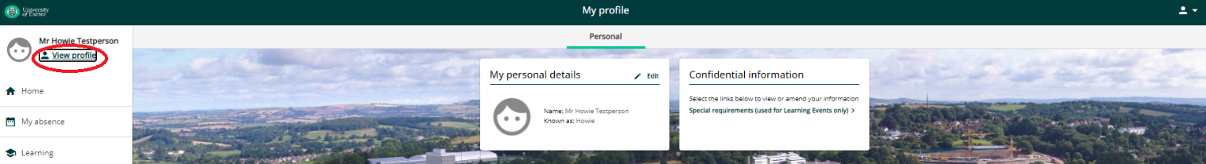
Clicking on ‘View profile’ (circled red above) will allow you to view and edit personal details and special requirements.
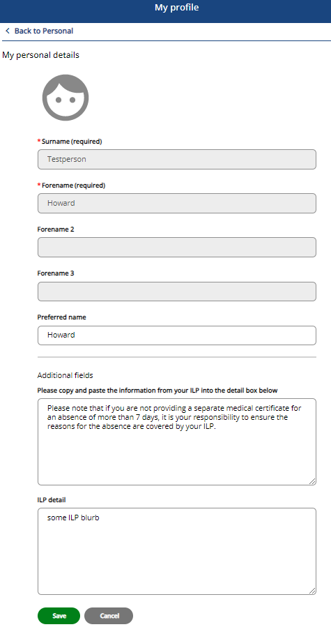

If you want to change your name, this must be done in the Student Record System. To do this, you must either log an enquiry via SID online or bring an official document, such as your passport, driving licence or marriage certificate to the Student Information Desk (Forum Building, Streatham Campus or Info at St Luke’s) or Registry Services in the Peter Lanyon Building, Penryn Campus.

Within 'My personal details' you have the opportunity to add Individual Learning Plan (ILP) details. If you are not providing a separate medical certificate for an absence of more than 7 days, you will need to ensure the absence is for a reason covered by your ILP and that the information is entered in the 'ILP detail' field.

Within the ‘Confidential information > Special requirements’ section (see below) you can record details of any special requirements and mobility constraints. This is used for learning events management only.
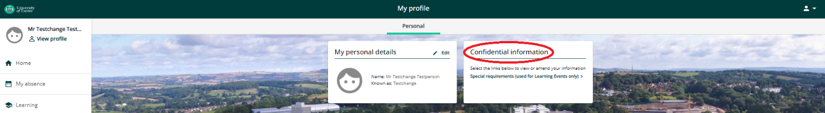

Absences (inc holidays, sickness, compassionate, armed forces reservist leave, jury service, study leave)

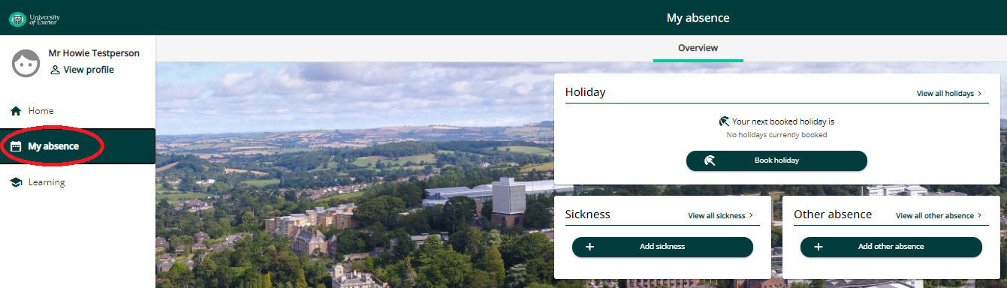

Go to

This screen allows you to view scheduled annual leave dates (View all holidays), book annual leave, record sickness, view your historic sickness record (View all sickness) and record ‘Other absence’ which includes compassionate, armed forces reservist leave, jury service, and study leave.

Absence period: There are various options 'Full day’, 'More than one day' or ‘Part day'. Depending on which one you choose, other context-sensitive menus may appear.

- Part day: This option allows you to request part of a single day's annual leave or report part of a single day’s sickness. If you select this, you will be prompted for the Start Date and another menu ('Morning or afternoon') will appear. To request/report a half day's absence, select 'Morning' or 'Afternoon'.

- Full day: This option allows you to request/report a full single day's absence. You will be prompted for the Start Date.

- More than one day: This option allows you to request/report one or more consecutive full days' leave. If you select this, you will be prompted for the start and end dates of your leave.

Recording Annual Leave

Click on the section
To request annual leave, click on

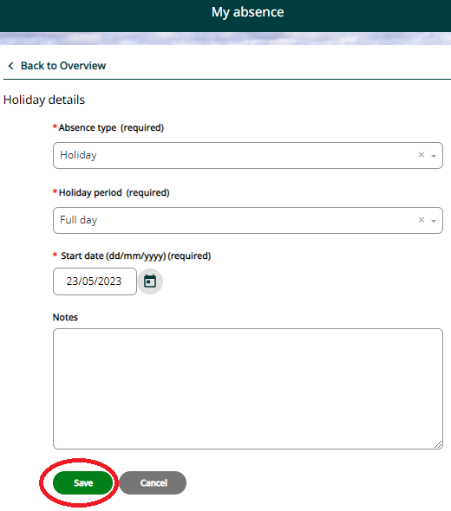
  - Select an absence period (Part day, Full day or More than one day)
  - Enter the start date (and end date if ‘More than one day’)
  - Click on 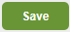

Editing/deleting leave
To change future absences click on ‘View all holidays’ and select the relevant period of leave. For absences in the past, contact your PGR Support Team to make the changes.

Recording Sickness Absence

Click on the section
And then, click on
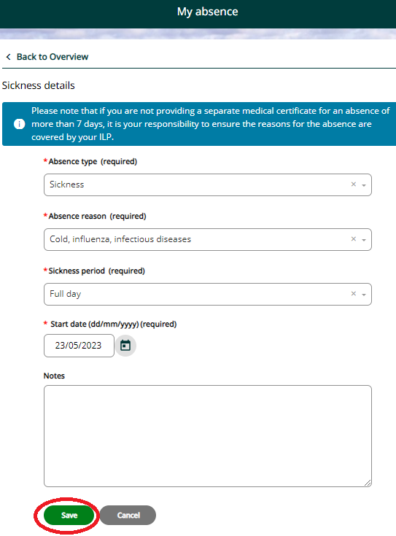
  - Select an absence reason from the drop down list
  - Select an absence period (Part day, Full day or More than one day)
  - Enter the start date (and end date if ‘More than one day’)
  - Click on

NB Please note that if you are not providing a separate medical certificate for an absence of more than 7 days, it is your responsibility to ensure the reasons for the absence are covered by your ILP.

Details of your ILP can be viewed/recorded under ‘View Profile>My Personal Details’

Editing/deleting leave
To change future absences click on ‘View all sickness’ and select the relevant period of leave. For absences in the past, contact your PGR Support Team to make the changes.

Recording Other Leave (such as armed forces reservist leave, compassionate leave, jury service, or study leave).

Click on the section

Click on

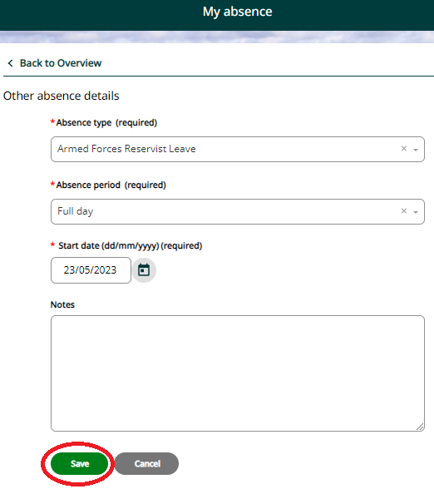

  - Select the Absence type from the drop down list.
  - Select an absence period (Part day, Full day or More than one day)
  - Enter the start date (and end date if ‘More than one day’)
  - Click on

Editing/deleting leave
To change future absences click on ‘View all other absence’ and select the relevant period of leave. For absences in the past, contact your PGR Support Team to make the changes.

Viewing scheduled holiday dates, sickness absences and other types of leave

Whilst in the ‘My absence’ section click on the relevant link e.g. ‘View all holidays’ (see below circled in red):
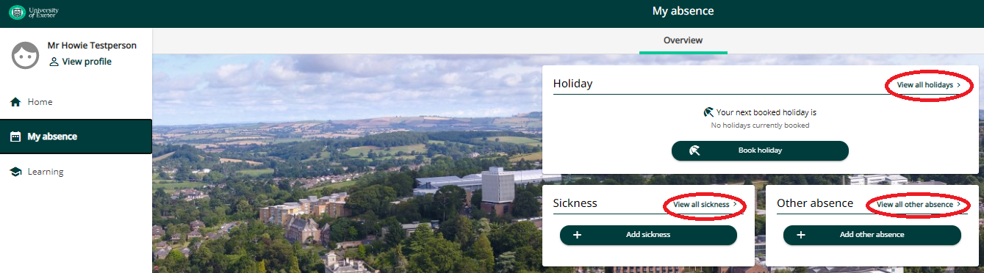

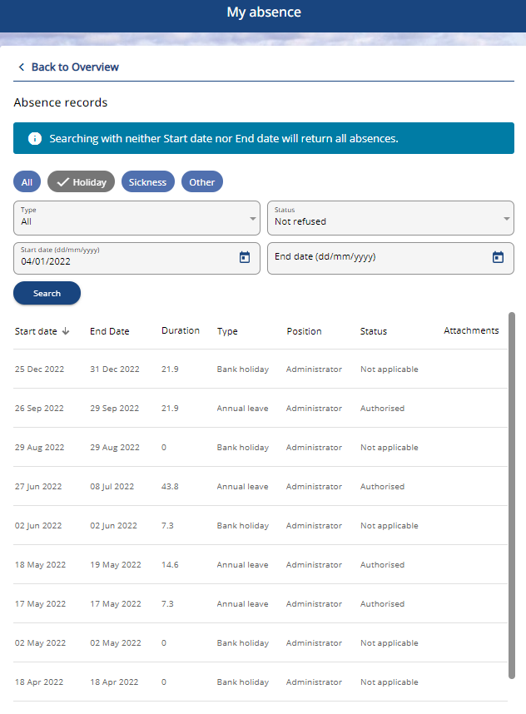
Regardless of which link you choose, you can use these filters to view the dates of holidays, sickness and other leave.

Absence calculations run overnight which populates duration. NB in some instances the duration will not display; this is a known issue which should be resolved soon.

Editing/deleting leave
To change future absences click on the relevant ‘View all holidays/sickness/other absence’ and select the relevant period of leave. For absences in the past, contact your PGR Support Team to make the changes.

Booking Learning Events

How to book a course
Click on the section which automatically opens to the ‘Courses’ tab.
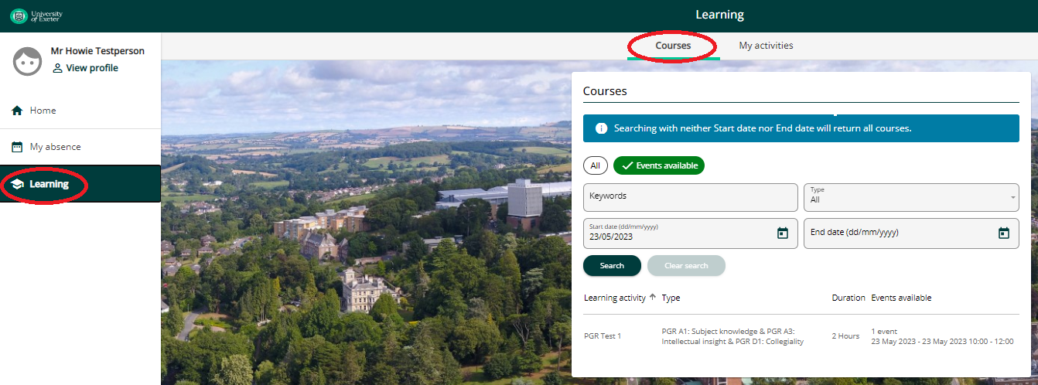

Search for a course by entering a keyword with the wild card character * eg ‘*writing’. Alternatively, you can visit the Doctoral College website (to identify the course title you wish to search for).

Once you’ve identified the course click on it. This will show the full details for the course, the dates available, including how many spaces are available.
If there are no spaces available for your chosen course, you can use the button to add yourself to the waiting list. Please note that those on the waiting list will be contacted when new dates are arranged.
If there is a space available, click on – this will take you to the ‘Course booking details’ screen (see below).

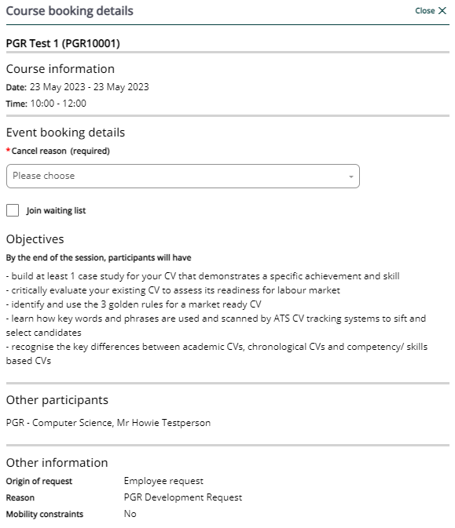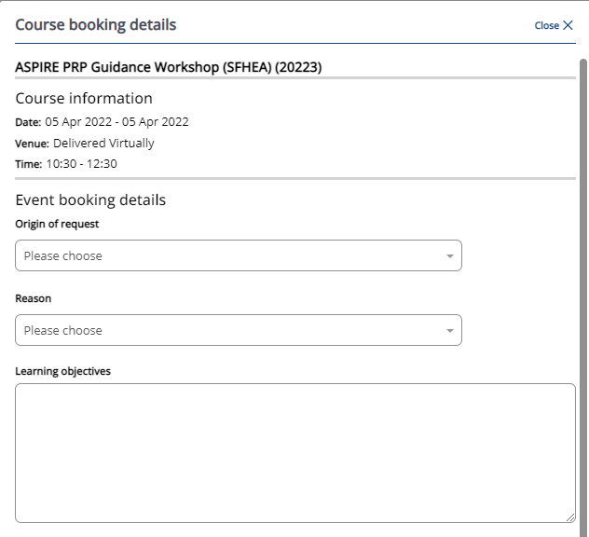

Enter the relevant details and click

Your booked course will appear as a new learning activity on the ‘My activities’ tab.

When you book or cancel a learning activity you will receive confirmation via email. You will also receive a calendar appointment. You should open the calendar appointment and save and close it to add the course to your calendar.

Viewing booked and completed courses
Click on the section and select the ‘My Activities tab.
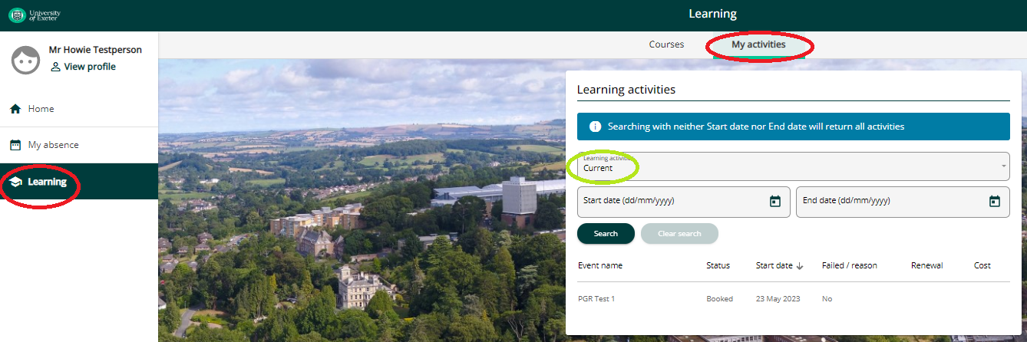

This screen allows you to view all your learning activities whether current, booked, completed, cancelled or on a waiting list. To change the view, you can do this by using the filter to modify your view (circled in green above).

How to cancel a course
Click on the section and select the ‘My Activities tab.

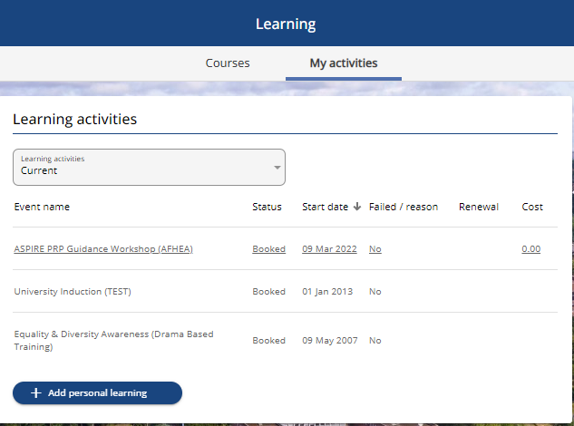
Click on the course you wish to cancel.

On the ‘Course booking details’ screen (see below) enter the reason for cancellation and select the button.
You can, at the same time as cancelling, join the waiting list for the course. You will then be automatically notified of further dates as they become available.

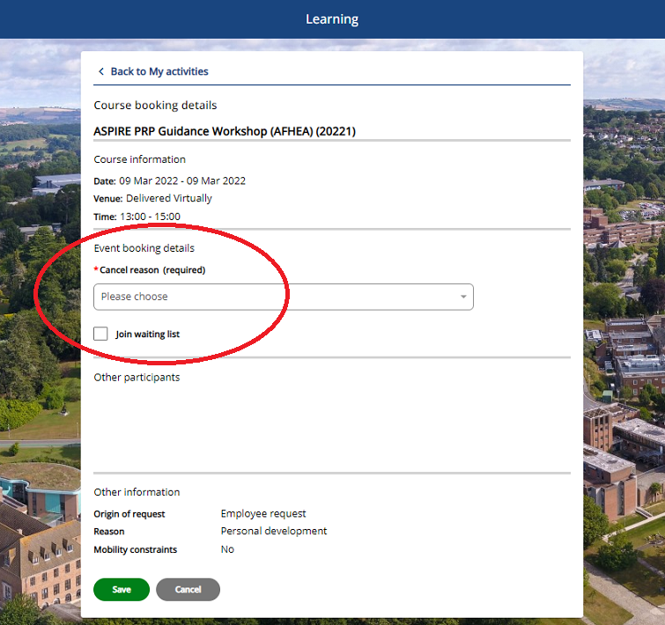

The Learning>My activities screen also allows you to record personal learning activities.

Click on and add details of any relevant training undertaken independently.

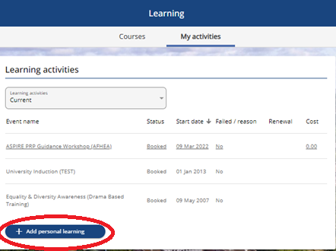

Record special requirements (dietary and/or access requirements)

Click on View profile

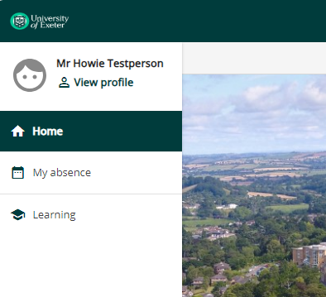

Click on Special requirements (used for Learning Events only) in the Confidential information box.

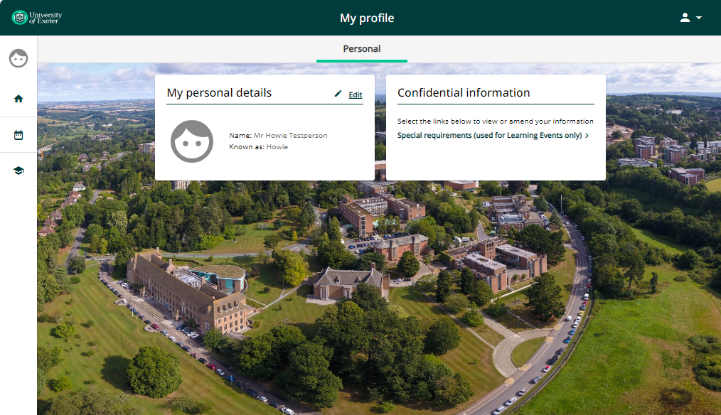

Complete the information as appropriate and click Save. This information only needs to be completed once and will feed through to the Learning events information. If you’re completing this information near to a session date or want to check any details, please contact researcherdevelopment@exeter.ac.uk.

