Cognos Analytics Upgrade – Notes for Financial Planning (FP) users
Previously Cognos Reporting and Cognos Financial Planning (FP) were all available in the same environment, however, with the release of an updated version of Cognos on 19th July 2017, the Cognos Reporting and FP tools are now held in 2 different environments.
All Cognos reports are now accessed in the new Cognos Analytics environment at http://cognos.exeter.ac.uk
The Cognos FP modules are available separately in a separate environment, however, please note that the recommended way to access the FP modules is still through the new Cognos Analytics environment where links are available alongside the usual suite of FP reports
Please also be aware that the route folder for accessing the FP tool and report was previously called ‘Business Planning’ but is now called ‘Enterprise Planning’

Instructions on How to Access FP Modules in New Cognos Analytics
Previously FP modules have been accessed within their relevant folder:
E.g. within the 2017-22 Financial Plan folder if we select Teaching:
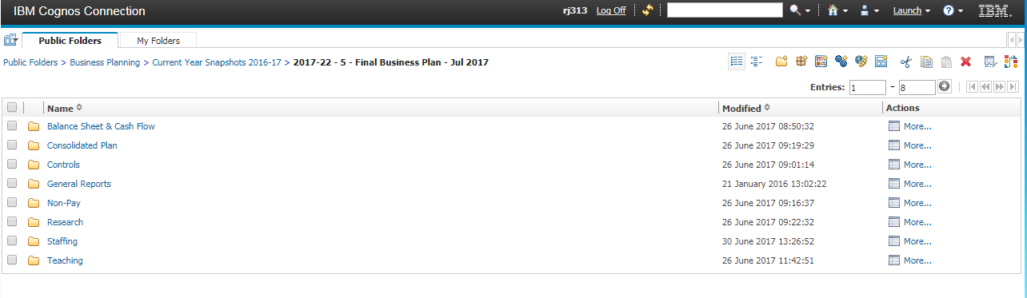
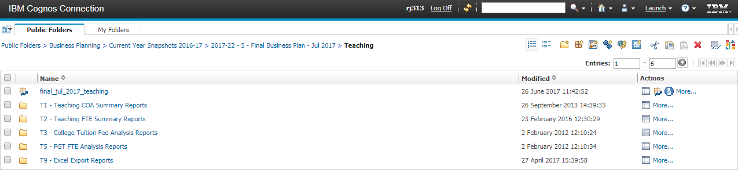
We can see the final_jul_2017_teaching module here.
In the new Cognos Analytics environment, once we have navigated to the folder for the required FP snapshot (e.g. 2018-23 Financial Plan) then ALL the modules are available through the top link instead of in each individual folder:
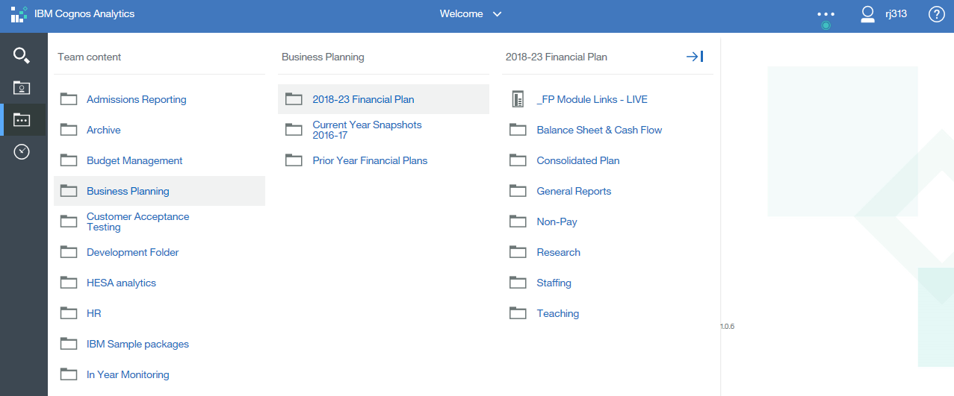

This ‘_FP_Module Links – ?’ link will then take you to this page where you can click to access each module:
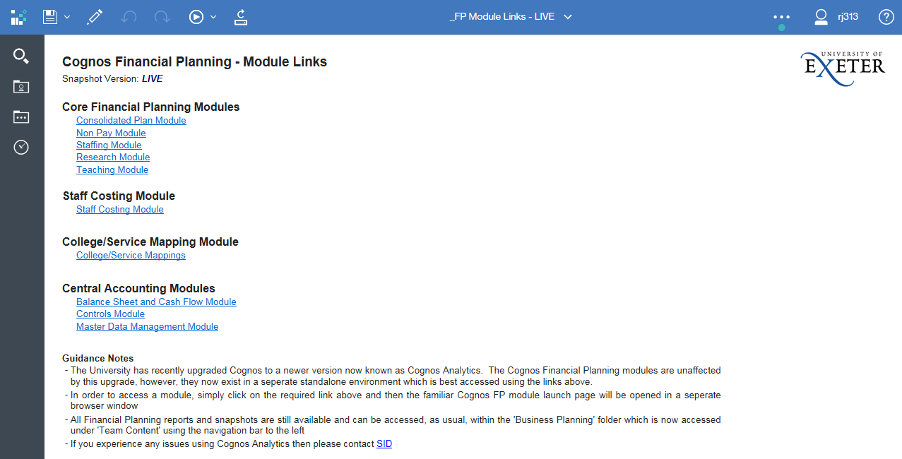
Selecting a module will then open a new browser window showing the familiar launch page for the selected module:
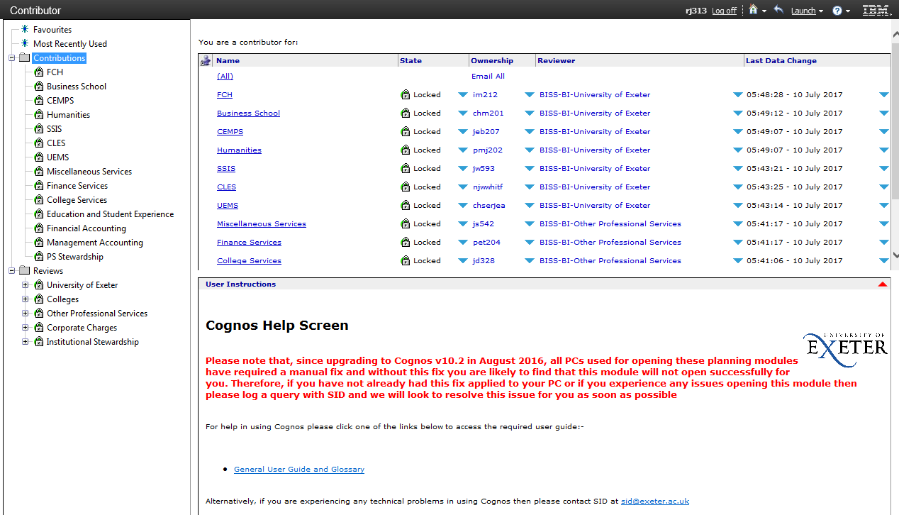
As you can see in the new Cognos Analytics Environment, within any of the individual folder of the 2018-23 Financial Plan (e.g. Teaching as below), we are able to run our familiar suite of FP reports but there are now no direct links to the module:

