YEAR END JOURNALS

Overview

At the year end, the process is such that when the system is available again (currently Tues 4th August), the defaults for creating journals would have moved to the new financial year. Any journals created normally will default to P1, 20/21.

In order to be able to post journals into the old year, special journal formats have been created to allow this.

Formats

These are the formats:

GLJNLPY Prior Year Journal Creates journal in prior year, period 13
GLJNLRPY Reversing Prior Year Journal Creates journal in P13, reverses in P1 20/21

JNLPAYPY Prior Year Payroll Journal Creates PY ledger journal in prior year, P13
JNLPAYRV Reversing Prior Year Payroll Jnl Creates PY Jnl in P13, reverses in P1 20/21

Access to Formats

Certain roles need to have access to these formats. These roles are:

Current Profile | Security Category | Note
UOE.FIN_ACCT_CASH_OPS | FIN_CASH | All Finance to have access per Tanya
UOE.FINANCIAL_ACCOUNTANT | FINACPAY | All Finance to have access per Tanya
UOE.FPR_CORE | FPRCORE | All Finance to have access per Tanya
UOE.FPR_CORE_BUDGET_ADMIN | FPRBUDAD | All Finance to have access per Tanya
UOE.MANAGEMENT_ACCOUNTANT | MGTACCT | All Finance to have access per Tanya
UOE.RESEARCH_FINANCE_MGT | RESPAY/RESPAYR | Per Bernie/Mark
UOE.RESEARCH_PROJECTS_ETL | $DEFAULT | Has access automatically
UOE.RESEARCH_SYSADMIN | $DEFAULT | Has access automatically

Access would be given temporarily until 12th August when access would revert back to normal.

Timetable

Users with profiles above will be able to post prior year journals until 5pm on 12th August.

3rd Aug to 5pm 12th Aug: All Profiles above
5pm 12th Aug to 5pm 21st Aug: UOE.FINANCIAL_ACCOUNTANT & UOE.RESEARCH_PROJECTS_ETL
From 5pm 21st Aug: UOE.FINANCIAL_ACCOUNTANT only

Templates

Two templates are used:

Master GJ Prior Year Batch Upload Journal.csv
Master PY Batch Upload Journal.csv

Uploading in CIAnywhere

The year end is set up so that all journals are uploaded rather than manually entered and they use the 2 template files. The type of journal is determined from the defaults that are entered.

These can be run via the GL Officer role in CIAnywhere:

First upload the journal file to the cloud in your $USRAREA folder

Search on Server Folders

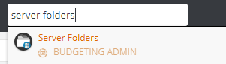

Then on $USRAREA

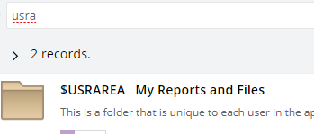

Highlight the folder and Open Folder button and Add file from local drive

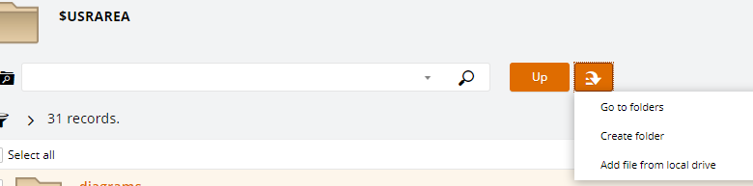

And upload the journal template to this folder.

To run the process in the GL Officer role in CIAnywhere

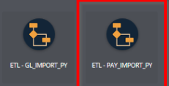
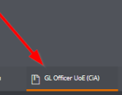

There is a separate ETL for GL journals and Payroll journals

After clicking in either the GL_IMPORT_PY or PAY_IMPORT_PY icon, select Edit at the top right of the screen to get the selection screen up:
.

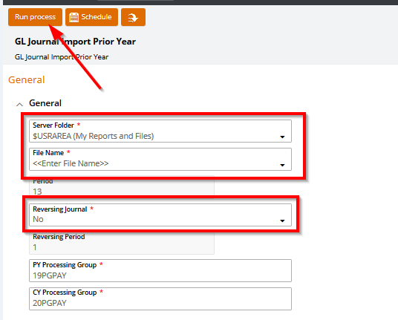

The Server Folder should default to $USRAREA

Under the File Name box, you can select the drop down and you should see the file in your User Area folder that you want to upload.

Under the Reversing Journal box, if No is selected, the journal will just post to P13
If Yes is selected, the journal will post to P13 & reverse in P1 20/21

Nothing else needs to be changed.

Click Save

Run Process to upload.

Once uploaded, go to Data Entry as normal to attach backing evidence and then Submit for Approval.

