University of Exeter – portfolio climate metrics
31 July 2023
Weighted average carbon intensity
The Weighted Average Carbon Intensity (WACI) model calculates the portfolio’s exposure to carbon-intensive companies, where carbon intensity is measured as scope 1 and 2 carbon emissions per £m sales in the previous year. This is then weighted according to the size of the holding within the portfolio.

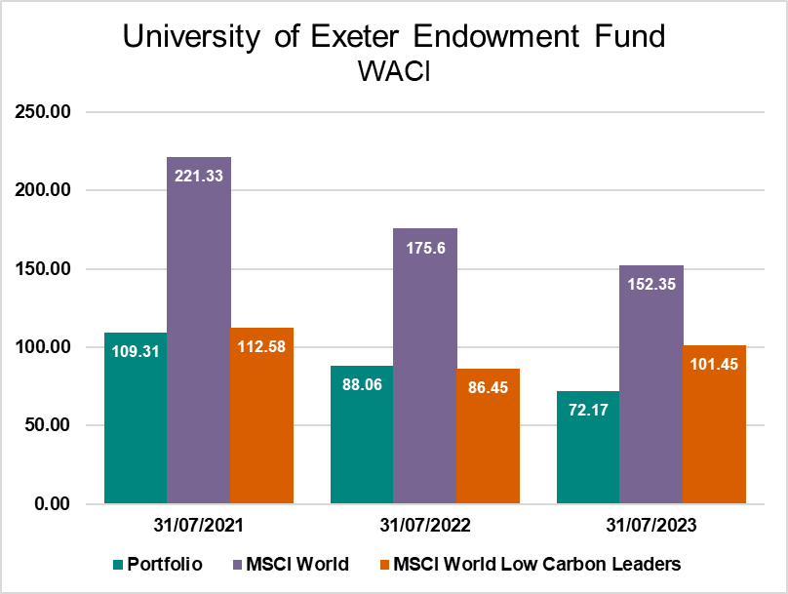
All major asset classes can be measured and compared, including fixed income, equity and managed funds. However, there is not a consensus around how to quantify the carbon footprint of certain investments such as complex financial instruments, including derivatives and short positions, as well as sovereign bonds. As such, certain managed funds cannot be reliably estimated and are therefore excluded from the measurement.

This portfolio continues to make good progress and is decreasing at a rate significantly above the EU Technical Expert Group’s recommendation of 5-7% a year.

More generally, we have seen a number of the companies in the portfolio make significant reductions in their scope 2 emissions by signing green power purchase agreements and building out their onsite renewables capacity. On the flip side, areas of challenge include the decarbonisation of heavy and medium duty fleets.

Portfolio carbon footprint
31 July 2023

This shows the carbon ‘owned’ by the equity portion of investment portfolios. It looks at the scope 1 and 2 carbon emissions reported by companies, either to the CDP (Carbon Disclosure Project) or in their annual reports, and the percentage of each company’s shares owned within a portfolio. These are then aggregated to determine the amount of carbon ‘owned’ by a portfolio through its specific shareholdings.
Comparison benchmarks are calculated by allocating the portion of the portfolio invested in equities and covered by carbon data across index constituents according to their respective market cap weightings. The FTSE 350 and MSCI World Indices are used as comparators.
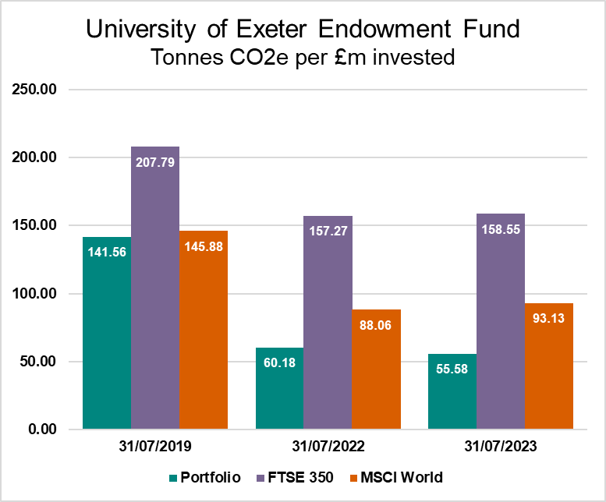
It is also possible to compare the carbon footprint of different sized portfolios by using a measure of carbon ‘owned’ per £1m invested.

Again, under this methodology, the portfolio is making good progress.

Benchmark figures are provided by MSCI.

