**Initiative to promote exercise in green spaces, free of charge. Offers possible workout locations with suggested workouts.**

**Our aim is to BREAK DOWN BARRIERS preventing people exercising (money, far away location) and encourage people to start integrating small amounts of activity into their lifestyle to improve mental and physical wellbeing.**

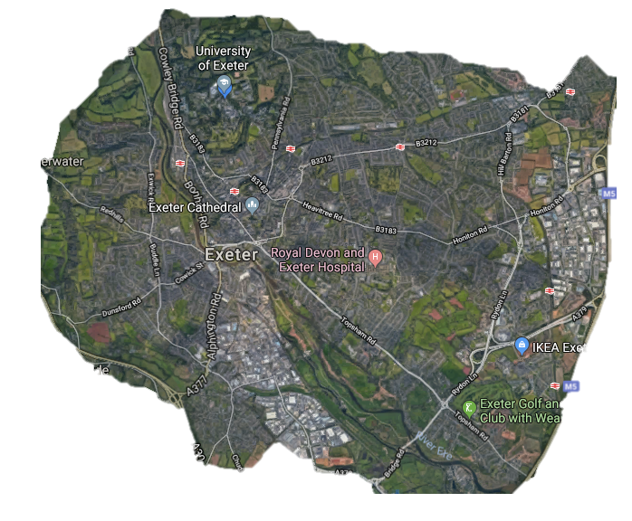

**UNIVERSITY**

Yoga and Pilates

Sprints up forum hill

**BELMONT PARK**

Outdoor gym workout using equipment

**QUAY/DUCKES MEADOWS**

Group workout

**NORTHENHAY GARDENS**

Quiet fields

Yoga and Pilates workout, can be carried out in groups.

**HEAVITREE PLEASURE GROUND**

‘weights session’ with everyday objects

**LUDWELL VALLEY PARK**

Hill sprints HIIT workout

Run up hill, 10 reps of exercise at top, walk down. Repeat with different exercise 5 times in row.

**STAIRCASE**

Sprints up and down stairs.

Include other exercises – hopping, two footed jumping.

**EXE-CISE**

**INTERACTIVE MAP, providing a range of possible, easily accessible locations to carry out exercise in.**

**Targeting Exeter University students to enhance their mental wellbeing.**

**Basic, intermediate and challenging routines using everyday objects as equipment.**

**Undertaking exercise in the outdoors, around natural elements – rather than just in the gym can also improve physical and mental energy as much as 40% – The Peninsula College of Medicine and Dentistry**

**‘**

**’**

**Improved confidence, self esteem and body image**

**Releases endorphins**

**Reduced anxiety and protects against depression**

**Reduced stress**

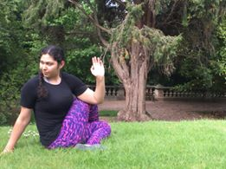

**Improved mood quality and sleep**

