Guidance for setting up your workstation

To ensure that you reduce the risk of pain and ill-health associated with DSE use, setting up your workstation correctly is vital. It is the responsibility of all DSE Users to ensure that they have followed the requirements stipulated in the DSE Standard i.e. set up their workstation and have completed a DSE Self-Assessment. By following the steps below, the layout of your workstation and associated equipment can be adjusted to ensure you are able to work safely.

It is recognised that the correct set up of your workstation may not feel comfortable at first, however it will encourage correct posture and safe working practices. If additional equipment is needed, please request these via your line manager.

When making adjustments to your workstation, you may find some items are bulky or heavy to move e.g. monitors. If this is the case, ask for assistance and do not attempt to move them yourself.

Step 1 – Chair  - The height of the chair should be adjusted so that your hands and forearms remain horizontal when you place your fingers on the middle row of keys on the keyboard  - Your elbows should be bent at 90 degrees  - There should be no angled wrist – up or down  - After adjusting the height of the chair you may find your feet are dangling or cannot be placed firmly on the floor  - Your knees must be slightly lower than your hip creating a slight downward slope (Note: too much of a slope will create pressure on the back of the thigh) | 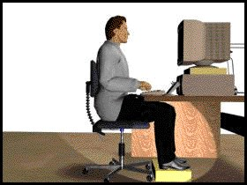
- You may require a foot rest to ensure that your feet can be placed firmly on a solid and stable surface (this will relieve any pressure on the back of the thigh)

Step 2 – Backrest  - Adjust the angle of the back rest and seat base to ensure that your back is supported when your sat in an uprights working position  - If you cannot sit back and upright without the back of your knees touching the front edge of the seat i.e. able to fit a clenched fist in the gap, you may need to change your chair to one with a shorter seat base  - If you have a large gap between the edge of the seat and the back of your knee the seat base is too short for you and a larger seat base is required to fully support your legs (hip to back of knee)  - Adjust the back rest support so that it supports the lower region of your back (curve) | 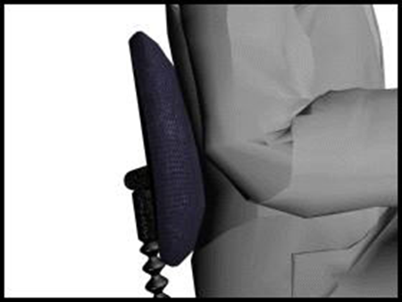
NB: If the back rest does not fit into the curve of your back, you may benefit from additional back support
Step 3 – Arm Rests  - If you cannot position yourself close enough to the desk because the armrests are in the way you may need to have them removed, if they are not height adjustable and cannot be lowered sufficiently to be clear of the underside of the desktop  - Your arms should hang straight under your shoulders in line with your body and your elbows bent to 90 degrees (as noted above in step 1) | 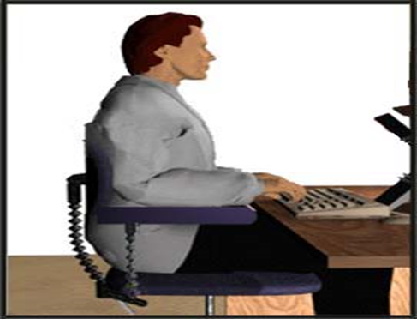
NB: You should not rest your arms on armrests whilst typing or operating a mouse

Step 4 – Desk  - Ensure that you are sitting directly in front of the monitor and keyboard  - Sit close to your desk, allowing for your wrists to be supported by the desk when you are not typing  - You shouldn’t put anything between the keyboard and you e.g. papers  - If you often have to refer to documents whilst typing, you may benefit from a document holder  - The document holder should be placed at the same height and distance from you as your monitor or between the keyboard and screen | 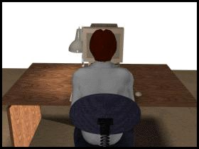
- Cables should not be trailed across the desk, a cable management system should be used and cables threaded up through the holes on the desk (if fitted)
- The use of extension leads should be avoided where possible
- Equipment e.g. mouse, keyboard, heaters should not be brought in from home
- Position any additional equipment e.g. phones, paper trays and notes in an accessible place to avoid twisting and overstretching

Step 5 – Keyboard and Mouse  - The keyboard should be positioned directly in front of you  - Your elbows should be vertically under your shoulders and your fingers should naturally cover the middle row of keys  - The mouse needs to be positioned as close to you as possible next to the keyboard (to the left or right depending on your preference)  - Your mouse should be used with your elbow vertically under your shoulder and close to the side of your body (left or right depending on your preference) | 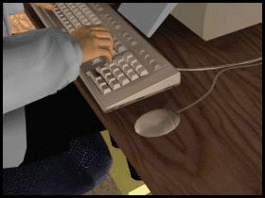
- If you have a laser mouse you don’t need a mouse mat, if you have a mouse with a ball you will need a mouse mat

Step 6 – Monitor  - The height of the monitor should be adjusted so that, when you are in a seated position in front of the monitor looking straight ahead, your eyes are level with the top of the screen i.e. toolbar  - The height of the monitor can be adjusted by raising the screen on the stand (if fixed with a height adjustable function) or by using monitor risers or other sturdy item e.g. box files. You must ensure that this is stable and able to support the weight of the monitor  - Your monitor screen should be cleaned regularly so that text and graphics can be read and viewed clearly | 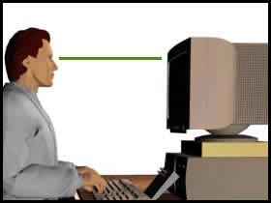
- Your head (in neutral position) is recommended to be positioned approximately an arm’s length away from the monitor, whichever distance is most comfortable
- The screen quality and settings should also be considered for comfortable viewing of graphics and reading text
- It may also be comfortable to have the monitor tilted upwards slightly from the vertical line

NB: If the height and/or distances noted above are not comfortable, consider referring to the eye sight test section of the DSE standard. In addition, the monitor height may need to be different e.g. lower for those who wear varifocal lenses.

Step 7 – Environment  - Temperature and humidity should be adjusted to ensure you are comfortable  - If you suffer from dry eyes you should seek medical attention  - Eliminate glare or reflections on your screen by closing blinds or, if possible, move the workstation so that it is at right angles to the window | 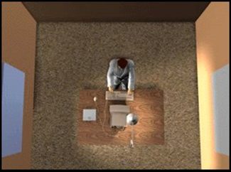
Step 8 - Carry out a DSE Self-Assessment

