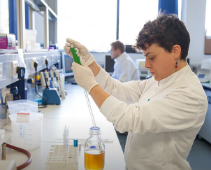
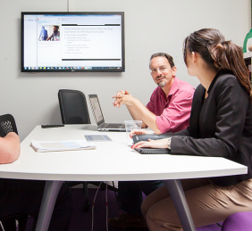
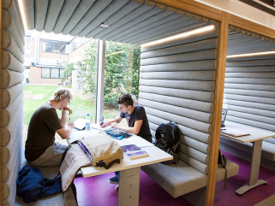

In delivering its vision, the University is committed to providing a working environment with a culture where staff are able to work effectively and flexibly, with access to appropriate tools, training and space, while ensuring sustainable and efficient use of its resources.

The University of Exeter is a leading, internationally recognised higher education institution and our driving ambition is to become a global 100 research leader and create graduates of distinction within a community of the most talented and creative minds.
We believe that:
- we work at our best in active collaboration, between colleagues and external partners;
- we support and inspire each other to be the best that we can be;
This policy, which applies to all of our campuses, represents our aspiration to provide a sustainable estate that can:  - meet the diverse range of requirements for space,  - provide space that is fit for purpose and in sound condition and,  - provide workplaces that meet the needs of your workstyles.  It will be applied with sensitivity, when appropriate opportunities arise.  It is the University of Exeter’s aspiration to provide a working environment for all staff that supports a range of ways of working, collaboration and a strong supportive community, wherever you might work. This will be supported by working together and linking with HR flexible practices while using IT to provide appropriate tools for connected and more mobile staff. | In particular the policy aims to:  - ensure that all staff have access to appropriate good quality working space;  - comply with all legal requirements and other requirements to which the University subscribes;  - set and communicate clear principles, quantifiable space objectives and parameters;  - define responsibilities for administration and governance;  - ensure that we use our estate wisely and thus maximise investment opportunities;  - encourage and support staff to think imaginatively about how they use space and their options for working flexibly.  The Provost has ultimate responsibility for the management of our space. All staff are asked to contribute in delivery of this policy.  Professor Janice Kay  July 2015
- to make the exceptional happen, fresh ways of working and solutions with impact are required.
Introduction
1.1 A key strategic objective of the University is to ensure that the estate effectively meets the diverse range of staff and student requirements and that space is allocated according to need.
The University of Exeter acknowledges that space is an expensive and limited resource and recognises that effective management is necessary, to ensure the available space meets the strategic objective of providing a sustainable estate that is of optimum size, fit for purpose and in sound condition.
All staff are actively encouraged to support the policy to ensure that the University can work towards providing better workplaces for everyone and focus new investment to best deliver our institutional aims and ambition.
1.2 This space management policy document sets out the over-riding management principles that the University will adopt in order to effectively manage and allocate space across the entire University Estate across all campuses and buildings for the common good of all users.
6.0 Workplaces
6.1 The working environment of the University should be designed and adapted to support the University’s core vision by focusing on:
- Sustainability- ensuring careful and efficient use of available resources.
- Adaptability- Space should be adaptable and designed for long term reconfiguration. Flexible workspace and working practices which harness the use of technology should be encouraged to maximise utilisation of offices and workstations.
- Working Together and Supporting Partnership – Spaces should always aim to support collaboration as well as individual concentration and should provide a welcoming environment for students and our partners.
6.2 The University aims to work towards an average work space allocation of between 5 and 10m² NIA (Net Internal Area) per person (FTE) with no individual allocation above or below this. No workstation for staff which can be occupied for long periods (touch down settings excluded) should be in space standards below those outlined in the Workplace (Health, Safety and Welfare) Regulations 1992 – Regulation 10.
6.3 Allocation of Workspace for new projects - The exact mix of spaces will be defined in consultation with the project monitoring group to ensure it meets strategic aims and specific user requirements.
6.4 Members of staff should not have more than one allocated office or workstation. Where current responsibilities require staff to work between two buildings, a workstation will be available in the secondary location but there may be a requirement that this is shared.
6.5 Staff visiting for more than 6 months on a full time basis will normally be provided with a dedicated workstation within a departmental area if it is required and available.
6.6 Staff visiting for less than 6 months, part time lecturers or staff on less than 0.5FTE will normally be provided with shared workspace and access to department facilities in shared office accommodation if requested and in line with what facilities are available.
6.7 Fully retired staff will not normally be provided with office accommodation. Exceptions required specific support and endorsement by the College Dean.
6.8 All requests for cellular space will be considered in terms of work style and may be reviewed or reallocated at regular intervals to ensure the estate is effectively supporting the University’s objectives.
6.9 All workspaces, including all cellular offices, must be made available for use by others during periods of low utilisation that are expected to be 3 months in length or greater.
6.10 For all staff whose workstyles allow, the preferred model will be to locate staff in shared office accommodation with a space allocation that supports their business needs.
6.11 All existing cellular offices with an area greater than 12m² NIA should aim to be occupied by at least 2 full time staff whenever possible within the limitations of building’s fit factor. Extension of departmental cellular office accommodation will be considered less favourably where this has not been achieved.
6.12 Sizing of Spaces
6.12.1 Where cellular offices are provided, the standard area provided for all grades of staff will be 9m² NIA, unless the layout of existing accommodation precludes this.
6.12.2 Individual offices will be sufficient for meetings between two or three people, but are not intended for larger meetings or tutorials. Instead, small bookable shared meeting spaces should be provided.
6.12.3 Open plan office space will be designed on a basis of between 5-8m² NIA per workstation and configured depending on the specific needs of the team using the space. This should aim to include an allowance for quiet work areas and meeting spaces.
6.12.4 All individual workstations will have a desk size in line with workplace guidelines document depending on the configuration of space. Personal and team storage space will be provided within each team’s works area and this should aimed to be aligned to best practice, as outlined in Space Guidelines.
6.12.5 Additional space to accommodate supporting facilities (including printers, recycling, tea pointers and cleaning stores) in line with the space guidelines should be provided to ensure user needs can be adequately meet.
6.13 Configuration of workplaces on grounds of confidentiality, security and privacy
6.13.1 Where sensitive and/or personal data is utilised as part of the office activity, this requirement must be clearly articulated. There are office management and IT implications for the use of this data related to the provision of secure digital and physical storage solutions, which can only be accessed by authorised staff. While the existence of this requirement will not preclude the use of open plan workspaces, the spatial and physical security of the office environment will take into account the need to mitigate casual observance of restricted data on screens or desks. Data sensitivity is not a justification or a requirement for cellular space.
6.13.2 Access to private accommodation for private phone calls can be made through the provision of quiet rooms in new shared office areas or through management solutions, which facilitate access to offices when they are unoccupied.

This policy recognises that those who are lab based require use of a separate workspace for write-up therefore this clause excludes workspaces within controllable laboratory environments.
The “fit-factor” refers to the ability of a building to accommodate change and the reallocation of space.

