Name of Inductee: Job Title:
Line Manager: Contact Details:
Induction Facilitator: Contact Details:
Buddy: Contact Details

Start Date:

Managers’ Onboarding Guidance

- The following guidance is aimed at assisting line managers through the process of onboarding new staff. You should also use the relevant induction checklist for your new joiner to help organise the onboarding programme and to help guide your conversations. Each new joiner will have slightly different requirements and needs, please consider the individual when putting together their onboarding programme.

- Once the interview and selection process has been concluded, a job offer will be made to the successful candidate. This will usually involve a verbal discussion, in which the terms of the offer will be agreed with the candidate, including the salary and start date. This is followed by the issue of a binding contract, which is subject to the satisfactory completion of the university pre-employment screening process. This screening includes confirmation of the candidate’s eligibility to work in the UK. Line managers, with support from induction facilitators, are key to ensuring that once the job offer has been made the staff onboarding process begins.

- Elements of the onboarding process (the induction checklists) must be covered and have mandatory tasks within them. However, the wider onboarding process is about making a new colleague feel welcome and settling them comfortably into their role. You might delegate parts of the onboarding process to induction facilitators, specialist departments or buddys, however, the line manager should take the lead in welcoming the new colleague and ensuring that they understand their role and the tasks within it.

- Colleges, Departments and Services might have additional inductions that cover specific local requirements, these should be delivered in addition to the information in the induction checklists and not replace them.

- Homeworking: Where homeworking is permitted, it is understood by both parties this is only permitted in UK territory, from a personal address in the United Kingdom. Employees of the University are not authorised to deliver work on behalf of the University from outside the United Kingdom, unless expressly agreed in their contract of employment or for short overseas business or research trips agreed by your department and Human Resources. For more information about working overseas please visit our Global Mobility Webpage .

Policy Statement
The University has a code of practice for onboarding which sets out our policy and guidelines.

Policy Statement
The University will ensure that:
- Each College/Department has nominated induction facilitators who are responsible (with the line manager) for organising elements of the induction of new staff. The induction facilitator may be the line manager or someone else within the College/Department.
- It is the responsibility of the College/Department to advise People Development of any deletions or additions to their list of induction facilitators to peopledevelopment@exeter.ac.uk
- The onboarding process is applied in line with the University’s Equality, Diversity and Inclusion policy of fair treatment of its staff, potential staff or users of its services.
- All staff employed are given the same core information. In order to achieve this, as a minimum, the line manager and induction facilitator will work though the relevant induction checklist within the first few weeks of employment.
- The Line Manager will complete Probation reviews and a Performance Development Review (PDR) within three months of commencing work with the new starter.
Guidelines
In order to achieve the aims of the Policy Statement onboarding should:
- Start from the moment that a new member of staff is appointed, first impressions are important.
- Cover all essential information at the earliest opportunity.
- Address the generic areas of induction.
- Line managers or Induction facilitators should introduce all new staff to their onboarding timetable.
- Have no specified length for the process as individuals will have different needs but it will typically be carried out over several weeks.
- Have time allocated to it so that the new member of staff does not feel rushed and be timetabled so that an employee, and those involved in the induction, has a clear plan of what will be covered and when. This needs to be planned before they commence work and should take effect from their first day of employment.
- Be evaluated by the new member of staff, line manager and the induction facilitator at regular intervals (People Development will undertake this task).

Bespoke Inductions should be considered when designing an onboarding programme (these are to be used in addition to the generic check list, they do not replace it):

- COVID-19 Return to Campus: An additional induction is required if staff are returning to any campus or University of Exeter run site. The Covid-19 Information and Advice site provides relevant information.
- Line Managers: Members of staff who will be taking on a line management role must complete the associated induction checklist in addition to this list (coming soon).

Pre-Arrival:

Action | Detail | Suggested lead | Completed
Appointment checklist
ESR1 | Complete the appointment tab on the eSR1 and submit to the recruitment team. | LM
Issue contract paperwork | The recruitment team will prepare and issue the contract paperwork on your behalf, and confirm progress with you. | Recruitment Team
Right to work (RTW) check | If the RTW check was completed at the interview stage please ensure the documents are submitted to the recruitment team. If the check was not completed please inform the recruitment team who will manage this on your behalf.  Please note that the candidate will not be able to start their role until this check has been completed. | LM / Recruitment Team
Pre-employment screening | The recruitment team will confirm the details and status of any pre-employment screening checks that are required for this position. This may include employment references, a pre-employment medical check, and DBS checks. | Recruitment Team / HR
Onboarding Programme planning
Following the acceptance of the offer, there are a number of steps a manager must take in preparation for the applicant’s start date.
Welcome communication | Communication is key to making someone feel welcome to their new role. As soon as the post is confirmed send out an email, letter or have a telephone conversation to welcome them to their new role - see the end of this checklist for possible wording. | LM
Induction Facilitator (IF) | If required nominate your IF on the ESR1 form. To find out who is available visit the onboarding web pages (in the Line Manager and IF Guidance section). Confirm they are available and able to support the programme. It is vital that they are contacted prior to being nominated. | LM
Create an onboarding timetable | Use the induction checklist and information in this guide to create an onboarding programme. Consult with your induction facilitator about who will cover each part. | LM/IF
Assign a buddy | If relevant assign a buddy from your team. More guidance about the role of a buddy can be found on the onboarding web pages (in the Line Manager and IF Guidance section). | LM
COVID 19 considerations and requirements | Confirm the current requirements whether working from home or at a university managed site. If coming to a site confirm Current Requirements | LM and relevant Building Manager
Desk space | Communicate with the new colleague in order to confirm where they will be working and what support they might need (equipment, access etc). | LM/IF
Remote / Home working | If the new joiner will be working remotely make sure they have the equipment and support they need to get going. | LM or IF
Identify and arrange training | Consider training that can be booked prior to the new joiners arrival:  - IT Training  - Role specific training  - Health and Safety training  - Work shadowing / process training  - Check whether the role requires additional mandatory training, for instance Corporate Conscience, H&S, specialist equipment and line management courses. | LM
Identify and arrange 1:1 meetings | Consider those individuals who are vital for the new joiner to meet early on. Also consider how wider team members will meet new members of staff. | LM
Access issues | Confirm any access issues early if possible with Occupational Health team | LM
Probation requirements | Make sure you are happy with the requirements of the new joiner’s probation. Start to consider some simple work objectives for the probationary periods. | LM
IT account request | Request an IT induction for the new starter, approximately 2 weeks before the new member of staff is due to start. Confirm between yourself and the induction facilitator who is receiving the IT account details (if you have nominated an IF on the ESR1 form they will receive the details). | LM
IT equipment | The logistics of getting appropriate IT equipment ordered and sent to the new employee can take time. As soon as the new position is confirmed IT equipment should be ordered to prevent any delays. | LM (likely via / with support from College Ops staff)
International Staff | Are your staff working or coming from abroad? If so ensure you have read the information about Global mobility guidance for manager | LM
Connecting with your team | Talk to the wider team about their role and the new starter’s onboarding. How and when will everyone meet? | LM
Assign a Buddy? | Discuss the possibility of having a buddy or mentor from your team who can help you through those early stages. | LM
Day 1 meeting arrangements | Communicate to the new joiner who will meet them and where. If meeting on campus also consider discussing lunch options. | LM
Timetable review meetings | Block out time in your own calendar to catch up with the new joiner regularly in those first few weeks | LM

Day 1

The first day of work should be about feeling part of the team and getting those mandatory parts of the induction process completed. This can sometimes be a tricky balance between giving the new member of staff time to absorb information and getting key tasks achieved. Consider the role the new colleague is undertaking and try to order the programme so that the vital parts are covered in the first few days, spread the rest out over the next few weeks. Perhaps start with:

- Meet the new member of staff – informal chat and introductions
- Run through the onboarding programme with them so they know who they are meeting and why.
- Meet the induction facilitator (if relevant) - get the IT set up
- Start to run through the induction checklist including the mandatory training
A few further considerations:
Dos
- Be there!
- Assign and introduce their induction facilitator and buddy (if assigned)
- Make them feel welcome
- Cover the essentials on the checklist
- Appreciate that they may be nervous
- Plan in review meetings
Don’ts
- Give them a stack of paperwork/manuals to read on the first day
- Leave them alone for long stretches of the day
- Expect them to remember everyone’s name after the first day.
- Expect them to go around and introduce themselves
- Think that the first day is the end of your involvement. You need to plan the first few weeks with them carefully.

Beyond Week 1:

As well as your new starters first day, you also need to consider a plan of activities for the first few weeks (it is suggested that, as a minimum, the first two weeks follow a schedule). Your induction facilitator might continue with the induction checklist but as the manager you should consider having those wider conversations around probation, performance review and of course working environment and wellbeing.
Each day should concentrate on an aspect of the individual’s job role and involve meeting key stakeholders and colleagues who may impact upon their job. Don’t book events or meetings “back to back”; plan in time for the individual to reflect and write up notes.
It is important that each week there are review sessions with the line manager. Regular review meetings help to build up a working relationship, provides the new starter with the opportunity to ask questions and enable the manager to assess how the individual is settling in.
Consider using the pillars below to frame your wider conversations:
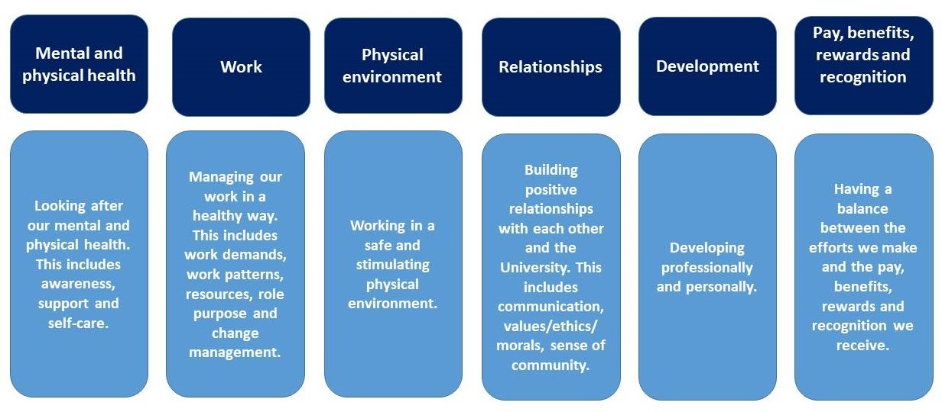

POSSIBLE WORDING FOR INITAL WELCOME EMAIL – THIS IS GUIDANCE ONLY

Subject: Welcome to the University Of Exeter - onboarding information

Dear [NAME]

Congratulations on your appointment with the University of Exeter, we look forward to welcoming you to [NAME OF COLLEGE/SERVICE/DEPARTMENT] on [START DATE].

Your role will be working [ON XXCMAPUS / REMOTELY FROM HOME] and we will be in touch soon to confirm details about how this will work and to make sure you know where to be on day one.

I have connected you with an induction facilitator [NAME] and they will also meet with you on your first day to confirm details of your induction programme. [NAME] can be contacted at [EMAIL ADDRESS] or by phone on [PHONE] if you have any questions about your induction prior to your start.

If you have not already done so, please bring a copy of your passport and/or any other accepted document relating to your right to work in the UK on your first day. Unfortunately you will not be able to commence your employment if we have not verified your right to work. Please let me know as soon as possible if you will have any problems providing these documents on your first day or if you have any further questions about this check. For further information please visit the University of Exeter website http://www.exeter.ac.uk/staff/employment/righttowork/proof/

When you arrive we will arrange for you to receive a UniCard. The UniCard identifies you as a staff member at the University and is required to access buildings and online electronic resources, as well as providing certain travel discounts. Once you have returned your contract you are able to apply for your Unicard by emailing universityreception@exeter.ac.uk with your name, date of birth and photo. The Unicard will be prepared in advance and ready for you on your first day.

Once again, congratulations on your appointment and I look forward to meeting you. Please do not hesitate to contact me if you have any questions before you join,

Yours sincerely

POSSIBLE WORDING FOR FOLLOW UP WELCOME EMAIL – THIS IS GUIDANCE ONLY

Subject: Welcome to the University Of Exeter - onboarding information

Dear [NAME]

I hope you are well, we look forward to welcoming you to [NAME OF COLLEGE/SERVICE/DEPARTMENT] on [START DATE].

Campus working: As discussed (if previously agreed) on your first day, you should arrive at [BUILDING] reception at [TIME] and ask for [NAME – LINE MANAGER OR BUDDY/INDUCTION FACILITATOR]. Do get in touch if you have any queries about travelling to the University.

Remote working: You will be working remotely to start with, we will chat through how this works and how we can support you remotely.

I have connected you with an induction facilitator [NAME] and they will also meet with you on your first day to confirm details of your induction programme. [NAME] can be contacted at [EMAIL ADDRESS] or by phone on [PHONE] if you have any questions about your induction prior to your start.

For further information on transport information to the University please visit the University of Exeter website pages:

If you have not already done so, please bring a copy of your passport and/or any other accepted document relating to your right to work in the UK on your first day. Unfortunately you will not be able to commence your employment if we have not verified your right to work. Please let me know as soon as possible if you will have any problems providing these documents on your first day or if you have any further questions about this check. For further information please visit the University of Exeter website http://www.exeter.ac.uk/staff/employment/righttowork/proof/

When you arrive we will arrange for you to receive a UniCard. The UniCard identifies you as a staff member at the University and is required to access buildings and online electronic resources, as well as providing certain travel discounts. Once you have returned your contract you are able to apply for your Unicard by emailing universityreception@exeter.ac.uk with your name, date of birth and photo. The Unicard will be prepared in advance and ready for you on your first day.

Once again, congratulations on your appointment and I look forward to meeting you. Please do not hesitate to contact me if you have any questions before you join,

Yours sincerely

