eClaims Claimant Guide – Hours Claim

Table of Contents
Hours and Breaks 2
eClaims 3
Logging in 3
My Account Page 3
Adding a claimant profile 5
Adding additional claimant profiles 6
Creating Your Hours Claim Timesheet 6
Submitting Your Hours Claim Timesheet 8
eClaims notifications emails 9

Hours and Breaks
All Claimants
Must take a minimum uninterrupted break of 20minutes if working more than 6 hours each day – breaks are not paid
Must have a rest period of 11 consecutive hours in each 24 hour period.
Must also have at least one day off a week; this can be averaged over 2 weeks.
All Claimants should not be exceeding a 36.5 hour working week.
Any claims inputted over 48hours will be paused and require further approval.
All claimants cannot submit a claim longer than 12 hours per day.
Workers aged 16/17
If a young worker is required to work more than four and half-hours at a time, then they are entitled to a break of 30 minutes. A young worker is also entitled to twelve uninterrupted hours in each 24-hour period in which they work. Young workers are also entitled to 2 days off each week and this cannot be averaged over 2 weeks.
Visa Restrictions
Those users on a Tier 4 General visa are not able to work more than 10/20hours per week depending on the stipulations of their visas.
PhD Students
Those users who are doing a PhD at the university will not be able to exceed more than 15hours a week due to university guidelines.

eClaims

Logging in
- With the I.T. account details your line manager has provided you with, you should be able to login to eClaims. If you login with any other type of University of Exeter I.T. account the system will allow you access but you will be asked for a payroll number to be able to submit your claims. If you have forgotten your password you will need to contact the SID desk to get this reset.

My Account Page

- Every user will be taken to the “My Accounts page” after logging into eClaims
- Here you will be able to easily see if you have successfully provided us with your right to work information, entered your payroll number and provided us with further information regarding the type of Claimant you are.
- If any of your sections appear in a red box and require further information you can click on this symbol within the, my accounts page.
- This page will show you all your Active Job role profiles and a list of current claims (Approved, Rejected, In approval or Draft) will be displayed at the bottom of the screen based on the previous Claimant cut-off date
- Please set your claimant type accordingly because if you do require a Visa to work in the UK your timesheets will be changed accordingly based on the stipulation of your Visa agreement. PhD students also have limited weekly timesheets also
- If you are unsure what any of the sections mean you are able to take a visual tour of the page by clicking this Icon.
- Terms and conditions of the university and working restrictions can be accessed by this Icon

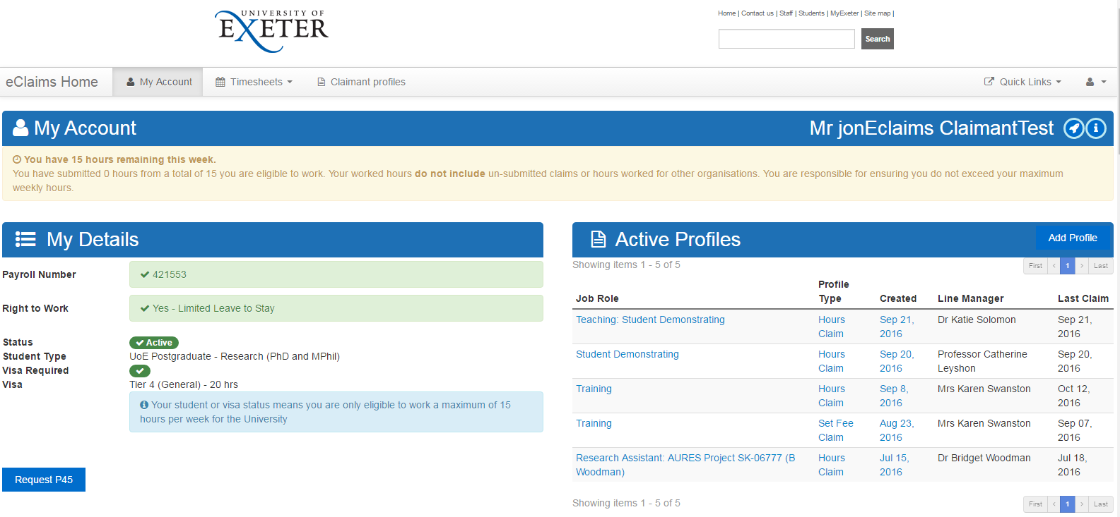
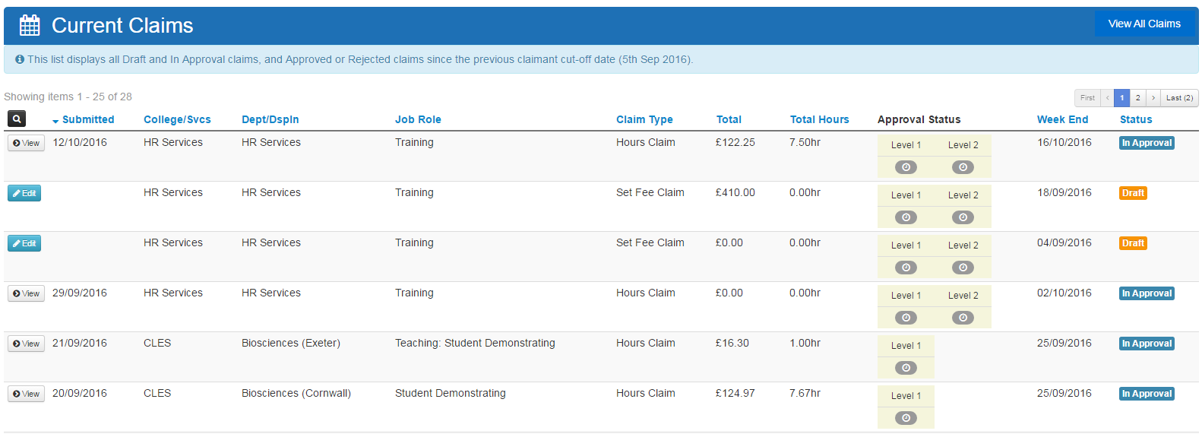
- If you have a restriction on your Account by either your student status or visa restriction this will show at the top of the my account page. And again in the blue box under your student type / Visa requirements.

- If you require to request a P45 this can be done from the My Accounts page under the Request P45 option. You would need to request this and then click Save on your details.
If you select this option you will see that your status will go from active to inactive and you will also get this message. By selecting this option you will not be able to submit any timesheets on the system and will be made a leaver on our payroll system.

Adding a claimant profile
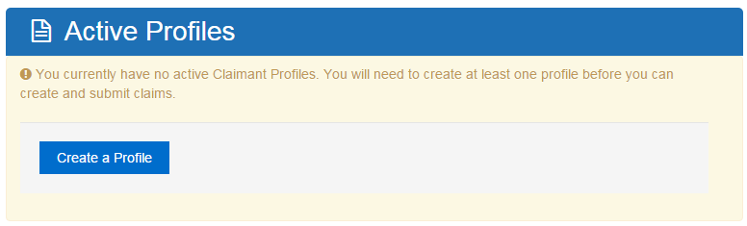
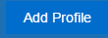
- On the “My Accounts page” under “Active Profiles” you will be able to add a new Claimant profile to the system if it is the first time you have used the system. Or using the Add profile option
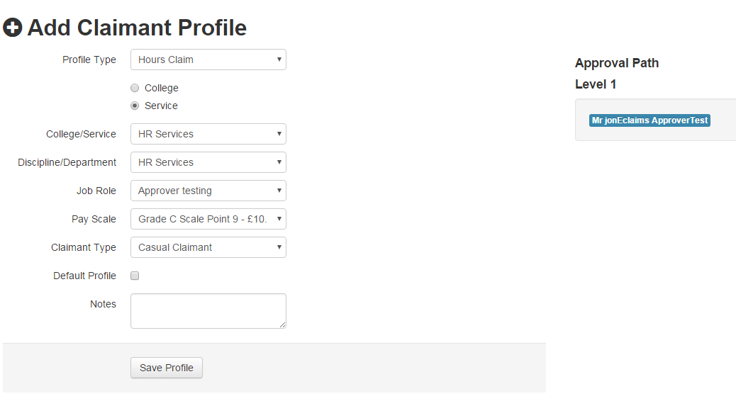
- Your line manager should have provided you with the information to be able to select from the follow drop down to create an Hour claimant profile.
- Please Note: You may see additional Approval Path levels, however on Level 1 you should be seeing your line managers name if you have selected the correct options.
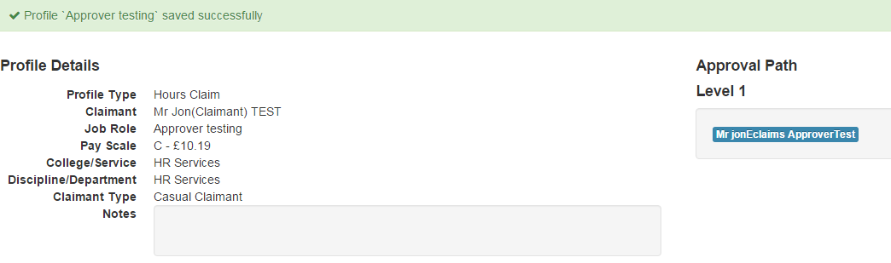
- Once you are happy that your profile is correct please click save profile and you will see this confirmation.

Adding additional claimant profiles
- You can also add additional claimant profiles on the Claimant profile screen as well as the accounts page, if you have other jobs at the University, by clicking Claimant Profiles and then Add Profile
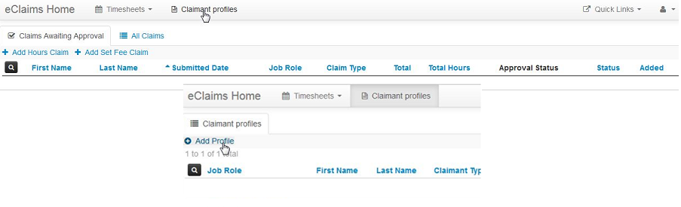

Creating Your Hours Claim Timesheet
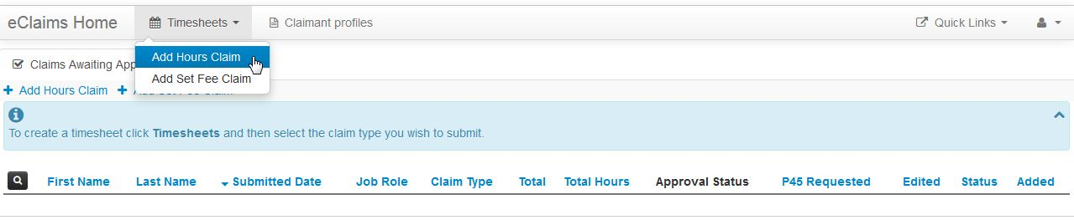
- Click Timesheets and then Add Hours Claim.
- Select the Job Role you wish to claim for from the dropdown list.
- Then fill the Start Date and Time followed by the End Date and Time for the Claim period. Please put your claim to the nearest 5 minutes of your shift.
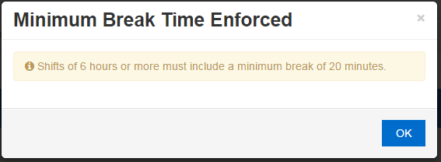
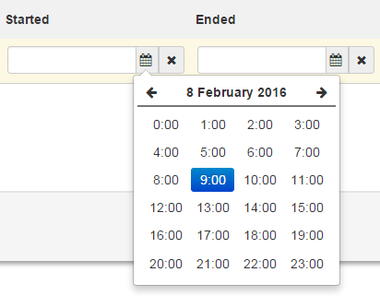
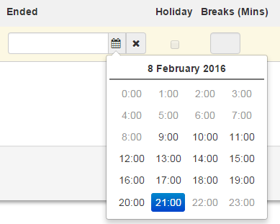
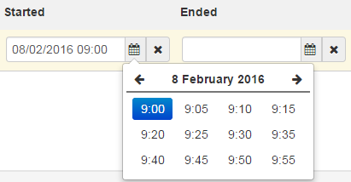
- Please enter any break taken in minutes. Please Note: if you do not enter a break and work over 6hours the system will enforce an automatic unpaid 20minute break.

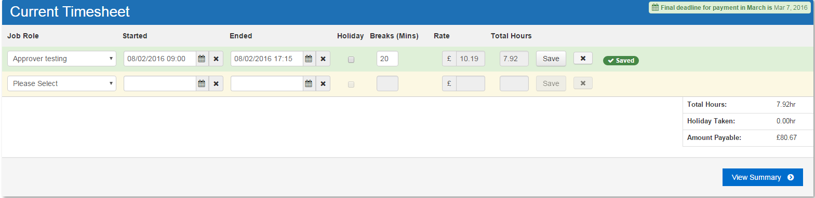
- Once you have inputted all the information for that Shift, please click Save and a new row will be automatically added to the timesheet if required.
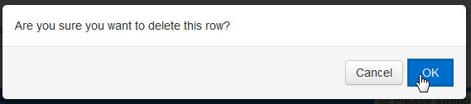
- To remove any of the rows of information please click the X button to delete that Row. Once clicked you will be asked to confirm that deletion.
- The row will then go red and then disappear from the current timesheet.

- If you notice you have selected the wrong time or inputted the wrong about of time for you break you can edit this but you will need to click Save again to update the changed.

Submitting Your Hours Claim Timesheet
- Once you have completed your timesheet Click View Summary. Please Note: We recommend that you submit your timesheets on a weekly basis
- You will then be taken to a summary page where you can review your timesheets split into rows by week ending dates.
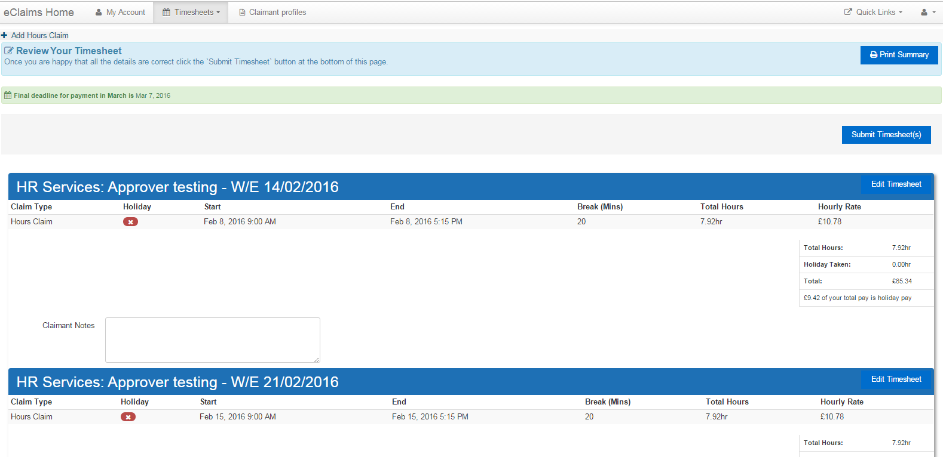
- On this screen you can Print a Summary of this timesheet if required, Edit the current Timesheet to make any corrects and if it looks correct you can then Submit Timesheet(s)

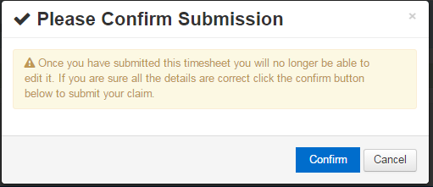
- Once you click Submit Timesheet(s) you will receive this confirmation message
- Please Click Confirm to confirm submission of this timesheet. Please Note: Once you have done this you will not be able to edit this timesheet again.

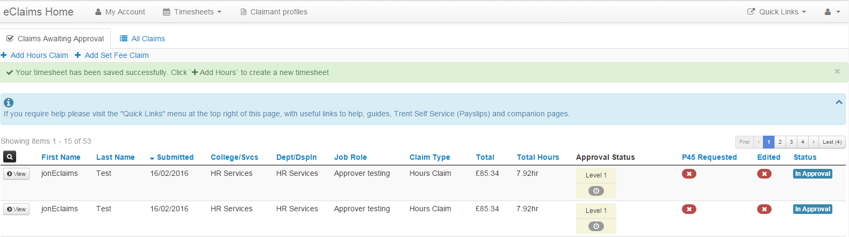
- Your timesheet will then be sent for Approval and you will be return to the claims awaiting approval screen to see that this has been submitted successfully.
- Your two timesheets will be split out into two separate claims automatically due to having different weekending dates.

eClaims notifications emails
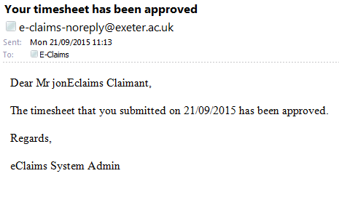
- If the claim has been approved you will receive this notification.

- If the Claim has been rejected you will receive this notification with rejection reason.
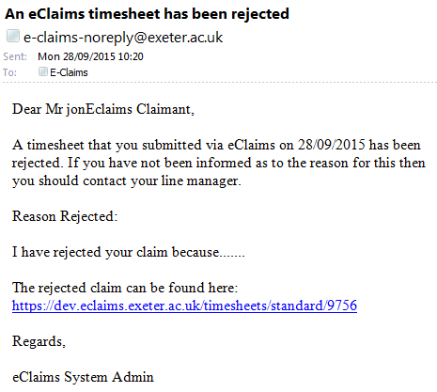

- If your claim exceeds 36.5 hours you will receive this warning

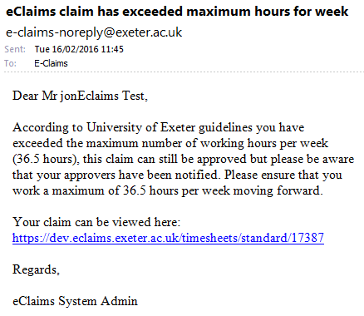

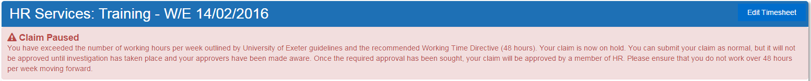
- If your claim is submitted over 48hours you will receive this warning on your timesheet plus an email. Please Note: Claim can still be submitted.
