eClaims Approver Guide – Approving Add Hours/ Set Fee Claims

Table of Contents
Hours and Breaks 2
Logging into eClaims 3
My Accounts page for Approvers/Admin’s 3
Adding Costcodes 4
Viewing a Timesheet 5
Approving an hours claim 6
Approving a Set Fee claim 8
eClaims System Notification emails. 8
Claimant’s Notification emails. 8
Approver’s notification emails 9

Hours and Breaks
All Claimants
Must take a minimum uninterrupted break of 20minutes if working more than 6 hours each day – breaks are not paid
Must have a rest period of 11 consecutive hours in each 24 hour period.
Must also have at least one day off a week; this can be averaged over 2 weeks.
All Claimants should not be exceeding a 36.5 hour working week.
Any claims inputted over 48hours will be paused and require further approval.
All claimants cannot submit a claim longer than 12 hours per day.
Workers aged 16/17
If a young worker is required to work more than four and half-hours at a time, then they are entitled to a break of 30 minutes. A young worker is also entitled to twelve uninterrupted hours in each 24-hour period in which they work. Young workers are also entitled to 2 days off each week and this cannot be averaged over 2 weeks.
Visa Restrictions
Those users on a Tier 4 General visa are not able to work more than 10/20hours per week depending on the stipulations of their visas.
PhD Students
Those users who are doing a PhD at the university will not be able to exceed more than 15hours a week due to university guidelines.

Logging into eClaims
- Your College/Service super user should set your access up to the system. You should log into eClaims with your normal University of Exeter I.T. account details

My Accounts page for Approvers/Admin’s

- Every time you login to eClaims you will be now taken to the My Accounts page
- On here you will see when the next approval deadline is and also claims that require your approval rather than All Claims
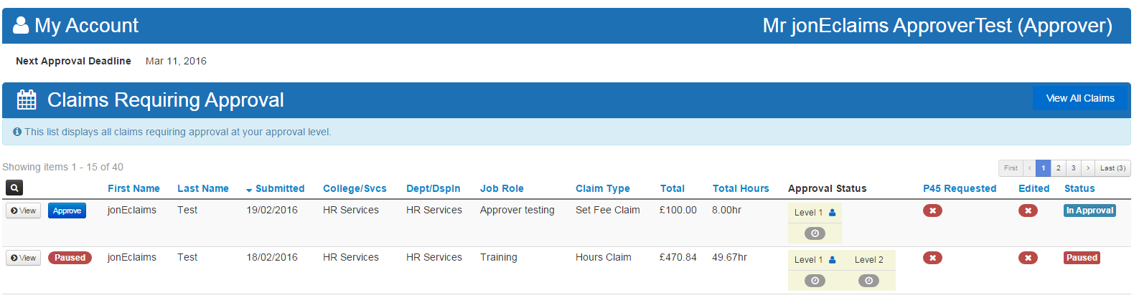
- On this page you will see all claims require approval as well as any paused claims that might be in view.
- If you login and you have no claims awaiting your approval you will see this message on the “My accounts page”.
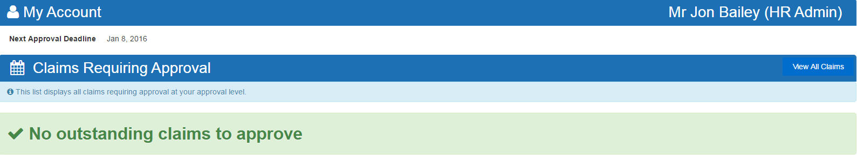
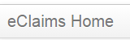
- To See all claims or to export any reports then please click on eClaims Home

Adding Costcodes
- Before you can authorise the hours a person has worked, you must define a cost code against which they will be paid. If you are unsure of what the code should be, contact your departmental finance team.
- Once you have entered or copied a cost code, it will remain in the system for the next time you log in. The code must currently be valid in the APTOS system, or it will not work.

- Click Costcodes.

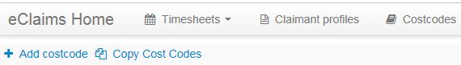
- Click Add Costcode or Copy Costcode.

- Enter an identifiable name for your new costcode. This name is not visible to anyone else and is just to help you quickly identify the costcode.

- Enter the costcode (you can copy and paste the costcode from another system or document). You can also copy a costcode from another user to your user profile.
Please note: Costcodes can only be a maximum of 39 Characters.

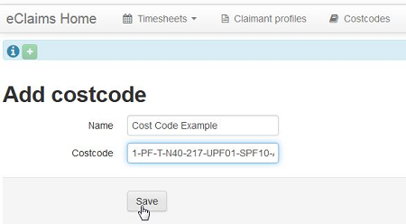

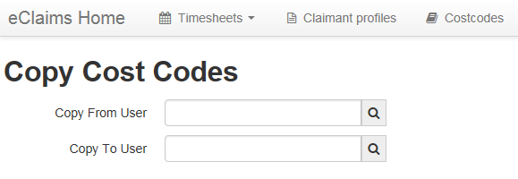

- Click Save or Copy Cost Codes.

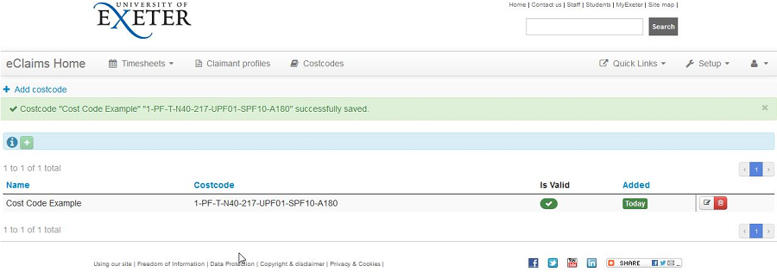
- Once the costcode is added you will be shown a list of all costcodes you have saved. The Is Valid column is a live check against APTOS. If the Column is showing a red X symbol then the costcode will no longer be usable within eClaims.

- Only valid Costcodes can be added. If an invalid Costcode is entered an error will be shown. Costcodes with a trailing space are not valid. If your code produces an error message like the one below, please check it with your departmental finance team

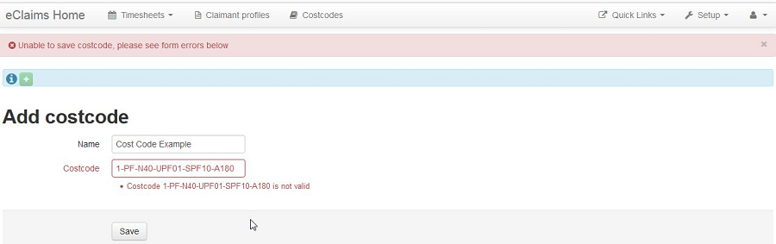
Viewing a Timesheet
- Approvers can approve claims that have been submitted by claimants. When you log in you should see a list of submitted but unapproved timesheets, provided there are any outstanding. If there are multiple levels of approval, the previous level must be approved before you can approve at your level.
- If you are viewing timesheets from the accounts page or the claims awaiting approval screen you will see the options to view or Approve the claim if the claim is at your level of approval.
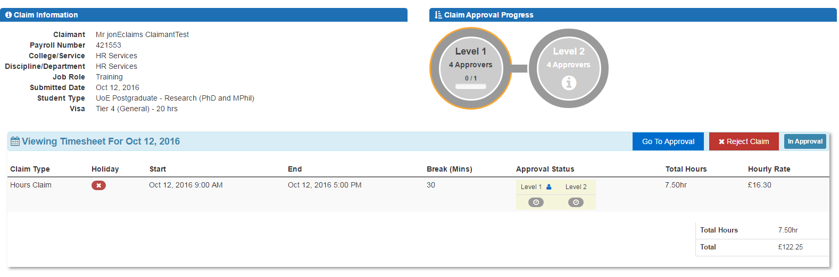
- To view the timesheet press View. Note that hovering over the approval column will show the names of the approvers at that level of approval path. A blue person icon will be shown next to the level that you are part of.

- If you clicked Approve instead of View it will take you straight to the Go To Approval screen
- From this screen you can check over the claim to ensure it is correct and either Go To Approval or Reject Claim if this appears to be incorrect. Also view the job role information and the student/visa information of the claimant (if applicable)
- If your Claimant is on a Visa or doing a PhD you will also be advised of this on the Approve Screen to inform you that this should not be exceed.

Approving an hours claim
- Once you have clicked the Go To Approval screen you are able to see the claims in a broken down timesheet split into Shifts. From this screen you can reject the claim, edit the claim, add a comment, a costcode and approve the claim.
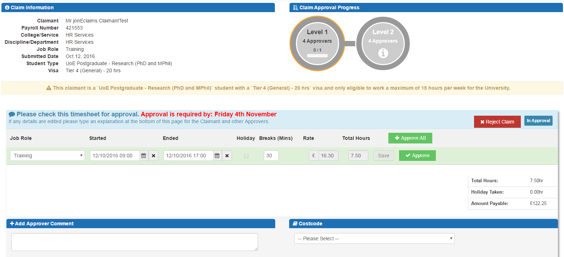
- This screen will also reinforce when the next approval deadline in the middle of the screen for that month.

- If you edit the claim by clicking in any of the Started, Ended or Break boxes you will need to Save the row before approving the relevant row.

- Once you have made any amendments required (Discuss with Claimant first before making changed) you can then click Approve on each row or Approval All if the timesheet is correct.
- You can then add an optional comment to the timesheet that will be visible to all users.

- If the job role has multiple levels of approval the timesheet needs to have a valid costcode before it can be fully approved, Please Note: other levels of approval can change costcodes if incorrect
- Once are you are happy with the timesheet please Click Save, Once saved you will be returned back to the My Accounts page screen to approve any other outstanding claims. Please Note: Once you have saved the claim you will not be able to edit the claim again but your next level of approval can. If you are the last level of approval and notice any issues with the timesheet please contact e-claims@exeter.ac.uk
- If you are the final level of approval and do not enter a costcode and click save on the timesheet you will see this message below and the claim will still be In Approval

Approving a Set Fee claim
- Approving a Set Fee claim is done in the same way as approving an Hours claim. Please follow the same steps as above.

eClaims System Notification emails.

Claimant’s Notification emails.
- If the claim has been approved by yourself the claimant will receive this notification
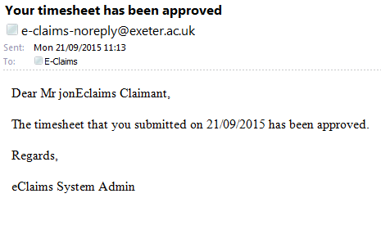

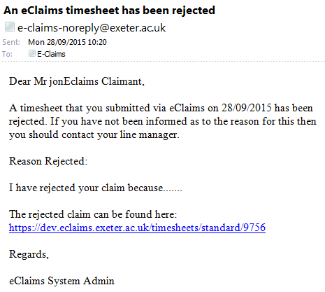
- If the claim has been rejected by yourself the claimant will receive this notification

Approver’s notification emails
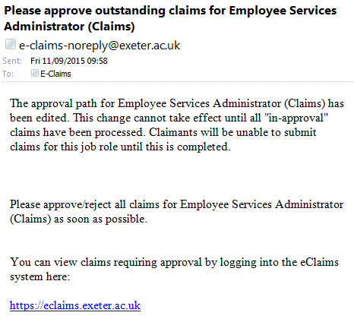
- If a change has been made to an approval path you will receive this notification
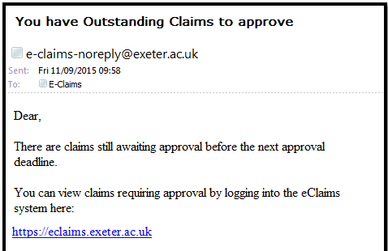
- When approvers are near Authorisation Cut-off date for that months payroll you will receive this notification

- If a claimant exceeds 36.5 hours on their timesheet in a week, you will receive this notification.
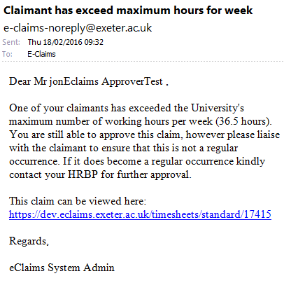

- If a claimant exceeds 48 hours on their timesheet in a week, you will receive this notification.
