eClaims - Quick Guide to Approve/Reject an Hours Claims timesheet
* We recommend that you approve your timesheets weekly to ensure a deadline is not missed. *

Please Note: Once you have approved/rejected a timesheet, you cannot change this and the claim would need to be edited by your next level of approval or rejected and the claimant re-enters the claim

View/Approve Timesheet
- Clicking View will take you to summary of the Claim
- Clicking Approve will take you to the Go To Approval Screen

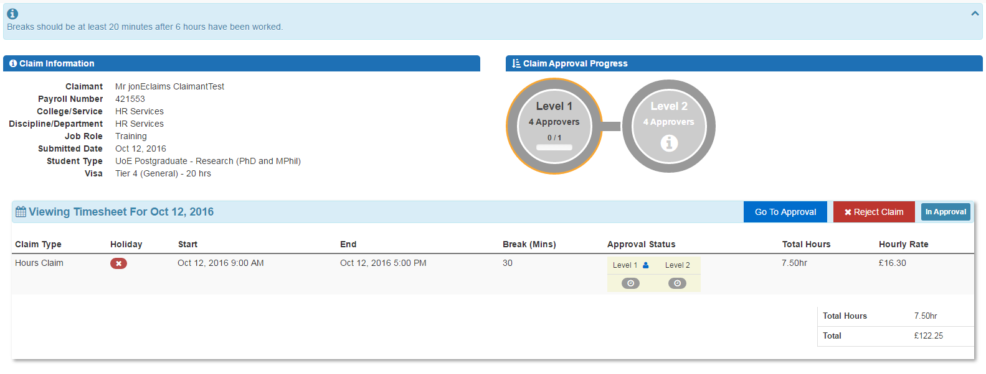
View Timesheet
1
2 information is correct and accurate
3Ensure information is correct and accurate

- Ensure claim information is correct and accurate
- Go To Approval
- Reject Claim

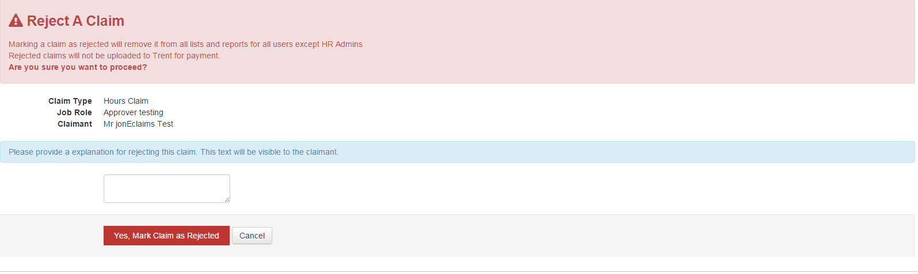
Reject Claim
1 e
2mation is correct and accurate
- Add Rejection note, this is visible to the Claimant and approvers for legacy reasons. This note is also emailed to the claimant when the claim is rejected.
- Yes, Mark Claim as Rejected or Cancel

Go To Approval
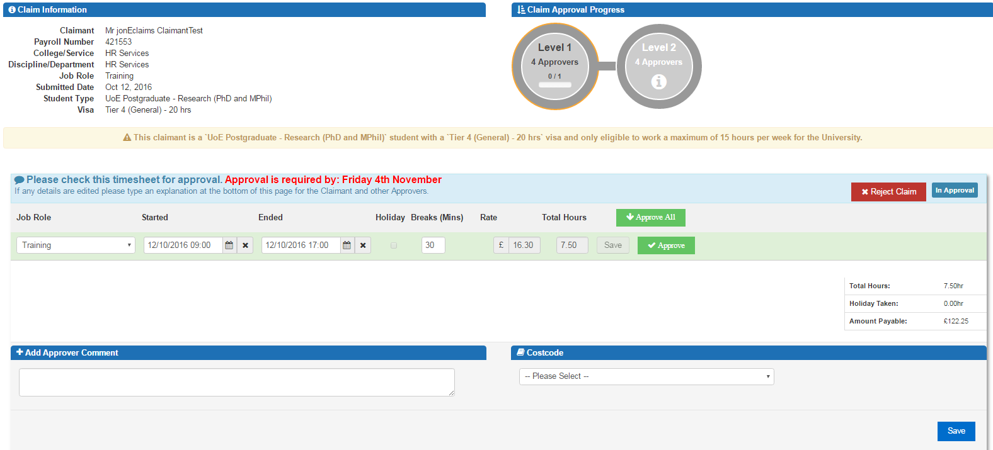
- If the Claimant has a restricted timesheet by a Visa or PhD you will be informed here
2on is correct and accurate
1nformation is correct and accurate
33Ensure information is correct and accurate
44Ensure information is correct and accurate
55Ensure information is correct and accurate
6
7

- Restriction message is shown here
- Check Timesheet
- Reject Claim
- Approve Timesheet
- Add optional Approver Comment
- Add Costcode
- Save

