# eClaims - Quick Guide to Create a Set Fee timesheet

**\* We recommend that you submit your timesheets weekly to ensure a deadline is not missed. \***

## Please Note: Once your timesheet has been submitted, you cannot change this and your claim would need to be edited by your line manager or rejected to be able to re-submit your claim.

# Add Set Fee Claim

# 

# Set Fee Timesheet

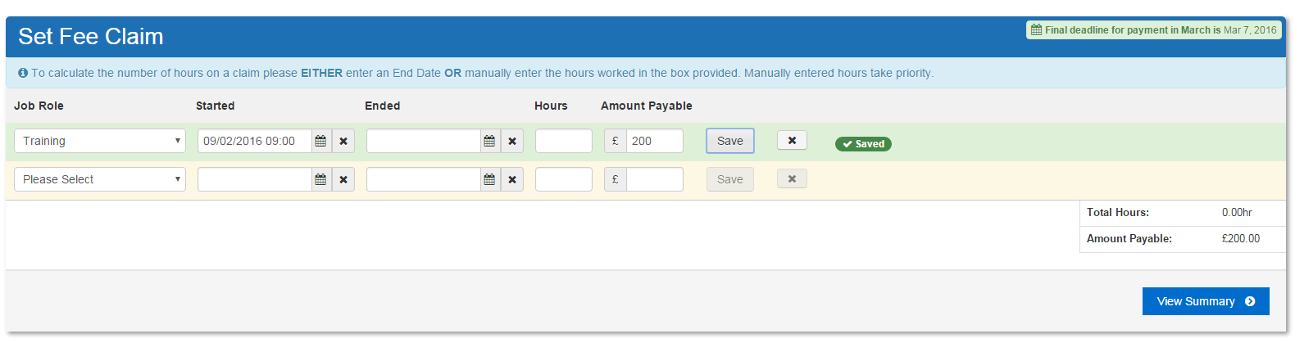

1

2

3

4

5

6

7

8

1. Choose your Job Role
2. Enter your day’s start date and time
3. Enter your day’s Finish date and time (Optional)
4. Enter the Hours you worked (Optional)
5. Enter the Amount Payable
6. Click Save against every individual row entered
7. Once saved a new row will be added (Click **X** to delete a row)
8. When all Rows are enter click View Summary

# View Summary

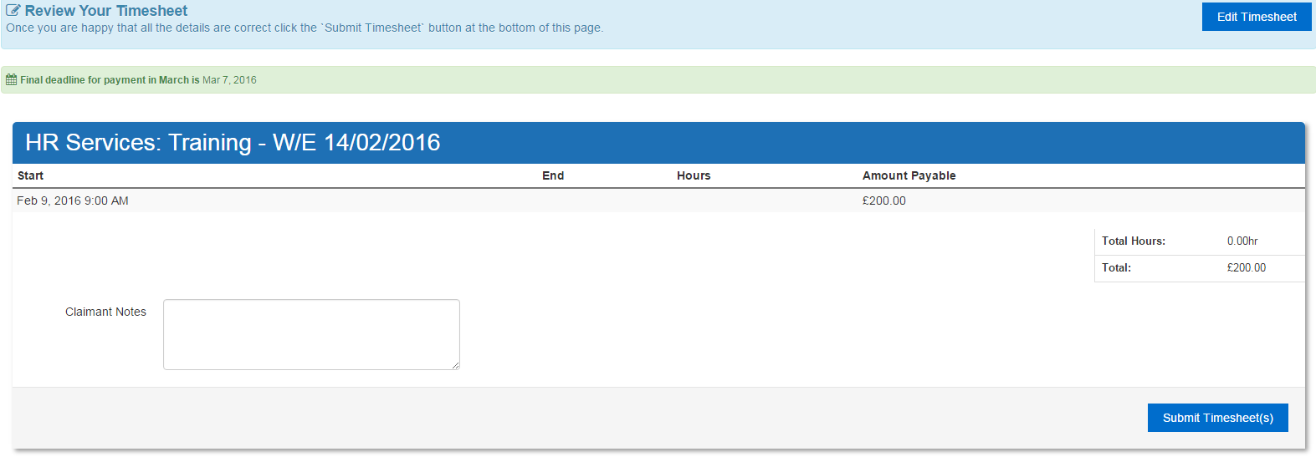

11

21

31

41

1. Confirm that your Summary sheet is correct
2. Edit timesheet if it appears incorrect
3. Add claimant notes for your approver
4. Submit Timesheet

# Please Confirm Submission

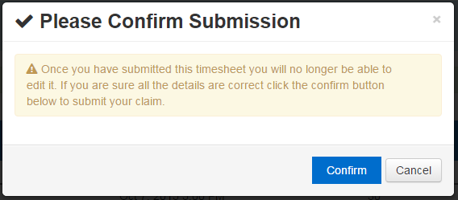

* Once this has been confirmed, the claim has been submitted and will be awaiting approval.